Heart Rate Monitoring During Behavioral Stress Tests in Bold and Shy Rainbow Trout (Oncorhynchus mykiss)

大胆害羞的彩虹鳟鱼（Oncorhynchus mykiss）行为压力测试期间的心率监测
by Eleftherios Kasiouras, Gautier Riberolles, Albin Gräns, Andreas Ekström, Johan Höjesjö, Jonathan A. C. Roques, Erik Sandblom and Lynne U. Sneddon

Abstract
Monitoring stress in captive fish is crucial for their welfare, but continuous physiological measures in unrestrained animals are challenging. Rainbow trout (Oncorhynchus mykiss) exhibit divergent personalities, ranging from bold to shy, which correlate with cortisol-mediated stress responses. To determine whether personality affects the sympathetic nervous system, heart rate was measured during three potentially stressful events as a proxy for sympathetic nervous system responses. Firstly, trout were classified as bold or shy, using a novel object test. Subsequently, trout were implanted with biologgers to record heart rate in vivo at rest during and after the behavioral tests. Following recovery, the fish underwent a second novel object test, a confinement test, a pair-wise contest, and a final novel object test to explore the degree of boldness over the experimental period, which remained consistent. Heart rate was relatively higher in both bold and shy animals during the confinement test and the pair-wise contest compared with the novel object test, which indicated that heart rate monitoring was a valid gauge of the valence of the experience. Heart rate responses did not differ between bold and shy trout, indicating that behavioral phenotype did not influence the autonomic stress response. Thus, heart rate is a reliable indicator of stress without the need to account for intra-specific behavioral variations.

Keywords: animal personality; behavior; biologgers; rainbow trout; heart rate; stress physiology; welfare

Key Contribution: Heart rate is a robust indicator of stress independent of rainbow trout’s behavioral phenotype. Biologgers can be used to gauge how stressful a behavioral test or captive situation may be.

摘要
监测圈养鱼类的压力对它们的福利至关重要，但对不受约束的动物进行持续的生理测量是具有挑战性的。虹鳟（Oncorhynchus mykiss）表现出不同的性格，从大胆到害羞，这与皮质醇介导的压力反应有关。为了确定人格是否影响交感神经系统，在三个潜在的压力事件中测量了心率，作为交感神经系统反应的指标。首先，使用新颖的对象测试将鳟鱼分为大胆或害羞。随后，在行为测试期间和之后，将鳟鱼植入生物记录仪，记录休息时的体内心率。恢复后，这条鱼接受了第二次新物体测试、禁闭测试、配对比赛和最后一次新物体检测，以探索实验期间的大胆程度，这些测试保持一致。与新对象测试相比，在禁闭测试和成对比赛中，大胆和害羞的动物的心率相对较高，这表明心率监测是评估这种体验价值的有效指标。大胆和害羞的鳟鱼的心率反应没有差异，表明行为表型不影响自主应激反应。因此，心率是压力的可靠指标，无需考虑特定个体内的行为变化。

关键词：Star-Oddi DST milli-HRT生物记录器，动物心率温度记录器；行为；生物记录仪；虹鳟；心率；应激生理学；福利

关键贡献：心率是一个与虹鳟鱼的行为表型无关的强有力的压力指标。生物记录器可用于衡量行为测试或圈养情况可能带来的压力。

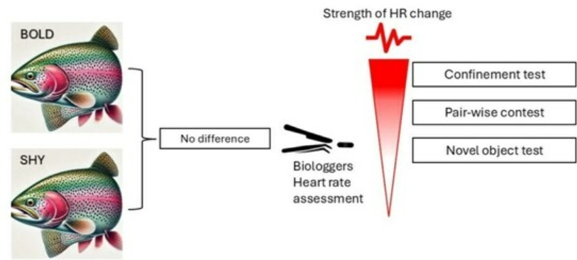
摘要示意图

1. Introduction
Understanding the impact of poor living conditions or the effect of different stressful husbandry procedures would help guide and improve the way in which salmonids and other fishes are reared [1]. Due to intraspecific differences in stress response, individual variation may mean that stressors differentially impact individuals [2]. Thus, it would be important to characterize individual variation in response to a variety of novel challenges or stressors and find a robust indicator that could differentiate between stressors in vivo rather than at the end of a stressful event (e.g., terminal blood sampling), which only provides correlative information [3]. Since good animal welfare is vitally important for ethical reasons as well as ensuring normal growth, reproduction, and immune function, it is important to understand how individuals may exhibit different behavioral and physiological responses to stressors in captive environments [4,5]. Further, this intraspecific variation in behavior might present a confounding factor in laboratory studies and make welfare assessments problematic in an applied context.
The definition of boldness or, conversely, shyness, as provided by Wilson et al. (1994), is the propensity to take risks in the face of danger [6]. An individual’s degree of boldness or ‘personality type’ is a strong and crucial driving force when it comes to the evolution of populations since phenotypic variation can influence the fitness of an individual and, ultimately, the survival of the population [7]. Boldness is also defined as how individuals respond to risk and novelty. In general, bold animals are more risk-prone, active, more likely to explore novel objects or different environments, and they are also more likely to spend time in the open, as opposed to shy individuals who are risk averse and cautious [8,9]. Note that the degree of boldness exists along a bold and shy continuum where individuals at the extreme ends can coexist with intermediate animals, but some species, such as rainbow trout (Oncorhynchus mykiss), tend to have a dichotomous distribution with fewer intermediates [9].
When investigating the stress response of individuals, bold animals usually have a proactive coping style and respond to stress with relatively low hypothalamic-pituitary-adrenal (HPA/HPI; interrenal in fish) axis activity, while shy individuals have a reactive coping style and exhibit a higher HPA/HPI response [10,11,12], as reflected by low and high plasma cortisol levels respectively [10]. Pottinger and Carrick (1999) created two distinct lines of rainbow trout by selecting individuals based on the magnitude of cortisol response to confinement where fish exhibited divergent endocrine responses to a stressor [13]. This study demonstrated that it was possible to distinguish fish by selecting individuals with low or high plasma cortisol concentrations after stressful events. Four consecutive generations were produced where post-stress plasma cortisol concentrations remained significantly greater in high, in contrast with low, stress-responding lines. There was a moderately high heritability for HPI-reactivity to stress [13]. Moreover, Øverli et al. (2007) reported that these divergent physiological traits were correlated with boldness in such a way that low-responding fish exhibited a bold phenotype and high-responding fish exhibited a shy phenotype [14]. Thus, the rainbow trout is a valid model for the study of boldness due to the link between an individual’s physiological response to stress or stress coping style and their behavioral phenotype.
When a fish is exposed to a stressor, i.e., something that threatens homeostasis, the brain perceives this and elicits a physiological response [15]. A cascade of physiological events occurs, including the activation of the hypothalamic-sympathetic chromaffin cell (HSC) and the activation of the HPI axis in fish. These responses constitute the primary stress response. Both the HSC and the HPI axis are responsible for the release of stress hormones in fish, specifically the catecholamines adrenalin and noradrenalin and the glucocorticoid cortisol, respectively [16]. These hormones together are responsible for the regulation of the secondary stress response, which includes both cellular and metabolic responses. The more rapid HSC axis specifically affects the cardiovascular system along with other systems, which affect both the hydromineral balance and the immune system. Increases in heart rate during stress are part of the fight or flight response [17,18], and as such, heart rate is often measured as an indicator of how stressful an experience is [19]. Changes in heart rate can be assessed using implantable biologgers, which collect heart rate over a prolonged period [20].
When adrenalin and noradrenalin are released, they trigger a myriad of effects, including increased heart rate, stroke volume, and blood pressure, as well as ventilation to increase cardiovascular tissue oxygen transport [21]. The catecholamine response is more rapid in comparison to the release of cortisol [14]. Acute stress responses are adaptive if they allow the animal to recover, but chronic stress and high levels of cortisol can have a negative effect on physiology [22,23]. Thus, changes in heart rate may provide a more rapid and accurate means of assessing stress in a freely moving animal since changes in heart rate are swifter than cortisol release. Currently, it is unknown as to whether bold and shy rainbow trout differ in heart rate responses to stress as they do in the production of cortisol. Most of the stress-related parameters (cortisol, brain gene expression) have been measured after the behavior occurs when investigating boldness in fishes, so they can only be considered as correlates rather than mechanisms of differing behavioral phenotypes [24].
The aims of this study are to assess if intraspecific variation in behavior (bold or shy phenotypes) influences the heart rate of rainbow trout and whether in vivo heart rate monitoring can provide information on the valence or on the perceived intensity of different tests. Determination of heart rate during these challenges will assist in exploring the cardiac responses to two behavioral tests and a standard stressor, confinement, which has yet to be measured in bold and shy individuals. The tests differ in the experience they provide: firstly, the novel object test reflects neophobia, i.e., risk-taking when exposed to an unfamiliar object; secondly, a confinement test is known to elicit a maximal stress response when measuring cortisol [25,26,27]; and thirdly, pair-wise contests were staged since trout are territorial and engage in aggressive interactions where bold are often more aggressive than shy fish [28,29,30]. Based upon previous studies, we expect that shy individuals would have a greater heart rate response to these tests compared with bold trout. If the fish perceive the tests differently, this could be reflected in heart rate measurements in terms of the magnitude of change from resting heart rate, thus providing insight into how stressful these tests are perceived.

2. Materials and Methods

2.1. Animals
Rainbow trout (mean ± SE: weight = 390.69 ± 0.09 g; length = 29.62 ± 0.01 cm; n = 32) were obtained from a local anonymous commercial supplier. The trout were transported to the aquarium facility at the University of Gothenburg, Sweden, and held for a period of at least two weeks in one stock tank (145 × 145 × 40 cm) to acclimate to laboratory conditions before they were used in the experiments. During this time, fish were fed three times per week ad libitum using commercial fish pellets (Spirit Trout 600-40A Grade 7, Skretting, pellet, Stavanger, Norway). Water parameters were maintained within the following values: temperature = 10 ± 1 °C, pH = ~7.2, NH4+ < 0.1 mg/L, NO2− < 0.1 mg/L, NO3− < 20 mg/L and continuous water aeration was provided via an air stone. The water was filtered in a semi-closed system with ~10% fresh water replaced per day. Half of the tank was covered from above to provide shelter, and stone pebbles were used as substrate enrichment. To ensure good welfare, animals were observed regularly, especially during feeding, since stressed fish exhibit anorexia [31]. The light/dark cycle was 12:12 h, light/dark with a dim up and down of 30 min to reflect dusk and dawn, respectively.
Fish were chosen randomly and transferred to an individual tank in an adjacent room with the same water supply. Upon capture, fish were carefully netted from a stock tank and were anesthetized in a 25 L bucket containing water and MS-222 (FINQUEL, Argent Chemical Laboratories, Redmond, WA, USA; 80 mg/L) buffered with sodium bicarbonate, 80 mg/L). Their standard length (to 0.01 cm) and weight (to 0.01 g) were measured. Then, fish were immediately transferred to their individual tanks (65 × 35 × 35 cm), where all fish showed recovery. The tanks were supplied with fresh water from the semi-closed recirculation system at a flow rate of 3 L per min. Following the transfer, fish were allowed to acclimate for 14 days and were fed manually each day around 9 AM, using pellets at 1% body weight. All fish resumed feeding three days after the surgery. The recovery of the animals after the surgery was monitored closely for 14 days, where wounds were visually inspected regularly, and there were no signs of infection. Moreover, the feeding behavior and the swimming patterns were monitored throughout the recovery. At the end of the experiments, the wound was physically inspected, and it appeared to be fully healed. Additionally, the heart rate was recorded and returned to pre-surgery values after a few days from the surgery. There are also studies confirming that three weeks (21 days) is sufficient to fully recover from biologger surgery [3]. Uneaten food, if any, and waste were removed manually each day by using a siphon approximately 45 min to 75 min after feeding.
Three out of the four sides of the tanks were covered with black opaque plastic, preventing visual disturbance from neighboring tanks. Moreover, each tank had a plastic lid, half of which was opaque, which provided shelter, and the other half transparent. Each fish was provided with one anchored PVC plant with 20cm green fronds as enrichment, and an opaque curtain was hung in front of the tanks to prevent visual disturbance.

2.2. Behavioral Tests
Rainbow trout were characterized individually as bold or shy using a novel object test as described in Sneddon et al. (2003) [9]. Fish were characterized as bold when approaching the novel object in less than 3 min; the rest were characterized as shy. Then, biologgers were surgically implanted as described below. After three weeks of post-surgery recovery, the fish were subjected to four tests, including a novel object test, a confinement test, a pair-wise contest, and a final and third novel object test. The two additional novel object tests were conducted to test for consistency of boldness over the experimental period.
During the behavioral tests, fish were filmed with digital cameras (Sony, HDR-CX240E, Handycam, 9.2 megapixels, Tokyo, Japan). To avoid visual disturbance, the cameras were positioned behind an opaque curtain with small holes for camera placement located in front of the tanks. When the experiment was started, the cameras were turned on from behind the curtain, and the experimenter left the room during the tests. To exclude circadian rhythm-induced variations, all behavioral tests were performed approximately at the same time every day at 9 a.m., within 30 min [32,33].

2.3. Shy–Bold Categorization: First Novel Object Test
A novel object was introduced to the tank on the left or right side of the tank, and responses were recorded via video. A different novel object was used for each novel object test. Three exploration zones were defined in a square shape at 5, 10, and 15 cm from the novel object position. Entrance to the zone was considered valid when the fish had the front of its head, from the tip of the snout to the eye, in the zone. The following variables were recorded and used for the analysis: latency to enter the 15, 10, and 5 cm zones, respectively, time spent in each zone (s), time spent at a greater distance than 15 cm (s), the frequencies of the fish entering the 15, 10 and 5 cm zone (number of entries/min) and the time (s) spent inactive (no movements except for gill ventilation). Trout were classified as bold if they entered the 5 cm zone within 3 min and shy if they did not enter for 15 min [9,34].

2.4. Biologger Surgery
Two weeks after the first novel object test, the fish were implanted with biologgers to monitor cardiac activity during the behavioral tests. Biologger implantation followed the method described in Brijs et al. 2018 [20]. The fish were transferred in a 25 L bucket containing 10 L aerated 10 °C water from the recirculation system containing MS-222 (with a concentration of 150 mg/L), buffered with sodium bicarbonate (300 mg/L). Fish were kept in this bucket until reaching surgical anesthesia as indicated by a cessation of ventilation.
The fish were then placed on an operating table covered with soft water-soaked foam. During the surgical procedure, anesthesia was maintained during the surgery by continuously irrigating the gills with 10 °C aerated water, containing 75 mg/L of MS-222 buffered with 150 mg/L of sodium bicarbonate. The biologgers were implanted within the abdominal cavity in a position known to obtain optimal signal quality and strength [20]. A 25–30 mm mid-ventral incision was made ~40 mm posterior to the pectoral fins. The biologger was then inserted with the flat end facing anteriorly and gently pushed toward the pericardium until the rounded end of the biologger was no longer visible at the anterior end of the incision. This ensures that the biologger was placed in close proximity to the heart. The biologger then was anchored with the side containing the two electrocardiogram (ECG) electrodes facing ventrally toward the abdominal wall by a suture attached to the logger via a hole in the ceramic casing. The wound was closed with interrupted stitches using 3–0 sterile monofilament nonabsorbable Prolene suture material (Ethicon Inc., Somerville, NJ, USA). The total duration of the surgical procedure was approximately 20 min, including capture, anesthesia, biological implantation, recovery in a tank bubbled with air, and transfer of the fish to its individual aquarium.
The fish were allowed to recover from the surgery for 21 days before any experiments. If the fish were performing normal behavior and were feeding, then we deemed they had recovered. If we observed reduced swimming, increased bottom dwelling, lack of interest in food, or hiding behind the plant for prolonged periods of time, this indicated poor welfare. Also, if fish do not feed for more than three consecutive days, this is an indication that their welfare is compromised [24]. The behavior and feeding of the fish were monitored to ensure a complete recovery. Three fish had wounds with a suspected fungal infection after the surgery and were treated with daily salt baths (11 ppt) for 10 min over 3 days, which allowed them to fully recover. Salt baths are an appropriate treatment for infections in freshwater fish [35]. After a week, all fish were feeding and behaving normally, so no fish were excluded from the study.

Biologgers and Heart Rate
The biologger device was from Star-Oddi DST milli-HRT biologger (Logger version 4 FM/CR16/4800/MSO/RST, STAR-ODDI, Gardabaer, Iceland, dimensions: 13.0 mm diameter, 39.5 mm length, 5 cm volume and mass in air of 11.8 g). Biologgers monitor the heart rate via a single-channel ECG amplifier with electrodes integrated into the ceramic case of the logger. Each biologger has a real-time clock with an accuracy of ±1 min/month−1. Heart rate was sampled at 100 Hz and 6 s sampling intervals, and the heart rate was derived from the mean RR-interval, i.e., the time between two consecutive R waves (ventricular depolarizations) in the ECG. The biologgers were programmed prior to implantation, and the data were retrieved after the experiment using the application software Mercury v 3.18 and the associated Communication Box (STAR-ODDI, Gardabaer, Iceland). Heart rate was recorded every 30 min during the period prior to the experimental tests, and the sampling frequency was increased to record at every 20 s during the one-hour test period. Values retrieved from the biologgers were also graded from the biologgers with a quality index (QI). Measurements were scored from 0 to 3 where 0 is great, 1 is good, 2 is fair, and 3 is poor. It has been previously confirmed that data with QI 0 are highly accurate; though they include measurements with QI 1, the potential error margin declines to <3 beats/min when several values are averaged [3]. In our study, the data that were included in calculating the averages and graded with QI 0 were 78.96%, and the sum of QI 0 and QI 1 data was 96.13%. However, to avoid working with fragmented data, it was decided that both values with QI 0 and QI 1 were to be included in the analysis, and the results were still sufficiently accurate. The following averages were calculated with values with good QI (0 and 1). The routine heart rate was calculated as the average of all the measurements taken within a day (24 h) prior to each behavioral test. The average during the test includes all the measurements until each experiment ends. Following that, the average heart rate after the test was calculated up to the point at which the fish had recovered from the test, which, in turn, defined the time point at which the heart rate had returned to the pre-test resting heart rate. Additionally, the recovery period was calculated as the time in seconds it took for the heart rate to return to the pre-test resting heart rate level. Similarly, the maximum (highest value during the tests) and minimum (lowest value during the tests) heart rate were also calculated during each behavioral test. Furthermore, three additional calculations were made. The recovery rate was defined as the difference between the maximum and minimum heart rate divided by the recovery time. The 20th percentile of the recovery rate: the 20th percentile of all heart rate measurements received during the test divided by the recovery time. Finally, the magnitude of change during each test was calculated by subtracting the maximum from the average resting heart rate.

2.5. Second Novel Object Test
Another novel object test was performed following the same methodology as the first test to determine if boldness had changed after the surgery. The novel object was different from the object that was used during the first test to prevent habituation.

2.5.1. Confinement Test
Four days after the second novel object test, a confinement test was conducted, similar to the study of Pottinger et al., 1992 [25]. The fish were transferred into a novel, unfamiliar white plastic tank (47 × 65 × 30 cm), filled with 28 cm depth of water to confine the fish to a small area. Video cameras were placed above the tanks to record the behavior. The tanks were covered with transparent glass lids. The average size of the animals was around 30 cm, so although animals could turn in the tanks, swimming was restricted; hence, the animals could not turn easily. The following variables were analyzed with tracking software (LoliTrack, Loligo Systems, Viborg, Denmark) for analysis: time spent in the central zone (s), time spent wall-hugging (s), time spent active (s) and time spent inactive (s). At the end of the confinement test, the fish were transferred back into their home tanks.

2.5.2. Pair-Wise Contests
The pair-wise contest was conducted 6 days after the confinement test, similar to Sneddon et al., 2016 [24]. One day before the pair-wise contest, fish were transferred into a novel contest tank to prevent any prior ownership effects. The contest tank was divided in half by a black opaque plastic divider, and one fish was transferred into each side of the tank. The contest tank was similar in size to the home tanks (65 × 35 × 35 cm per fish) and was filled with water coming from the same recirculated system as the home tanks. The following day, the plastic barrier dividing the tank was manually removed. Behavior was recorded for 15 min with cameras. The following variables were recorded as frequency per min for each fish of each pair for the analysis, following the methodology of Sneddon et al., 2016 [24]. Frontal display, lateral display, contact with mouth, attack, displacement, chasing, circling and retreat. Additionally, the fish were matched according to their size (weight) to ensure that size differences were not a confounding factor. Size can be a confounding factor since larger trout dominate smaller trout [33]; thus, size-matching eliminates this. Further, bold fish dominate shy fish, so the pairs were shy versus shy and bold versus bold [24,33].
Following the 15 min of a pair-wise contest, the fish were transferred back to their home tanks. The water was entirely renewed, and the tank was cleaned thoroughly to exclude any confounding effects of pheromones left in the water after the contest. The dominance index was calculated for each fish by summing up aggressive acts (Contact, Displacement of the opponent, Chasing) and subtracting the number of retreats by direct observation of the videos (exhaustive focal sampling) [Dominance index = (Bite + Attack + Displacement + Chasing)-Retreat]. Thus, the fish with the highest dominance index was the winner of the contest.

2.5.3. Third Novel Object Test
Six days after the last pair-wise contest, a final novel object test was performed applying the same methodology, but again, a different object was used for the first two sets. This test was conducted to determine the consistency of boldness over the experimental period.
One hour after the end of the novel object test, when cortisol concentrations are known to be highest after a stressor [9], fish were euthanized by a percussive blow to the head. Brain and blood samples were taken for another study.

2.6. Statistical Analysis
In the first novel object test, 16 bold and 16 shy individuals were identified with no intermediates. The analysis was conducted in SPSS version 29.0 (IBM Corp., Armonk, NY USA). A Principal Component Analysis (PCA) was conducted to identify the most indicative parameter that differentiated bold and shy fish to ensure that correct classification of personality occurred: from the measurements of the 1st novel object test Kaiser–Meyer–Olkin value exceeded 0.6 (KMO = 0.670). The three factors of PCA were revealed with an Eigenvalue > 0.1 (lat15 = 6.145, lat10 = 2.298, lat5 = 1.206). The rotation method that was used was the Varimax with Kaiser Normalization. The results of this study are consistent with previous research [9], which showed that latency to enter the 5 cm zone was the most reliable indicator of boldness. Furthermore, a Kruskal Wallis test was performed on the data to compare the latencies to approach the object within 15, 10, and 5 cm for each of the three novel object tests. Therefore, to categorize fish, the latency when approaching the object within the 5 cm zone was used. Typically, the bold fish are characterized by a short latency (less than 3 min), and the shy fish by long latencies (more than 10 min). The novel object test data were tested for normality using the Shapiro–Wilk test, and except for the three latencies (15, 10, and 5), the rest met parametric assumptions; therefore, independent T-tests were used to test for differences in behavior between bold and shy trout throughout the three novel object tests.
The confinement data were normally distributed, and so each behavior was tested using an independent T-test to determine if there was a difference between bold and shy trout. The parameters that were analyzed between bold and shy were time spent in the central zone (s), time spent wall-hugging (s), time spent active (s), and time spent inactive (s).
In the pair-wise contest, the dominance index was compared between bold and shy fish using an independent T-test, and to compare shy winners, losers, or draws (unclear results during the contest), a one-way ANOVA was conducted. The same comparison was used for the bold trout winners, losers, or that draw.
During the 2nd novel object test, the confinement test, and the pair-wise contest, the most important periods were the 24 h before. So, the resting (normal/baseline) heart rate was calculated from all the measurements taken within the 24 h before each test. The average heart rate during the test is the average of all the measurements taken when the test occurred. Finally, when the heart rate returned to normal resting heart rate after the test, the measurements to that point were calculated into an average, which is the recovery (post-resting) average and the time that took for the fish to recover to when the heart rate was the same as the previous 24 h was the recovery time. Additionally, the maximum and minimum values during each test were measured. The magnitude of change was also calculated as the difference between the maximum value and the average heart rate during the test. Recovery periods are important because they reflect how quickly the fish can recover after the test. As the normal heart rate differed for each fish, the 20th percentile of all the measurements of heart rate, per test, per individual was calculated. Then, the recovery rate was calculated as the 20th percentile of the measurements of heart rate divided by the recovery time per test per individual. The data were normally distributed and were analyzed with a two-way ANOVA. A two-way ANOVA was also conducted to compare the differences in their averages (before, during, after), recovery rate during and after the novel object test, confinement test, and pair-wise contest. Additionally, the maximum, minimum, and magnitude of change during the test were compared with a two-way ANOVA.
An independent T-test was used to analyze the differences between weight and length. First the standard growth rate (SGR) was calculated for weight and length and compared using an independent T-test. Lastly, the significant data between the behavioral experiments, the heart rate data, and the physiological measurements were correlated using Spearman correlation for the data from the pair-wise contest and Pearson correlation for the rest of the data since they were normally distributed. The correlations were conducted in SPSSS (Version 29.0) to explore whether there were any relationships between these parameters.

3. Results

3.1. Consistency of Boldness
No differences were found between the three latencies when the novel object was approached within the 15, 10, and 5 cm across the three novel object tests, which indicated that boldness was consistent over time (Table S1).

Differences Between Bold and Shy in Novel Object Test
The behavioral parameters that were measured during novel object tests are shown in Table S2 and Figure 1. The time spent in close proximity to the novel object test was higher in the three different zones (5, 10, 15 cm) in bold fish compared with the shy fish (Table S2). Similarly, the frequency of entries into the 5, 10, and 15 cm zones and the time that the fish stayed in the area were greater for bold trout compared to shy. Both frequencies to enter the 10 cm zone and the 5 cm zone were different between bold and shy trout, with bold trout entering these zones more frequently and remaining longer in these zones than shy. Shy fish were more inactive than the bold (Table S2). Additionally, shy trout remained at a greater distance outside the 15 cm zone.

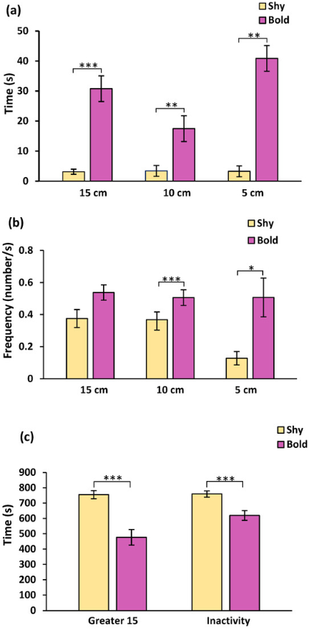
Figure 1. (a) Mean (±SE) time that fish spent in the 15,10, 5 cm zone (s), between bold and shy rainbow trout across the three novel object tests. (b) Mean (±SE) of the frequency that fish entered the 15, 10, 5 cm zone, between bold and shy rainbow trout across the three novel object tests. (c) Mean (±SE) time that fish spent in greater distance than 15 cm and inactivity time (s), between bold and shy rainbow trout across the three novel object tests (n = 16, bold; n = 16, shy; * p < 0.05; ** p < 0.01; *** p < 0.001).

3.2. Confinement Test
There were no statistical differences in the behavioral parameters that were analyzed for the confinement test (Table S3) between bold and shy.

3.3. Pair-Wise Contest
In the pair-wise contests, shy fish had a higher dominance score compared with bold fish (t(30) = 1.768, p = 0.048), which suggested that shy trout were more aggressive during contests than bold trout (Figure 2). Comparing the dominance score between shy winners, losers, or those that drew (unclear contest outcome), there were no significant differences (F(2) = 2.982, p = 0.086). Similarly, there were no differences in the dominance score between bold winners and losers or those that drew (F(2) = 0.724, p = 0.503).
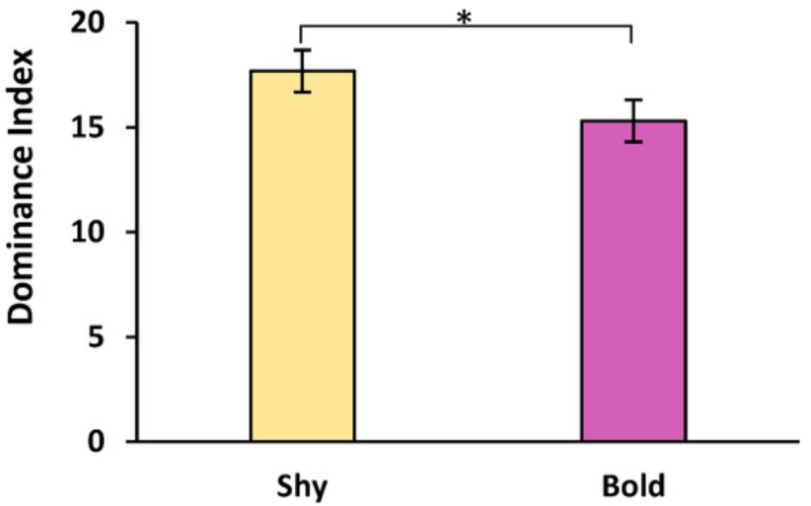
Figure 2. Mean (±SE) of the dominance index during pair-wise contests in rainbow trout (n = 16, bold; n = 16, shy; * p < 0.05).

3.4. Heart Rate
The minimum heart rate was similar when comparing bold and shy (F(1,90) = 0.367, p = 0.546) between the three tests (F(2,90) = 0.581, p = 0.561), and there was no significant interaction between boldness and test type (F(2,90) = 0.092, p = 0.912) (Figure 3a).

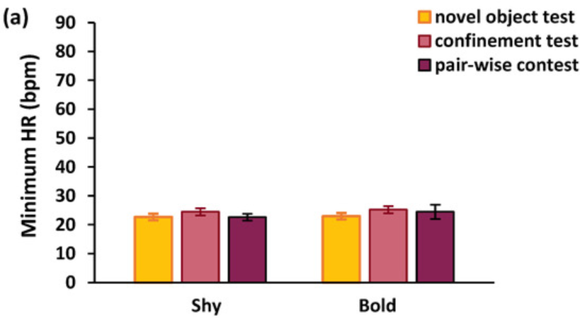
Figure 3. (a) Mean (±SE) of the minimum value of the heart rate (HR, in beats per min, bpm) during the novel object test, confinement test and pair-wise contest in rainbow trout (n = 16, bold; n = 16, shy). (b) Mean (±SE) of the maximum value of the heart rate during the novel object test, confinement test and pair-wise contest (n = 16, bold; n = 16, shy; * p < 0.05; ** p < 0.01). No significant differences were found between bold and shy animals.

The maximum heart rate was significantly different depending upon the type of test (F(2,90) = 6.781, p = 0.002; Figure 3b), but there was neither a significant difference between bold and shy trout (F(1,90) = 1.088, p = 0.300) nor was there any interaction between boldness and test type (F(2,90) = 0.279, p = 0.758). The maximum heart rate during the confinement test and pair-wise contest was much higher than during the novel object test (p = 0.032; p = 0.002; Figure 3b).
The average heart rate before the tests, also considered as resting or baseline heart rate, did not differ between bold and shy (F(1,90) = 0.150, p = 0.699) or between the three different tests (F(2,90) = 2.033, p = 0.137) nor was there an interaction (F(2,90) = 0.097, p = 0.908) (Figure 4a). When comparing the average heart rate during the tests, bold and shy trout were similar (F(1,90) = 0.000, p = 0.989), but differences were recorded between the three tests (F(2,90) = 31.633, p < 0.001); however, there were no interactions between boldness and test type (F(2,90) = 0.027, p = 0.974). The average heart rate during the pair-wise and the confinement test was significantly higher than the average heart rate values during the novel object test (p < 0.001; p < 0.001), but confinement and pair-wise contest heart rates were similar (p = 0.375) (Figure 4b). After the tests, the average resting heart rate was similar between bold and shy fish (F(1,90) = 0.953, p = 0.332), but the values amongst the three tests were significantly different (F(2,90) = 53.145, p < 0.001) with no interaction between boldness and test type (F(2,90) = 0.709, p = 0.495) (Figure 4c). Comparing the post-test heart rate, the pair-wise contest and the confinement test had a much higher average heart rate than the novel object test (p < 0.001; p < 0.001), but there was no difference between confinement and pair-wise contest (p = 0.882) (Figure 4c).

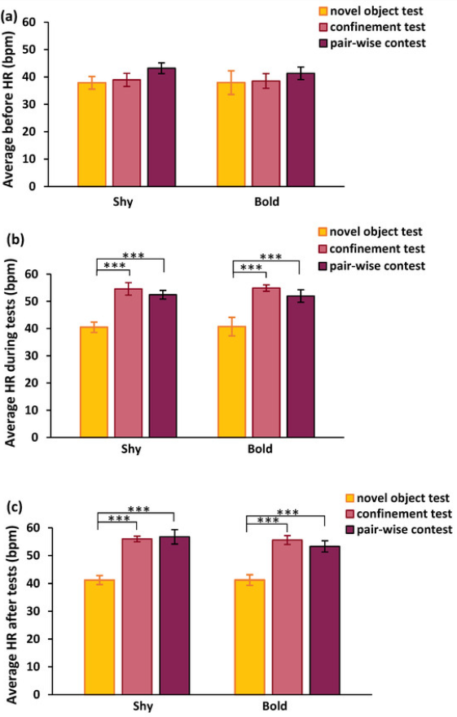
Figure 4. (a) Mean (±SE) of the average resting heart rate (HR, in beats per min, bpm) before the three tests (novel object test, confinement test, and pair-wise contest) between bold and shy rainbow trout (n = 16, bold; n = 16, shy). (b) Mean (±SE) of the average heart rate during the three tests (novel object test, confinement test, and pair-wise contest) between bold and shy (n = 16, bold; n = 16, shy). (c) Mean (±SE) of the average resting heart rate after the three tests (novel object test, confinement test, and pair-wise contest) between bold and shy (n = 16, bold; n = 16, shy; *** p < 0.001). No significant differences were found between bold and shy animals.
The 20th percentile of the recovery rate was significantly different between the three behavioral tests (F(2,90) = 3.785, p = 0.026), but there was no influence of boldness (F(1,90) = 0.190, p = 0.664), nor an interaction (F(2,90) = 0.470, p = 0.626). The higher the recovery rate, the faster the fish recovered from the test. The 20th percentile of the recovery rate of the confinement test was much lower than the novel object test (p = 0.026) but not different between confinement and pair-wise contest (p = 0.795), nor between novel object test and the pair-wise contest (p = 0.120) (Figure 5).
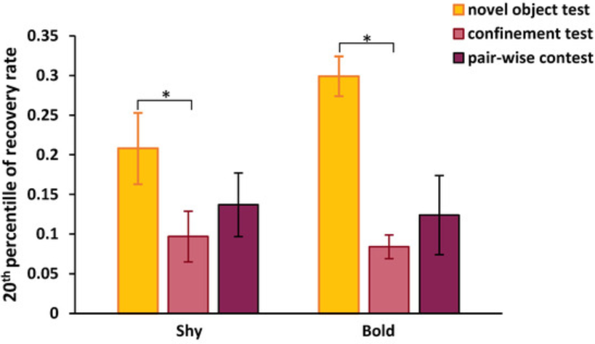
Figure 5. Mean (±SE) of the 20th percentile of recovery rate between the three competitions (novel object test, confinement test, and pair-wise contest between bold and shy rainbow trout (n = 16, bold; n = 16, shy; * p < 0.05). The 20th percentile of the recovery rate is defined as the 20th percentile of all measurements during the test divided by the recovery time. No significant differences were found between bold and shy animals.

Duration of recovery was different between the three behavioral tests (F(2,90) = 16.784, p < 0.001), but not between bold and shy trout (F(1,90) = 0.088, p = 0.767) and no interaction (F(2,90) = 0.596, p = 0.553) (Figure S1). The time to recover from the confinement test was longer in comparison to the novel object test and pair-wise contest (p < 0.001; p < 0.001), but not different between the novel object test and pair-wise contest (p = 0.973) (Figure 6).
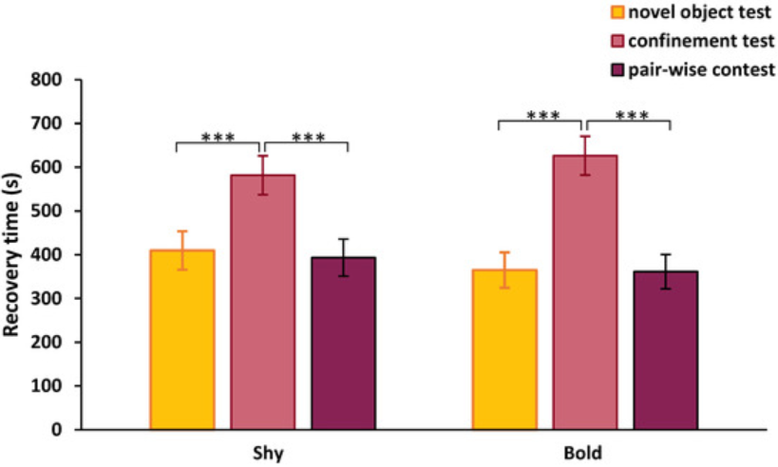
Figure 6. Mean (±SE) of the recovery time between the three competitions (novel object test, confinement test, and pair-wise contest) between bold and shy rainbow trout (n = 16, bold; n = 16, shy; *** p < 0.001). No significant differences were found between bold and shy animals.

Finally, the magnitude of the change in the heart rate was compared. No effect of boldness was observed (F(1,90) = 0.393, p = 0.532). Additionally, there was no effect between the three behavioral tests (F(2,90) = 2.307, p = 0.105) nor interactions (F(2,90) = 0.457, p = 0.635) (Figure S1).

3.5. Physiological Parameters
When comparing the values for length, weight, and standard growth rate (SGR), the only noticeable differences were in weight, in which bold trout were heavier than shy trout before the start of the experiments and also at the end of the experiments (Table 1).
Table 1. Comparison of the average (SE) weight, length, and specific growth rate (SGR) of rainbow trout before and after the experiments between bold and shy individuals (n = 16 bold and shy).

3.6. Relationships Between Parameters
There was a positive relationship between the latency to approach the novel object in 5 cm and the average heart rate before the novel object test (Rs: 0.411; p = 0.019) (Figure 7). No other correlations were significant between the novel object behavioral data and heart rate (Table S4A). There were also no significant correlations between the values of the confinement test and the heart rate data (Table S4B).

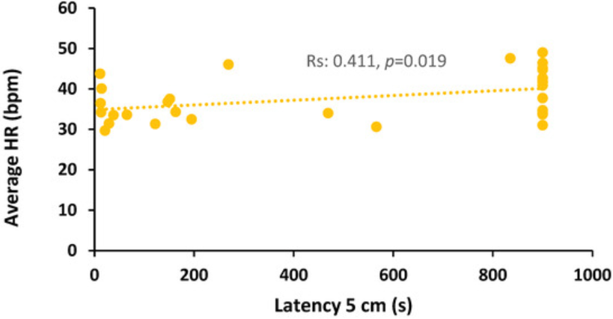
Figure 7. Pearson correlation between the absolute values of latency to approach a novel object to within 5 cm and the absolute values of the average heart rate (HR) before the 2nd novel object test in rainbow trout.

The dominance index from the pair-wise contest and the biologger data during the pair-wise contest was significantly correlated with a negative relationship between the dominance index and the average heart rate before the pair-wise contest (Rs: −0.373; p = 0.037) (Figure 8, Table S4C).

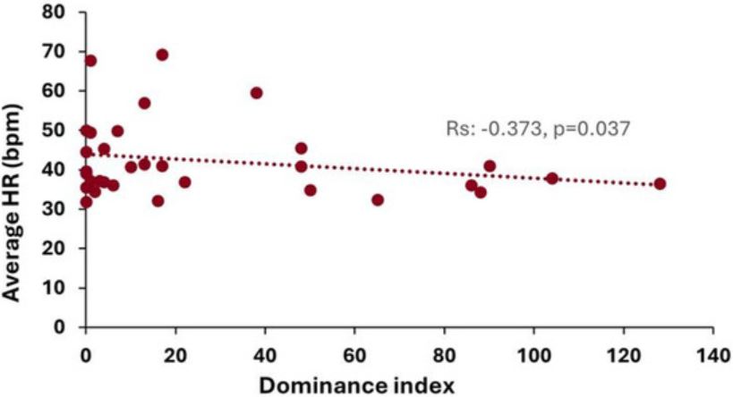
Figure 8. Spearman correlation between the absolute values of dominance index and the absolute values of average heart rate (HR) before the pair-wise contest in rainbow trout.

4. Discussion
Bold and shy rainbow trout exhibit distinct behavioral and physiological responses when exposed to stressors in previous studies [36], and the present study confirms these findings for behavior in the novel object tests. The ability to alter behavior can provide an adaptive advantage when an animal faces a new challenge [37]. During the experiments, shy fish displayed a classic neophobia to the novel objects that were introduced into their tanks. In contrast, bold fish readily explored the new item and approached it quickly. These responses were consistent over the experimental period, demonstrating that personality was unaltered by the tests or the surgical implantation of the biologgers. Monitoring the heart rate was crucial to gauge what test was more stressful for the fish. The recovery rate data demonstrated that the confinement test resulted in the highest heart rates and the novel object test the lowest. Previous studies have shown that bold and shy trout display divergent HPI responses linked to gene expression [34], but until the present study, the heart rate responses to these stress tests have not been investigated. Contrary to expectations, the heart rate responses did not differ between bold and shy trout, and thus, heart rate may be a more robust means of monitoring stress without the need to consider individual variation in behavioral phenotype.

4.1. Behavioral Tests
Shy fish took a relatively longer time to approach the object, spent less time in close proximity, and spent most of their time away from the novel object, whereas bold fish used the opposite strategy. The latency to approach within 5 cm was the most indicative parameter for assigning boldness/shyness, and this agrees with previous studies [9,33]. Responses during the three novel object tests demonstrated that the degree of boldness remained consistent over time, which agrees with other studies where undisturbed individuals did not alter their behavior [33]. Other behaviors observed during the novel object test followed a similar pattern: bold fish had lower latencies entering the 5, 10, and 15 cm zones, they spent more time inside these three zones (15 cm, 10 cm, 5 cm), and their inactivity time was lower than shy fish. Again, these results are consistent with previous studies [9,33] and further demonstrate that the surgical implantation of the biologgers and other behavioral tests did not affect an individual’s boldness. However, Frost et al. (2007) [33] demonstrated that bold and shy personalities were actually flexible and dependent upon previous experience such that shy winners of pair-wise contests became bolder and bold losers became shyer. In the present study, pair-wise contests were staged between contestants matched for size and boldness, whereas Frost et al. (2007) manipulated contest outcomes to ensure the focal fish had the experience of winning or losing [33]. Also, contestants had one interaction over 15 min, and this may not have been enough to influence their risk-taking behavior; thus, shy remained shy and bold remained bold. Future studies may wish to explore the influence of repeated contests or manipulate contest outcomes by staging interactions with much larger or smaller contestants to explore the impact of winning and losing on heart rate and boldness.
In the confinement test, bold and shy did not differ in their exploratory behavior in the very small space. Although shy fish appeared to stay closer to the walls more than bold fish on average, this was not significantly different. Previous studies have similarly shown that there were no differences in locomotion activity between bold and shy. Bold fish tend to have higher activity than shy only when an intruder is introduced to the arena [26]. Despite that, a power analysis showed that a population of 50 fish is needed (n = 25 bold; n = 25 shy) to detect a significant difference. Nevertheless, although there were no differences between bold and shy, the confinement test seemed to raise the heart rate more than the rest of the tests.
In the pair-wise contest, the fish were matched according to their size (weight) to ensure that size differences were not a confounding factor, and they were matched for boldness. Interestingly, shy fish exhibited highly aggressive behavior against their shy opponents. This resulted in a higher dominance index in shy fish compared with bold individuals. Bold fish, when pitted against their bold counterparts, did not exhibit overtly aggressive behavior, and little interaction was seen throughout the duration of the test. Previous studies that investigated pair-wise contests have shown that the positive experience of winning in interactions may increase an individual’s boldness, but in this study, the animals were size-mismatched [38]. This winner-loser effect occurs due to the reinforcement of strategic decisions in initiating and winning fights where winners continue to win and losers continue to lose. On the contrary, the negative experience of losing can result in a reduced degree of boldness exhibited by individuals [33,39,40]. In rainbow trout, a previous study suggested that shy fish that experience winning consecutive fights become bolder, whereas bold fish that lose fights become shyer [33]. However, in the present study, boldness remained consistent for the entire experimental period; thus, winning and losing in these contests had no immediate effect on personality. Decisions to engage in costly fighting are complex, and it may be that the shyer fish were more aggressive since they perceived their shy opponent to have a lower competitive ability or resource-holding potential than them, so they fought more intensely to obtain a dominant social status [41]. Rainbow trout form dominance hierarchies where the dominant obtains exclusive or priority access to resources and shows relatively higher growth [42]. Being dominant takes priority over responding to welfare challenges in this species [43]. Holding a high dominance status is very desirable and may explain why shy fish fight more intensely against a shy opponent. However, this does not explain why bold fish did not engage in intense fights. Typically, it is the loser of a fight that governs the contest content and duration since they give up and the fight ceases. If bold individuals are evenly matched, then they may decide that fighting intensely is not worth the costs in terms of energy or time, especially since these bold animals were exhibiting high growth rates. Thus, they may have perceived the environment as resource-rich, and there was no reason to engage in costly fighting since agonistic behavior typically occurs when resources are low [41]. Future studies should explore these hypotheses by staging pair-wise interactions between different combinations of bold and shy trout to disentangle the impact of boldness on contest outcomes.

4.2. Heart Rate Measurements
The use of biologgers to monitor the heart rates of the fish during these behavioral tests is a novel approach. There was an elevation of heart rate in all fish from the resting heart rate measured before, during, and after the confinement test and pair-wise contests, demonstrating that these tests were challenging and recovery was prolonged. Furthermore, the prolonged elevated heart rate during the recovery periods showcases that even the transfer of fish from the confinement test and pair-wise contest tanks to their home tanks can induce a high stress response, in addition to the actual tests. Previous studies have also confirmed these consistent variations in heart rate found in this study. Additionally, the use of biologgers can be a reliable method for assessing stress responses. When Brijs et al. (2018) tested netting fish as a stressor; they found similar increases in average and maximum heart rate consistent with the novel object test conducted in the present study [20]. Additionally, the most stressful event (the confinement test) increased the heart rate even more in comparison to the rest of the behavioral tests, and fish took the longest time to recover from the confinement test. The maximum and average heart rate recorded during the confinement test is similar to the maximum and average heart rate recorded in previous studies. This showcases that some practices in aquaculture or predation risk can result in an increased heart rate comparable to the confinement test [20,44,45]. These results demonstrate the capability of biologger implantation to record heart rate responses to differing behavioural tests in vivo, which is important as most physiological responses in bold and shy fish have previously been measured afterwards. These results also agree with previous studies where the activity patterns post-surgery were measured [46,47]. Additionally, other studies that implemented biologgers to assess anti-predator responses found similar results [48]. Biologgers could be used in studies exploring the welfare of fish and indeed, biologgers have been deployed in freely swimming rainbow trout in an aquaculture context [49]. Additionally, biologgers can be used not only in an experimental or aquaculture environment but also for monitoring a plethora of species in their natural habitat [50,51].
During stressful situations, the rapid release of catecholamines, such as adrenalin, increases heart rate, making it a potential indicator of stress during specific challenges [21]. These physiological responses give insight into the perceived valence or intensity of the event to the animal. It should be noted that the regulation of heart rate is more complex, and heart rate can rise simply due to energetic demands where more oxygen is required by the body [17]. Overall heart rate did appear to be a sensitive indicator of the stressfulness of the test and was unlikely to be related to heart rate rising simply in response to energetic demand since the animals were not particularly active in the novel object test in their home tank and could not move much in the confinement test. However, to confirm the relationship between heart rate and stress, future studies should also measure plasma adrenalin and noradrenalin since this is the primary stress response that elicits an increase in heart rate [17]. However, because biologgers need to be implanted with invasive surgery, a telemetry implant could provide very useful information for refining the management of freely moving fishes in captivity.
There were no differences between bold and shy trout when comparing different aspects of the heart rate (averages before, during, and after), the maximum and minimum, the recovery rate, and the recovery time). Previous studies indicate that individual behavior can be variable even if animals are classified as bold or shy personalities. Therefore, correlating stress response with individual variation in behavior may not be so straightforward and needs further study [52]. Although many studies show a clear link between stress responsiveness and behavioral phenotype [6,9,33,53] there are studies that show distinct behavioral differences in bold and shy animals that do not correspond to physiological responses [54,55,56]. Perhaps, there was a decoupling of stress responsiveness and behavior in the rainbow trout used in the present study, or the sympathetic nervous system production of adrenaline to increase heart rate does not differ between bold and shy animals. However, the elevation of heart rate values that were influenced by the type of behavioral test may be due vagal withdrawal. The novel object test appeared to be the least stressful compared with the more disturbing confinement test (moved from a home tank to a white tank) and the pair-wise contest (moved to a novel tank and confronted with a potential competitor). This difference in heart rate between the different tests and stressful conditions agrees with previous studies in trout and other species such as Atlantic salmon. The study of Yousaf et al. (2022) on Atlantic salmon (Salmo salar) demonstrated that recovery periods depend on how stressful behavioral tests such as handling, crowding, or vaccination were [57]. This agrees with the findings of the present study, where recovery periods were longer during the confinement test. Studies in common starlings (Sturnus vulgaris) report that the novel object test is mildly stressful, and there was no correlation with heart rate [58]. Furthermore, studies indicate that the increase in heart rate may be due to a higher concentration of catecholamines that increased heart rate during a response to stress [46], or alternatively, the parasympathetic drive was lowered, which can also elevate the heart rate [59,60]. It has been well established that bold fish interacted with the novel object, whereas shy fish did not engage and spent much of their time inactive during the test [9,14,61]. Although changes in heart rate could just reflect an increased oxygen demand from activity in the bold trout engaging with the novel object, there was no difference between bold and shy in any heart rate values. Additionally, plasma cortisol values were compared between bold and shy after the 3rd novel object test, and no differences were found (Mean (±SE) Bold: 84.57 ± 15.49, Shy: 107.4 ± 21.12 ng/mL, unpublished data). There was a positive correlation between average heart rate and latency to approach in the second novel object test, which may indicate increased oxygen demand in shy trout who may be showing an anxiety response to the object since they are much less active. However, future studies should investigate this further. Other significant correlations demonstrated that the average heart rate before the pair-wise contest decreased as the dominance index increased, which perhaps suggests that those trout that were more aggressive had a lower heart rate prior to the contest. This may suggest that relatively more aggressive trout had a lower mean heart rate and were fitter, perhaps explaining why they performed more aggressive acts than retreats during the contests. Future studies should investigate these results in more detail to explore the impact of exercise, increased oxygen demand, and behavioral stress to fully understand these findings.
The time for heart rate to recover after the test to normal pre-test values was higher during the confinement and lower during the novel object test and the pair-wise contest. Brijs et al. (2019) also suggested that handling alone increased heart rate and using biologgers [49]. Similarly, the heart rate during the confinement test and pair-wise contest was higher; recovery was longer and might be due to handling or the test itself. The rate of recovery was indeed lower in the confinement test and significantly different from the novel object test. The results suggest that the confinement test was more stressful than the novel object test and the pair-wise contest since the heart rate was elevated over a longer period after the event.

5. Conclusions
Heart rate changes differed between the tests, and thus, biologgers can be used to gauge exactly how stressful a behavioral test may be. These devices could present a means of differentiating between situations that cause stress in captive situations such as aquaculture or the laboratory, in order for us to understand how fish experience handling, cleaning of tanks, movement between tanks or farms, transport, size grading, and vaccination. Furthermore, by measuring the heart rate, biologgers could be used to explore whether adjustments to these procedures reduce stress. Therefore, we propose that future studies should explore using this technology to understand the stress response in vivo rather than making measurements after the behavior or stressor has occurred. Heart rate data could be used to ascertain the valence of an experience and provide insight into how stressful an event is to the animal. Since there were no differences between bold and shy rainbow trout in the present study, this suggests that boldness does not act as a confounding factor, and therefore, heart rate would be a robust indicator of stress without the issues of behavioral phenotype affecting data collection.

