Context-dependent variation in meerkat short note calls reflects emotional arousal
猫鼬短音叫声的语境依赖性变化反映了情绪唤醒

Abstract
Many animals produce the same call type in distinct contexts, yet acoustic variation can encode additional information, such as the producers’ emotional state. By doing so, animals increase their capacity to communicate within potentially limited vocal repertoires. Meerkats, Suricata suricatta, produce various types of short note calls during distinct behavioural contexts; sunning, i.e. basking in the sun, and sentinel, i.e. cooperative vigilance. These two contexts likely vary in underlying emotional arousal. We first investigated if heart rate differed between sunning and sentinel contexts, indicating potential variation in arousal states. Second, we tested if calls produced during sunning and sentinel vary in production rate, call type and acoustic structure. We implanted wild meerkats with heart rate loggers and recorded their behaviour and vocalisations. We found that sentinel behaviour was associated with higher heart rates and call rates, indicating increased affective arousal. The acoustic structure of calls produced during sentinel were consistent with predictions of increased arousal, compared to calls produced during sunning, showing increased jitter, shorter duration, and more abrupt in onset. Overall, our results suggest higher emotional arousal during sentinel behaviour than sunning, reflected in cardiac activity, call rate and acoustic variation. Our results highlight that even within short, seemingly simple vocalisations, acoustic variation can enhance the amount of information transferred.
摘要：
许多动物在不同的环境中产生相同的叫声类型，但声学变化可以编码额外的信息，如生产者的情绪状态。通过这样做，动物可以在可能有限的声音范围内提高交流能力。猫鼬（Suricata suricatta）在不同的行为环境中会发出各种类型的短音叫声；晒太阳，即晒太阳，哨兵，即合作警戒。这两种情况可能在潜在的情绪唤醒方面有所不同。我们首先研究了在阳光照射和哨兵环境下心率是否不同，这表明唤醒状态的潜在变化。其次，我们测试了在日晒和哨兵期间产生的叫声在生产率、叫声类型和声学结构方面是否存在差异。我们给野生猫鼬植入了心率记录仪，并记录了它们的行为和叫声。我们发现哨兵行为与较高的心率和呼叫率有关，表明情感唤醒增加。与晒太阳时发出的叫声相比，哨兵期间发出的叫声的声学结构与觉醒增强的预测一致，表现出抖动增加、持续时间缩短和发作更突然。总体而言，我们的研究结果表明，哨兵行为期间的情绪唤醒高于阳光照射，这反映在心脏活动、呼叫率和声学变化上。研究结果表明，即使在短而看似简单的发声中，声学变化也可以增强传递的信息量。
关键词：
StarOddi心率温度记录仪，动物植入芯片。

1. Introduction
The transmission of information from producer to receiver is an integral feature of vocal communication [1]. In many cases, information is transferred from producer to receiver via distinct context-specific call types [[2], [3], [4], [5]], or call combinations [[6], [7], [8], [9]]. Animals also use single units of the same call type to convey distinct information through call rate [[10], [11], [12], [13], [14], [15]], or variation in acoustic structure within individual calls [[16], [17], [18], [19]]. By encoding various types of information within a single call type, animals can increase the degree of information transfer possible, even with a limited vocal repertoire. The drivers behind variation in vocal production have been shown to be based on the internal motivational and emotional state of the producer and/or features of the external context experienced [[5], [19], [20], [21], [22], [23]].
Emotions are short-term affective responses to events or stimuli, and described as varying along the dimensions of valence (pleasant/positive or unpleasant/negative) and arousal (bodily activation; low to high) [[24], [25], [26]]. The emotional state – and particularly emotional arousal – experienced by an individual is associated with changes in physiology [27]. For instance, the activation of the sympathetic branch of the autonomic nervous system, representing the initiation of a physiological stress response and corresponding to an increase in emotional arousal, can be reflected in increases in heart rate [28]. The term ‘emotional arousal’ differs from the general physiological stress response, as it integrates the individual's perception of the situation [[28], [29]]. Increases in heart rate have been observed in response to stressors occurring within animals’ natural environment [[30], [31], [32], [33], [34]]. By studying physiological measures, we can better understand how perception of stimuli and contexts cause changes in emotional states, the scale of the internal response, and how this is then associated with behaviour and specific characteristics of vocalisations.
The different dimensions of emotions, valence and arousal, are predicted to be expressed in specific vocal patterns. Emotional valence has been shown to be often encoded in duration and spectro-temporal acoustic features of vocalisations, with shorter durations and lower fundamental frequencies (fo) in positive compared to negative contexts [[24], [35]]. Emotional arousal is encoded in features such as call rate, and spectro-temporal acoustic features in a consistent way across species [[24], [35]]. Generally, increases in call rate are associated with higher arousal states (see review [35]). For example, piglets, Sus scrofa domesticus, increase the rate of distress and contact calls during high arousal states [13]. The acoustic structure within call types can also encode arousal-related information, with changes in fundamental frequency, call duration, and entropy (chaos) often associated with increases in arousal [[24], [35]].
Few studies have directly looked at the relationship between physiological indicators of emotions and vocal production. Heart rate can be used as an indicator of emotional arousal [28]. Increases in heart rate have been shown to be associated with an increased probability of vocalizing in common marmosets, Callithrix jacchus, and long-tailed macaques, Macaca fascicularis [36,37]. Higher heart rates are associated with increases in call duration and entropy (chaos) in common marmosets [20]. Finally, in high arousal situations, indicated by heart rates, horse “whinnies” and goat contact calls, show higher fo and shifts in energy distribution towards higher frequencies [38,39]. All these above-mentioned studies used captive animals and experimental contexts of high arousal states. To our knowledge, with the exception of greylag geese, Anser anser [33], the relationship between heart rate and vocal production in wild, free-roaming animals has not been investigated yet [28]. Further studies are thus necessary to investigate the relationship between heart rate and vocalisations under natural settings.
Meerkats, Suricata suricatta, are a highly vocal species, constantly producing distinct call types that typically vary with behavioural contexts [40]. However, some calls with seemingly similar acoustic structure are produced in various behavioural contexts. One such example are short note calls, predominately soft, low-amplitude, tonal calls, consisting of various acoustic units of short duration (Fig. 1). The calls are classified based on the number of repetitions of units, as single-note, double-note, triple-note or multiple-note call types. They are typically produced when meerkats stand bipedally (upright, on hind legs) in the two contexts of sunning and acting as a sentinel. 'Sunning' short note calls are given while meerkats stand up, warming themselves in the sun after emerging from their sleeping burrow [41]. It has been suggested that sunning calls are an affiliative social call, since they are only given in the presence of other group members, and may act as a form of acoustic grooming [41]. 'Sentinel' short note calls, on the other hand, are given during cooperative vigilance when one meerkat undertakes vigilance from a raised position (e.g. bush or tree stump), allowing other group members to continue foraging with reduced individual vigilance [42]. Sentinel calls are thought to advertise to group members that a sentinel is on guard, and communicate the current risk of predation (such as raptors, small carnivores, snakes and rival meerkat groups), or lack thereof [42,43]. Whether these contextually different, but structurally similar short note calls differ acoustically has not been investigated yet.
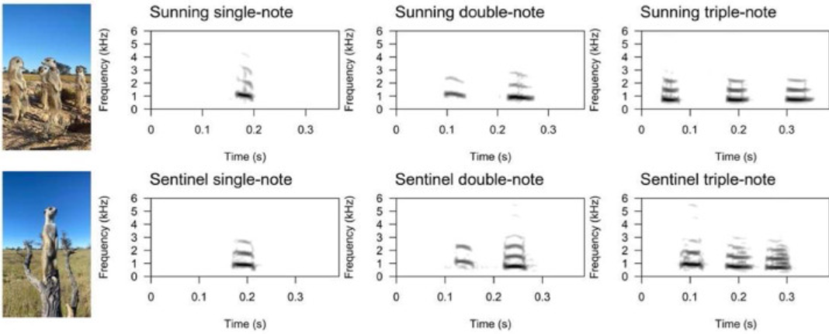
Fig. 1. Examples of spectrogram images of short note calls in various combinations in the context of sunning (top row) and sentinel (bottom row), and pictures representing the body and head posture during these behaviours.

To investigate if there is a difference between these short note call types when produced in the sunning versus sentinel context, we performed natural observations. Calls in both contexts are produced in similar body positions (bipedal) and with similar activity levels (stationary), making them ideal for a comparison excluding a risk of movement influencing heart rate [44,45]. Other studies have shown arousal differences, through heart rate, in wild, free-roaming animals [[33], [46], [47]]. However, these studies did not account for the effect of activity and movement. The confounds of activity are likely to be great [44,48], making it difficult to disentangle whether heart rate differences are related to changes in physical activity that are unrelated to emotional arousal, or to activity-independent changes in internal emotional arousal. During sunning, meerkats seem relaxed, slowly looking around or even with their head facing down, whereas during sentinel, meerkats seem alert as they are visually scanning the area with more rapid head movements (Fig. 1). We predicted that, as a likely affiliative behaviour, sunning behaviour to be a low arousal state of positive valence, and therefore associated with a lower heart rate [[49], [50], [51]]. In contrast, we predicted that, as a vigilance behaviour, sentinel behaviour to be a higher arousal state of more negative or neutral valence, and therefore associated with a higher heart rate. Individual attentiveness has been shown to be correlated with increased heart rate and arousal [52]. We also predicted that these variations in arousal state may, in turn, result in a higher call rate during sentinel behaviour than during sunning, and in variation in acoustic structure. Calls produced during sentinel behaviour are likely to have a higher fo, longer call duration, and increased entropy (chaos) compared to those produced during sunning [[24], [35]]. Few studies have been able to directly compare and quantify arousal-related differences, assessed through physiological indicators, within call types produced in differing contexts, whilst also controlling for the effects of physical activity and body posture. We aimed to investigate first, if the different behavioural states were associated with different heart rates, and therefore likely arousal states. Second, we aimed to determine if the different behavioural contexts and associated heart rates were reflected in call rate, call type production and acoustic structure.

2. Methods

2.1. Study site and population
The study was carried out at the Kalahari Meerkat Project, Northern Cape, South Africa [53], between March and June 2023. This population of meerkats has been studied for over 25 years with individuals being fully habituated to the presence of human observers at less than 1 m [54]. All individuals were identifiable from dye marks on their backs [55]. In total, we implanted 12 subordinate adult meerkats (6 females, 6 males) with heart rate loggers.

2.2. Ethical note
All experimental manipulations and recordings were carried out following methodology approved by the ethical committee of University of Pretoria (NAS029–2022) and the Northern Cape Conservation Service, South Africa (FAUNA 0906/2022). We investigated all possible alternatives for non-invasive heart rate monitoring, however due our study using wild, free-roaming animals, and meerkats weighing <1 kg and their fur, there were no external heart rate loggers available at the time of study. Due to the habituation of the meerkats, we were able to catch and rapidly anaesthetize them, within 2.4 ± 1.1 min from capture to anaesthesia, to minimize stress prior to the surgical procedure related to both implantation and removal of the loggers. As part of the long-term monitoring of this study system, meerkats within our population had been routinely captured, though limited to maximum four times per year for animal welfare and dishabituation reasons, and anaesthetised to take x-rays and blood samples. Meerkats recovered from anaesthesia within 54 ± 7 min for implantations and 27 ± 5 min for removals. All individuals were closely monitored following implantation daily for the first two weeks, and at least every two to three days until logger removal. Following removal, individuals were also closely monitored on the day of removal and every two to three days until healing, for around one week. We observed no obvious impact on meerkat behaviour one hour after implantation or removal. Individuals typically resumed normal foraging behaviour within one hour of release.

2.3. Logger implantation
We used Star-Oddi micro-HRT loggers to record the meerkats’ heart rate. The loggers recorded at a sampling rate of 600 Hz once every 15 s for six hours per day over five days. To implant the loggers, we caught and anaesthetized the meerkats, surgically inserting the loggers via a 1 cm subcutaneous incision at the base of the sternum (for detailed methods see Appendix). We then released the meerkats back to the group and monitored them for any adverse reactions. One week after the surgery, we began the five-day period of observations and experiments in combination with the heart-rate recording periods.

2.4. Behavioural and vocalisation observational recordings
To analyse the relationship between heart rate and production of sunning and sentinel calls, we collected behavioural and vocal data during natural sunning and sentinel events for the meerkats implanted with heart rate loggers. The loggers were programmed to begin recording approximately 30 min before the group’s average emergence time. We recorded all behaviours performed by the focal during the six hours of heart rate recording periods over two days (days two and four), and before or at least one hour after experiments conducted as part of another project on the three other days. Sunning behaviour was defined as when the focal remained standing up bipedally at the sleeping burrow facing the sun, this behaviour is performed first thing in the morning prior to the group beginning foraging. Sentinel behaviour was defined as when the focal was standing up on a bush or object while looking around, scanning the environment, this behaviour is performed after the group leaves the sleeping burrow and start foraging. Behaviours were recorded using a custom-made pendragon form [Pendragon Software Corporation, USA] on a tablet (Lenovo Tab V7). Simultaneous focal acoustic recordings were collected at a distance of 0.3–1 m with a Sennheiser directional microphone (ME66/K6) connected to a Marantz PMD-670 solid-state recorder (Marantz Japan Inc.; sampling frequency 44.2 kHz, 16 bits accuracy). Every call produced by the focal meerkat was verbally confirmed by the observer and additional contextual information recorded on a second channel via a second microphone (Joseph E-280 Dynamic Microphone). Timestamped calibration sounds were built into the pendragon form, recording a timestamp and playing a beep at the start of each recording period to allow for timestamp calculations between behavioural data and acoustic recordings.

2.5. Data preparation
We aligned the heart rate, behavioural and call data based on timestamps. Logger clock-drift was corrected by calculating the timestamp difference between logger programming time (the same as computer time), and the difference between logger download time and computer time, assuming linear drift. We extracted all heart rate data from periods of sunning or sentinel behaviour based on timestamps. We also used timestamps to pair periods of vocalisations produced during sunning and sentinel with heart rate. Then, we calculated mean heart rate per minute, total call rate per minute and rate of each call type per minute (single-note, double-note and triple-note calls) for each full minute of sunning and sentinel behaviour. Multiple-note and long-note call types were not produced frequently enough in both behavioural contexts to include in our analysis. To control for individual differences in baseline heart rate, we adjusted each heart rate by subtracting the individual’s mean resting heart rate from the heart rate recorded (hereafter ‘adjusted heart rate’). Average resting heart rate was calculated as the overall mean heart rate per individual recorded during stationary behaviour, as this behaviour reflects when the individual is awake but not moving, limiting the influence of movement or external factors, and was under observation to confirm activity levels. We defined stationary behaviour as when the individual was either sitting or standing, and therefore not moving. Heart rates from the first 10 s of each behaviour were excluded from the analysis to minimize the effects of previous activity on heart rate. We assigned an identity value to each behavioural period, to account for repeated measures within the same behaviour (Behaviour event ID). In our analyses, we only included individuals that produced vocalisations in both behavioural contexts, resulting in six individuals (three females, three males).

2.6. Acoustic analysis
Vocalizations were imported at a sampling rate of 48 kHz and saved in WAV format at 16-bit amplitude resolution. We annotated every call in Adobe Audition (Adobe Systems Inc., San Jose, CA, U.S.A.). Only calls positively identified as being produced by the focal from verbal confirmation during field recordings were used. Following previous studies, we distinguished between repeated single-note calls and multi-note calls (double-note, triple-note, multiple-note) based on the silence interval between multi-note calls, which had to be shorter that the silence interval to the previous and the following call [56,43]. Each sunning and sentinel call was extracted from the recordings and Hann band-pass filtered between 0.2 and 6 kHz for analysis. A maximum of 30 calls per individual, per context and per note type were randomly selected, and only individuals with at least five calls per context and note type were included in our analyses. Acoustic parameter extraction was performed in Praat [57] on the individual notes (single-note: SN, 1st double-note unit: DN1, 2nd double-note unit: DN2). We did not analyse the acoustic structure of triple-note calls as only half of the individuals produced them in both behavioural contexts. We extracted a range of spectro-temporal acoustic parameters, using a custom script (adapted from [[58], [59], [60]]; for detailed descriptions see Table A1).

2.7. Statistical analysis
We conducted statistical analysis in RStudio (version 2023.12.1; [61]). First, to compare heart rate between behavioural contexts, we used a linear mixed model (LMM; lmer function, lme4 library; [62]) with adjusted heart rate as the response variable and behavioural context (sunning or sentinel) as the fixed effect. We additionally fit a second model with behavioural context, latency between the heart rate measurement and the behaviour start time (seconds), and their interaction to check if heart rate varied over the behaviour duration, using AICc model comparison to determine whether controlling for time spent in the behavioural state influenced model fit. P-values were extracted using estimated marginal means with Tukey HSD adjustments post-hoc pairwise comparisons between the behavioural context (pairs emmeans function, emmeans library; [63]). Second, we built four negative binomial generalised linear mixed models (GLMM; glmer function, lme4 library; [62]), the first with the total number of calls per minute as the response variable, and the other models with the number of calls per minute for each call type (single-note, double-note and triple-note) as the response variables, respectively (one response variable per model); all models were fitted with behavioural context as the fixed effect. Again, we extracted P-values using estimated marginal means pairwise comparisons between the behavioural context (pairs emmeans function, emmeans library; [63]). Third, to investigate whether call rate was directly correlated to heart rate, we built three GLMMs with Poisson error structure with number of calls per minute for the different call types (single-note, double-note, triple-note) as the response variable (one per model), and behavioural context (sunning, sentinel), mean adjusted heart rate per minute and their interaction as fixed effects. Mean adjusted heart rate per minute only included instances where more than one heart rate per minute was recorded to calculate the mean. We extracted P-values from marginal effects coeffecients (estimate_slopes function, modelbased library; [64]). All models described above contained Behaviour event ID nested within Individual ID as random effects to control for heart rate measures from the same individual and from the same behavioural period.
To analyse the acoustic structure of the vocalisations, we first ran a principal component analysis (PCA) to eliminate redundancy within our set of acoustic parameters and determine which parameters accounted the most for the variance observed between calls (prcomp function, stats library; [61]). To check the prerequisites for a PCA, we ran a Kaiser-Meyer-Olkin test to determine sampling adequacy of the data (kmo_optimal_solution function, FactorAssumptions library; [65]), and removed highly correlated parameters (>0.8; see Table A1 for retained parameters). For the PCA, we scaled the parameters and used an orthogonal rotation transformation. Based on the loadings of the acoustic parameters on the Principal Components (PC), we selected two acoustic parameters per PC with eigenvalues greater than one (the two highest loading per PC with |r|≥0.05), and used the corresponding raw measures as response variables in linear mixed models (one per model; LMMs; lmer function, lme4 library; [62]). We did not include the second top loading acoustic parameter if it had an absolute r value of less than 0.50. To fit the model assumptions, the response variables jitter, variation total, time of max intensity, and fo standard deviation were log-transformed, and sound duration, sum of variance, mean fo, inflex and time of max fo were square-root transformed. The behavioural context (sunning or sentinel), note type (single-note, 1st double-note unit, 2nd double-note unit) and their interaction were fitted as fixed effects, and individual ID as a random effect. P-values were extracted using estimated marginal means pairwise comparisons between the behavioural context (pairs emmeans function, emmeans library; [63]). We did not include heart rate in the analysis of the acoustic structure as the 15 s interval was too great to associate a heart rate measure with an individual vocalisation. In addition, to determine if there were overall structural differences between short-note calls emitted during sunning and sentinel behavioural contexts, we ran a permutated discriminant function analysis (pDFA; [66]). The pDFA was conducted using a script provided by R. Mundry (lda function; MASS library; [67]). We ran a fully crossed design on PC scores 1–5, with individual ID as a control factor and behavioural context as test factor.
To assess model assumptions for normality and heteroscedasticity, we observed the model residuals distribution (KS test), dispersion and outliers (testResiduals function, DHARMa library; [68]), and autocorrelation (acf function, stats library; [61]). If model residuals did not fit a normal distribution, we transformed the data or used a GLMM instead of LMM depending on best residual fit. This was the case for the models investigating number of calls per minute, using negative binomial and poisson error-structures as described above.

3. Results

3.1. Effect of behavioural context on heart rate
Meerkats had significantly higher adjusted heart rates (bpm – mean resting bpm) when sentinel (n = 212 number of adjusted average heart rates per minute from n = 30 behavioural events, mean±se = 41.4±1.46 bpm) compared to sunning (n = 1797 number of adjusted average heart rates per minute from n = 142 behavioural events, mean±se = 1.62±0.64 bpm; Fig. 2; LMM: estimate (se) = 37.6 (4.22), 95 % CI (29.3, 45.8), t = 8.9, P <0.001). Inclusion of the interaction between heart rate measurement latency from behaviour start and behaviour context did not improve model fit (behaviour context only model: AICc = 16,759, model with measurement latency: AICc = 16,782, delta = 22), indicating that heart rate did not change substantially over time within the behaviour, and therefore, that the latency was not a relevant factor in explaining the difference in heart rate over time for each behaviours., that the latency was not a relevant factor in explaining the difference in heart rate over time for each behaviours.
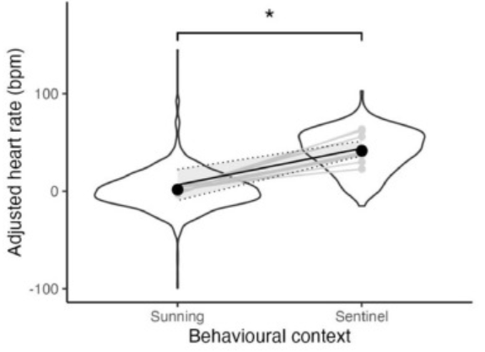
Fig. 2. Heart rate (bpm) adjusted for average resting heart rate per individual for sunning and sentinel behavioural context. The violin plots show the distribution of the adjusted heart rate, and the solid points show the mean with standard error bars. The solid black line with shaded sections and dotted line represents model estimates with confidence intervals. The light grey points connected by light grey lines represent each individual (n=8).

3.2. Effect of behavioural context on call rate
There was a significantly higher overall number of calls per minute during sentinel behaviour (n = 42 min from 14 behavioural events for 6 individuals, mean±se= 11.7±1.7) than sunning (n = 303 min, from 74 behavioural events for 6 individuals, mean±se = 4±0.26) (GLMM: estimate (se) = 6.7 (1.56), 95 % CI (3.63, 9.77), t = 8.9, P <0.001; Fig. 3). There was a significant difference in rate per minute for single-note calls between sentinel and sunning behavioural context; single-note rate was significantly higher during sentinel compared to sunning behaviour (sentinel: 4.57±0.83, sunning: 0.07±0.14; single-note: estimate(se) = -1.24(0.39), 95 % CI (-2.01,-0.47) z = -3.17, P <0.001; Fig. 4a). By contrast, there was no difference in rate between sunning and sentinel behavioural context neither for double-note calls (sentinel: 5.07±1.02, sunning: 1.69±0.13; estimate(se) = -0.19(0.55), 95 % CI (-1.28,-0.89) z = -0.35, P = 0.73; Fig. 4c), nor for triple-note calls (sentinel: 1.17±0.25, sunning: 0.53±0.06; estimate(se) = -0.68(0.63), 95 % CI (-1.91,0.56) z = -1.07, P = 0.28; Fig. 4e). Though we did not statistically analyse the call rate of multiple-note and long-note calls due to low sample size, both seemed to be produced at a higher rate during sentinel (multiple-note: 0.14±0.42, long-note: 0.55±0.2) than sunning behaviour (multiple-note: 0.08±0.02, long-note: 0.07±0.02).
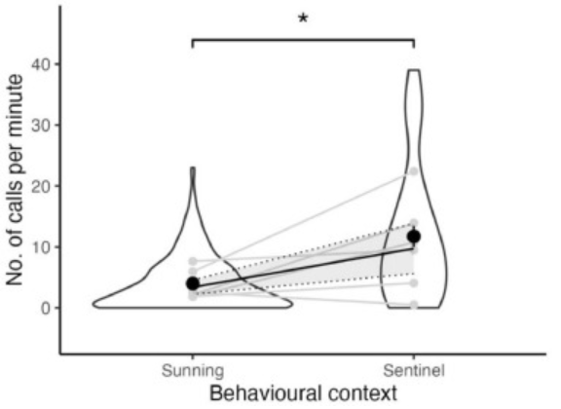
Fig. 3. Number of calls per minute for sunning and sentinel behavioural context. The violin plots show the distribution of the number of calls, and the solid points show the mean with standard error bars. The solid black line with shaded sections and dotted line represents model estimates with confidence intervals. The light grey points connected by light grey lines represent each individual (n=6).

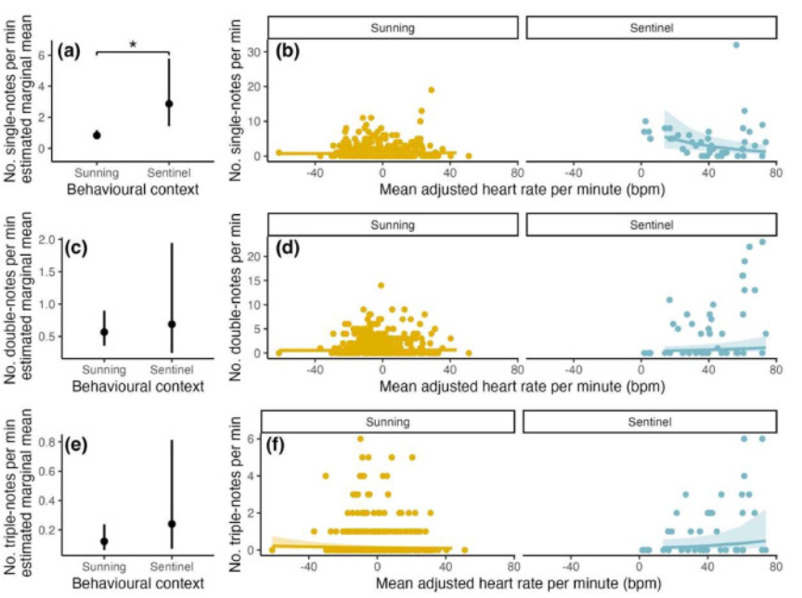
Fig. 4. Rate per minute of single-note (a, b), double-note (c, d) and triple-note (e, f) calls as a function of behavioural context and heart rate. Plots (a), (c), (d) show estimated marginal means as solid points with standard error bars. Plots (b), (d), (f) show model prediction slopes in the solid lines, with standard error as shaded, and raw data as points.

3.3. Effect of behavioural context on call rate and heart rate
The rate of single-note calls per minute during sentinel behaviour decreased significantly with increasing mean heart rate per minute (GLMM: coefficient(se) = -0.02(0.01), 95 % CI (-0.04, 0), t = -2.43, P = 0.02; Table A2; Fig. 4b). There was no significant effect of mean heart rate per minute on call rate per minute for the other two call types during sentinel behaviour (Table A2; Fig. 4), or for any of the different call types during sunning behaviour (Table A2; Fig. 4).

3.4. Acoustic variation between behavioural context
Analyses conducted on individual vocal parameters revealed some differences between calls produced during sunning and sentinel behavioural contexts (Sunning: SN n = 157 calls, DN1 n = 182 calls, DN2 n = 186 calls; Sentinel: SN n = 108 calls, DN1 n = 79 calls, DN2 n = 81 calls; from 8 individuals). For PC1, accounting for 32 % of the variance, the two top loading acoustic parameters were jitter and fo variation total (Table A3). Jitter (perturbation of fo) was significantly higher for all of the short note call types produced during sentinel than sunning behavioural context (LMM: SN: estimate(se) = 0.3(0.08), 95 % CI (0.15, 0.45), t = 3.96, P <0.01; DN1: estimate(se) = 0.2(0.08), 95 % CI (0.04, 0.36), t = 2.43, P = 0.02; DN2: estimate(se) = 0.24(0.08), 95 % CI (0.08, 0.4), t = 2.94, P <0.01; Table A4; Fig. 5a). By contrast, fo variation total (sum of difference between fo points) was significantly higher only in single-note calls produced during sentinel compared to sunning behaviour (estimate(se) = 0.26(0.08), 95 % CI (0.103, 0.418), t = 3.241, P <0.01; Table A4), and there was no significant difference for either unit of the double-notes between sunning and sentinel behaviour (Table A4).
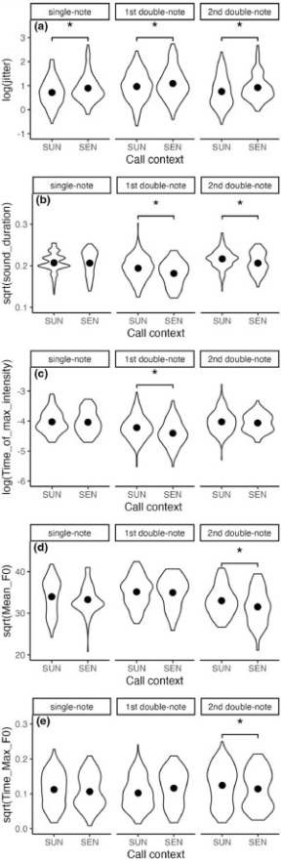
Fig. 5. Acoustic parameters, selected from the highest loading parameters for PC 1–5, measured within the different units of single-note and double-note calls as a function of the behavioural context (sunning or sentinel). The violin plots show the distribution of the acoustic parameters’ values, and the solid points show the mean with standard error bars.

For PC2, accounting for 19 % of the variance, the two top loading parameters were sound duration and sum of fo variance (Table A3). Sound duration (duration of the note) was significantly lower in both of the double-note units during sentinel than sunning behavioural context (DN1: estimate(se) = -0.01(0), 95 % CI (-0.02,-0.01), t = -3.92, P <0.01; DN2: estimate(se) = 0.01(0), 95 % CI (-0.02, -0), t = -3.32, P <0.01; Table A4; Fig. 5b), but did not differ significantly with behavioural context in single-note calls (Table A4). Sum of fo variance (sum of variation in fo relative to duration) did not vary significantly between sentinel and sunning behavioural context for any of the call type units (Table A4).
For PC3, accounting for 16 % of the variance, the two top loading parameters were time of maximum intensity and standard deviation in fo (Table A3). Time of maximum intensity (time within the call that maximum amplitude occurred) was significantly lower in the first unit of the double-note calls during sentinel than sunning behavioural context (estimate(se) = -0.11(0.05), 95 % CI (-0.21, -0.01), t = -2.23, P = 0.03; Fig. 5c), but did not vary between behaviours in the units of the other call types (Table A4). Standard deviation in fo did not vary significantly between sentinel and sunning behavioural contexts in any of the call type units (Table A4).
For PC4, accounting for 10 % of the variance, the two highest loading parameters were mean fo and inflex (Table A3). Mean fo was significantly lower in the second unit of the double-note calls during sentinel compared to sunning behavioural context (estimate(se) = -1.32(0.38), 95 % CI (-2.07, -0.57), t = -3.47, P <0.01; Fig. 5d), while there was no significant difference between behaviours for the other call type units (Table A4). Inflex (the number of fo ascending or descending inflections in relation to call duration) did not vary between behaviours in any of the call type units (Table A4).
Finally, for PC5, accounting for 8 % of the variance, the highest loading parameter was time of maximum fo (Table A3). Time of maximum fo (the time in the vocalisation that maximum fo occurs) was significantly lower in the second unit of the double-note calls during sentinel than sunning behavioural contexts (estimate(se) = -0.02(0.01), 95 % CI (-0.03, 0), t = -2.41, P =0.02; Fig. 5e), but did not vary between behaviours in the other call type units (Table A4).
In contrast to analyses conducted on individual parameters, the results of the pDFA carried out on the scores of PC1–5 did not reveal any significant difference in the overall call structure of short-note calls produced during sunning compared to sentinel behavioural contexts (classified = 56.4 %, expected = 58.44 %, P = 0.72).

4. Discussion
Variation in the acoustic structure within call types can provide an honest indicator of producers’ emotional state, enhancing the degree of information transmitted. Much of the previous research on emotion-encoding in vocalisations has focused on negatively valenced, high arousal contexts [[13], [19], [69], [70], [71]]. Here we investigated potentially more subtle emotion-encoding within two contexts of rather low general arousal states, but potential variation in both valence and arousal levels. The results suggest that sentinel behaviour is associated with a higher heart rate and overall calling rate than sunning behaviour. We also found variation in the rate of different call types between the two behavioural contexts. While there was no overall difference in the acoustic structure of calls emitted during sunning versus sentinel, our analyses revealed context-related variation at the level of specific acoustic parameters of the calls. The differences between sunning and sentinel calls were slight and likely undetectable to human ears, but overall sentinel short-note calls would be perceived as rougher/hoarser (higher jitter), lower in pitch (lower mean fo) more abrupt (shorter duration, shorter time to reach max amplitude and shorter time to reach max fo).
During sentinel behaviour, meerkats seem to be in a higher arousal state than when sunning. Individuals had higher heart rates and overall call rates, which are both common indicators of arousal state [[24], [28], [35]], during sentinel behaviour than when sunning. By comparing sunning and sentinel behavioural contexts, both performed when stationary, we could control for activity. Thus, the variation in heart rate and call rate between sunning and sentinel strongly indicates a difference in emotional arousal that is independent of physical activity. The difference in arousal state between these two contexts is likely driven by their underlying function/motivation. Sunning behaviour is generally a social activity and is thought to be a potential mechanism for social bonding between individuals [41]. In contrast, during sentinel behaviour, an individual is typically alone at a raised point, in an alert state and scanning the area for potential threats. Circadian effects could additionally influence cardiac activity between early morning sunning and sentinel during the active part of the day, with various features of cardiac activity shown to vary with circadian rhythms [72]. However, circadian effects primarily influence heart rate differences between sleep versus wake periods, and affect heart- rate variability and arrhythmia’s [72], rather than heart rate per se, as used in this study. In addition, sunning behaviour can occur several hours after emergence during winter when meerkats sun for longer to warm up, whereas in summer they are likely to begin foraging and sentinelling soon after emergence. Our data therefore covers a range of times since emergence for both behavioural contexts. Overall, the findings support a difference in affective arousal state between the two behaviours.
The use of the different call types varied slightly between sentinel and sunning behavioural contexts. Specifically, single-note rate was in general higher during sentinel than sunning, and decreased with increasing heart rate during sentinel. This may suggest that individuals are more actively communicating features about risk during sentinel, in line with previous suggestions that single-note calls are an all-clear signal [43]. Sentinels likely call more frequently due to their higher arousal state, and decrease their all-clear signal as perceived risk increases. There was no general difference in the rate of double-note and triple-note calls between behavioural context. The number of calls produced per minute was not affected by heart rate during sunning, neither when considering all call types together, nor each of them separately. There was also no effect of heart rate on the number of double-note or triple-note calls emitted per minute during sentinel. The lack of statistical difference between the number of double- and triple-note calls produced during sunning and sentinel behaviour is likely due to the high overall level of variation in call rate. The general variation in the rate of double-note and triple-note calls between contexts could suggest that their production is not linked to variation in affective state, instead varying in response to other emotion-independent contextual factors or indexical features of the individual. Rauber & Manser [73] show that there seem to be consistent individual differences in the use of the various single note call types. This is also supported by the overall lack of relationship between call rate and heart rate for these call types. Marmoset vocalisation rate and type have also been shown not to vary consistently with heart rate, suggesting that extrinsic factors play an important role independently of internal states [20].
The acoustic structure of the units composing the various short note call types varied subtly, but significantly between sunning and sentinel behavioural contexts. The pDFA revealed no overall difference between short-note calls produced in the two behavioural contexts, suggesting that they are not distinct call types. More detailed analysis of individual acoustic parameters showed variation in specific features. fo perturbation (jitter) was higher in all note types (single-note, first double-note unit, second double-note unit) during sentinel than sunning behaviour. During sentinel behaviour, both units in the double-note call were shorter in duration, the first unit took less time to reach maximum amplitude, and the second unit had a lower mean fo and took less time to reach maximum fo. The increased roughness (jitter) in sentinel calls is consistent with an increased affective arousal state. Jitter, the primary source of acoustic variation in short notes, is thought to increase with arousal due to increased muscle tension in the larynx and heartbeat modulated sub-glottal pressure [24,74,75]. The overall reduction in duration and frequency modulation might be suggestive of a more fearful internal state [76]. While call duration is generally predicted to increase with arousal [35], there is evidence that duration decreases in high arousal situations related to predation. Shorter durations are suggested to allow for faster response in receivers and lessen conspicuousness to predators [35]. Several other mammals have been described to have a similar reduction in duration with increased arousal in alarm calls and also other high arousal vocalisations [5,[70], [77], [78], [79], [80]]. The differences in acoustic structure between short-notes during sunning and sentinel behaviour may alternatively be related to contextual differences rather than arousal. However, the lack of difference in overall structure, and the consistent differences in heart rate, call rate and the subtle acoustic variation in arousal-related parameters suggests that the acoustic variation is likely related to arousal differences in short-note calls. Additional acoustic features, such as nonlinear phenomena (NLP) have also been shown to often increase under high arousal states [[81], [82], [83]]. Future work could investigate the presence of NLP in short-note calls and their link with arousal. The seemingly arousal-driven variations in short-note acoustic structure are consistent with the higher heart rate during sentinel behaviour, supporting a higher state of affective arousal in this context.
Emotional valence may also vary between sunning and sentinel contexts, influencing the acoustic structure of short note calls. Indeed, based on the function of emotions in guiding decisions, with positive emotions triggering approaches towards stimuli that enhance fitness and negative emotions avoidance of fitness-threatening stimuli [25], we can assume that sunning (affiliative behaviour) elicits positive emotions, while sentinel induces negative emotions due to the vulnerability to predators when taking this role. We were not able to explicitly investigate indicators of emotional valence in order to validate the underlying emotion experienced by the call producers, as such indicators remain largely unknown in meerkats. It has been suggested that emotional valence could be reflected physiologically through long-term changes in heart rate variability [[28], [29], [84], [85], [86], [87]]. However, we were not able to determine this parameter from the loggers. Negatively valenced vocalisations tend to be longer in duration and have a higher fo that is more modulated [[24], [35]], which differs from what is described here in the structure of sunning calls in comparison to sentinel short note calls. There is, however, less evidence of common acoustic indicators of valence compared to arousal across species [[24], [35]], making it harder to make predictions for acoustic variation linked to valence states based only on acoustic structure. Future investigations using heart rate variability or other valence indicators could provide insight into whether there is a difference in valence, resulting in acoustic variation, between the two behaviours.
The resolution of the heart rate data used in our study allowed us to explore general differences in internal state between behavioural contexts. However, the measurement resolution was not sufficient to capture the direct relationship between heart rate and call production. We calculated call rate and average heart rate per minute, which gives only a rough approximation of internal states each minute and its relationship with call production. There was also a large variation in call rate for all call types, particularly during sentinel. This variability could indicate reactivity and change in call production, and potentially short-term affective states, in response to specific stimuli or events that are greater than the effect of the general behavioural context. Due to the technological constraints on the heart-rate logger, we were not able to have a continuous sampling regime to examine exact heart-rate changes at the level of seconds before call production, and the effect of these changes on the acoustic structure. Previous work has shown that changes in heart rate in response to stimuli tends to be brief in duration before returning to baseline [33], and that heart rate changes are reflected in vocal production after a short interval [36]. This reactivity of heart rate is too short-lived to be captured by the minimum 15-second interval between heart-rate measurements possible with the loggers we used here. Currently, there are no devices, to our knowledge, that are lead-less and lightweight enough to collect continuous heart rate data on small animals in their natural environment. The current technology can give insights into the general differences in heart rate between behaviours, demonstrated by the overall difference in heart rate between sunning and sentinel, and supported by the acoustic variation associated with this general difference in state. However, the data resolution is not sufficient to allow a link to specific events, such as individual call production. Greater resolution in heart rate data could help disentangle whether the types of call type produced and call rate are linked to variation in affective arousal state.
To conclude, our results show that despite the overall similar structure of the calls produced during sunning and sentinel, there is variation in multiple specific acoustic parameters and call rate. This acoustic variation is likely related to differences in emotional arousal and associated constraints between the behavioural contexts. Few studies have quantified how much subtle variation in arousal states, as indicated by heart rate, is related to variation in acoustic structure during natural behaviours in free-ranging animals. The variation in the acoustic structure and rate of the various call types indicates the potential for emotion encoding even within very short acoustic units. These findings provide insight into the capacity for within and between call type information encoding in non-human animal vocalisations, and how this can enhance the amount of information transferred.

