接受基孔肯雅病毒样颗粒疫苗（Vimkunya）受试者的血清被动转移可完全保护非人灵长类动物免受病毒血症感染
Passive transfer of human sera from chikungunya virus virus-like particle vaccine (Vimkunya) recipients fully protects non-human primates from viremia

Abstract
Vimkunya, a chikungunya virus (CHIKV) virus-like particle (VLP) vaccine, is well-tolerated and induces a rapid, durable serum neutralizing antibody (SNA) response in individuals aged ≥12 years. This study evaluated the efficacy of human CHIKV VLP antisera to protect cynomolgus macaques from heterologous CHIKV challenge and determined an SNA titer that confers complete protection against viremia. Macaques receiving negative control sera had detectable viremia and RNAemia, whereas those receiving control anti-CHIKV IgG or CHIKV VLP antisera with pre-challenge NT80 ≥ 25.7 had no detectable viremia/RNAemia through 10 days post-challenge. Logistic regression showed that pre-challenge NT80s of 23.6 and 25.9 corresponded with 80% and 90% probability of protection, respectively. Data from seroepidemiology studies demonstrated that a neutralizing titer of >1:10 is protective in convalescent persons. The SNA NT80 threshold of 100 selected by US and European regulators to predict protection against CHIKV disease in humans is conservative by a factor of ~4.

Introduction
Chikungunya virus (CHIKV) is transmitted to humans through the bite of mosquitoes infected with CHIKV, primarily Aedes aegypti and Aedes albopictus. Once infected, a mosquito is infectious for the rest of its life and can transmit virus to multiple hosts. The disease is characterized by acute febrile illness, rash, and debilitating arthralgia1. Acute symptoms may persist for 1 to 2 weeks, while chronic disease has been seen to develop in over 40% of patients2. Since its re-emergence in the early 2000s, CHIKV has led to significant outbreaks across Africa, Asia, Europe, and the Americas, affecting millions of people and posing substantial public health challenges, as well as being a threat for travelers to areas with transmission. The presence of pre-existing CHIKV neutralizing antibodies is associated with decreased risk both of symptomatic CHIKV infection and subclinical seroconversion where individuals showed an increase in CHIKV titers with no symptomatic infection between testing years3. CHIKV has 4 main lineages: West African, Asian, and East/Central/South African (ECSA), as well as the Indian Ocean lineage (IOL), which emerged from the ECSA lineage. CHIKV, however, is characterized as a single serotype as CHIKV neutralizing antibodies from one CHIKV strain provide cross-protection from all CHIKV strains4,5.
The CHIKV virus-like particle (VLP) vaccine (Vimkunya, previously PXVX0317, Bavarian Nordic) contains 40 µg of CHIKV VLP adjuvanted with aluminum hydroxide and is provided as a single-dose pre-filled syringe for intramuscular injection. Vimkunya has been approved in the United States, European Economic Area, and the United Kingdom. The CHIKV VLP contains the envelope (E1 and E2) and capsid (C) proteins of CHIKV Senegal West African strain 37997. The VLP has a structure that is nearly identical to the infectious virus particle but is unable to replicate and thus does not pose a risk of infectivity or recombination with circulating strains. In preclinical mouse and non-human primate (NHP) studies (manuscript in preparation), Vimkunya was shown to elicit high levels of CHIKV serum neutralizing antibody (SNA) titers similar to those found after infection. In an NHP model, the vaccine provided protection against viral replication and dissemination after heterologous CHIKV challenge, and passive transfer of human CHIKV sera to susceptible mice provided protection against challenge6. Additionally, phase 3 clinical trials in individuals 12 to 64 years of age7 and 65 years of age and older8 showed that Vimkunya induced a rapid and robust immune response and was well tolerated.
Here, we assess whether passively transferred sera from Vimkunya vaccinated human participants to NHPs could provide complete protection against detectable CHIKV viremia, RNAemia, and disease after heterologous CHIKV challenge using a contemporary virulent strain. We also describe how these results were used to establish the SNA titer threshold used in phase 3 clinical trials to predict clinical protection in humans and how the threshold was set conservatively.

Methods

Viruses
The CHIKV strain LR2006-OPY19 (rescued clone) used for the NHP challenge was provided by Scott C. Weaver (University of Texas Medical Branch [UTMB], Galveston, TX). The full-length infectious clone was constructed as previously described and stored frozen at ≤−65 °C until use9. The clone was expanded in Vero 76 cells (ATCC CCL-81, henceforth Vero cells) to produce the working stock used in the challenge study. Prior to the start of the study, the stock titer of 1.9 × 108 PFU/mL was determined by plaque assay on Vero cells, and the stock virus genome was analyzed by the Next Generation Sequencing Core at UTMB to confirm consensus sequence.
CHIKV strain LR2006-OPY1 used for RT-qPCR (reverse transcription quantitative polymerase chain reaction) positive controls was provided by Lark L. Coffey (University of California, Davis). The virus stock was grown in Vero cells and titer and RNA concentrations were 2.65 × 108 PFU/mL and 6.76 × 1010 gene copies (gc)/mL, respectively.

Animals and welfare
A total of 28 specific pathogen free (tested by the vendor for Mycobacterium tuberculosis, Simian immunodeficiency viruses, Simian T cell leukemia virus, herpes B virus, Simian retrovirus 1 and 2) cynomolgus macaques were used in the study: 14 male, 14 female; 3.6 to 5.9 years of age upon arrival from the vendor, 2.6 to 4.5 kg at 27 to 47 days prior to challenge; with identification by body tattoo. Naive NHPs were obtained from Worldwide Primates Inc. (Miami, FL). All animals were shown to have ≤ LOD SNA titers on study Day -1. Following receipt, and prior to animal biosafety level (ABSL)-3 transfer, a physical examination (including behavioral assessment) was performed on animals and results documented by a veterinarian. Anesthetized macaques were surgically implanted with DST micro-T implantable temperature loggers (Star-Oddi, Gardabaer, Iceland) programmed to take a measurement every 15 min in the peritoneal cavity along the abdominal ventral midline. Animals were housed individually in ABSL-4 standard indoor primate housing, drinking water was provided ad libitum, a Certified Primate Diet (PMI, Inc.) given, and enrichment provided in temperature and humidity monitored NHP rooms with targets set at 64 to 84 °F (17.8 to 28.9 °C) and relative humidity of 30% to 70%, respectively, using calibrated thermo-hygrometers.
This study complied with all applicable sections of the Final Rules of the Animal Welfare Act regulations (9 CFR Parts 1, 2, and 3) and the approved Institutional Animal Care and Use Committee protocol (IACUC approval number 2105031 at the UTMB, Galveston TX). The study was performed at the UTMB animal research facilities in Galveston, Texas, which are fully accredited by the Association for Assessment and Accreditation of Laboratory Animal Care (AAALAC). The study was conducted in accordance with a study protocol, a signed quality agreement, and in conjunction with applicable standard operating procedures (SOPs).

Test articles for passive transfer
The CHIKV human immune serum (CHIKV VLP antiserum) used in this study was collected from study participants from two phase 2 clinical trials10,11. Serum for the challenge passive transfer was collected at 21 days postvaccination (peak titer and primary endpoint of clinical trials) following a single dose of Vimkunya (40 µg CHIKV VLP, adjuvanted). A total of 39 serum samples from phase 2 study participants that were seronegative at study start were pooled; the SNA NT80 geometric mean titer (GMT) of the pool was 2470 (range 118–8093). Pooled serum was mixed, aliquoted, and stored at ≤−65 °C until use.
The negative control serum (control serum) comprised a pool of sera from pre-immune (collected prior to vaccination) clinical trial participants who were baseline seronegative. The positive control CHIKV VLP immune IgG (CHIKV VLP IgG) was derived from an IgG preparation made from the plasma of 8 trial participants obtained by plasmapheresis after the receipt of two half-VLP doses of vaccine (20 µg CHIKV VLP, adjuvanted)10. IgG was purified using a scaled down, validated human hyperimmune gamma globulin purification platform at Emergent BioSolutions Canada Inc. The formulated CHIKV VLP IgG was determined to contain >99.5% IgG monomer/dimer by size-exclusion chromatography, 75 mg protein/mL by Biuret, and 79 mg protein/mL by A280, and an SNA GMT of 15,026 (range 11,790 to 19,151).

Study design
This passive transfer study in NHPs was conducted to demonstrate that human serum or IgG collected from participants vaccinated with Vimkunya protects animals from viremia (by plaque assay and RT-qPCR) following subcutaneous CHIKV challenge. The primary endpoint of the study was protection against viremia as measured by the more sensitive RT-qPCR assay.
A total of 28 NHPs were used for the study. The NHPs were screened by testing sera for CHIKV VLP-specific IgG by ELISA prior to enrollment and again on Day -1 (day before challenge) to ensure the absence of pre-existing immunity to CHIKV. The animals were treated on Day -1 by intravenous (IV) infusion of CHIKV immune serum, pre-immune negative control serum, or positive control CHIKV VLP IgG after blood draws (Fig. 1). NHPs were randomized by gender and body weight into 2 challenge cohorts of 14 animals each and 6 groups using SAS software (SAS Institute, Inc., Cary, North Carolina). Cohort 1 and 2 were treated consecutively. Group 1 positive control animals (N = 2) received 0.075 mL IgG/kg (5.6 to 5.9 mg/kg) of CHIKV VLP IgG (Table 1). CHIKV VLP antiserum pool test groups received 2.4 (group 2, N = 2), 1.2 (group 3, N = 6), 0.6 (group 4, N = 6), or 0.3 (group 5, N = 6) mL/kg of the CHIKV VLP antiserum pool. Group 6 negative control animals (N = 6) received 2.4 mL/kg of control serum. On Day 0, the challenge virus stock was thawed at room temperature, diluted in PBS to a target titer of 2.0 × 105 PFU/mL, and NHPs were challenged with a targeted dose of 1.0 × 105 PFU in a 0.5 mL volume via subcutaneous injection near the shoulder blade. The diluted challenge doses were 4.88 × 104 PFU and 3.63 × 104 PFU for cohorts 1 and 2, respectively; these were verified by plaque assay and crystal violet visualization of plaques. Twice daily clinical observations were performed from Day -4 through Day 10 including monitoring of food consumption, feces/urine, and activity/appearance. Daily body weight and rectal body temperature were measured from Day -1 through Day 5 and again on Day 10. Body temperature was also obtained every 15 min via implanted temperature loggers.
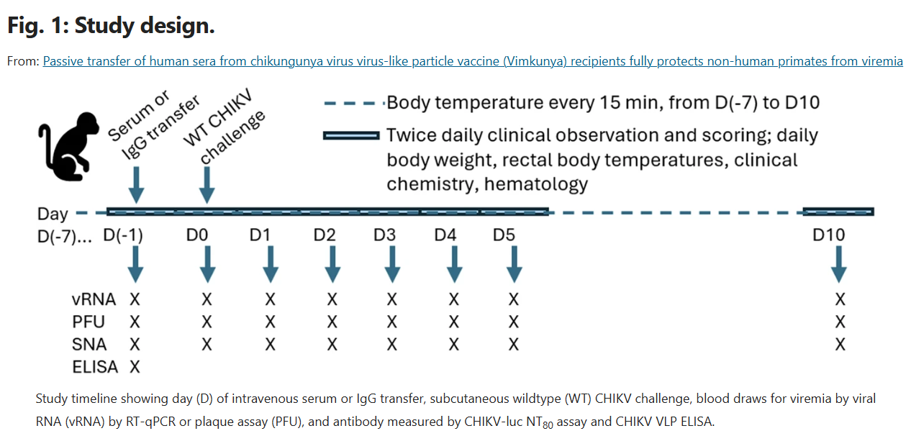

Table 1 Group numbers with numbers of NHPs (N) broken down by sex (#M/#F) with treatments and doses are shown
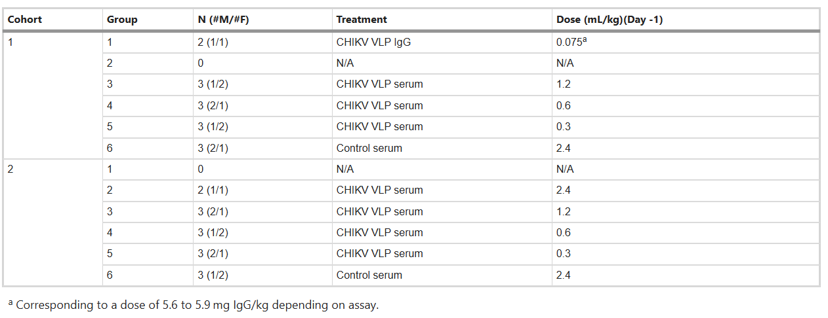
Blood samples were collected from the femoral vein of sedated animals on Day -1 through Day 5 and on Day 10 during the first daily observation. Blood samples were collected into serum separator and anticoagulation (EDTA) tubes. Processed serum samples were aliquoted, heat inactivated at 56 °C for 79 to 90 min, and frozen at ≤−65 °C prior to SNA titer determination. Animals were confirmed to be seronegative for CHIKV VLP binding antibodies and had SNA titers ≤ the limit of detection on Day -1 by CHIKV VLP ELISA and CHIKV-luc NT80 assay, respectively. Plasma was aliquoted and stored at ≤−65 °C prior to plaque assay or viremia determination by RT-qPCR.

Clinical chemistry analyses were conducted on harvested serum using the VetScan VS2®Chemistry Analyzer and hematology analyses were conducted on EDTA blood prior to plasma processing using the Abaxis VetScan HM5® Hematology Analyzer both under UTMB SOP. Clinical chemistry parameters included albumin, alkaline phosphatase, alanine aminotransferase, amylase, blood urea nitrogen, calcium, creatinine, globulin, glucose, potassium, sodium, phosphorus, total bilirubin, and total protein. Hematology parameters included white blood cell (WBC) concentration, red blood cell concentration, hemoglobin, hematocrit, mean corpuscular volume, mean corpuscular hemoglobin, mean corpuscular hemoglobin concentration, platelet concentration, platelet hematocrit, mean platelet volume, platelet distribution width, red cell distribution width, lymphocyte concentration, monocyte concentration, neutrophil concentration, eosinophil concentration, and basophil concentration. No animals met the predetermined euthanasia criteria while on study; therefore, on or after Day 10, animals were euthanized, temperature loggers were recovered, and temperature data were downloaded and assessed.

Quantification of SNA titers by CHIKV-luc NT80 assay

A luciferase-based CHIKV SNA assay (CHIKV-luc reporter strain based on Asian strain 181/25) was used to measure 80% neutralization titer (NT80) against CHIKV in human serum samples. Serum samples were thawed and initially diluted 5-fold and then serially 2.5-fold in Vero growth medium. CHIKV-luc stock virus was thawed and diluted in Vero growth medium, and an equal volume of virus was added to the serum dilutions to yield a final serum dilution range of 1:10 to 1:15,259. Serum/virus mixtures were incubated at 37 ± 1 °C, 5 ± 1% CO2 for 90 to 105 min then added to Vero cells that were previously seeded in 96-well microplates and incubated for 20 to 24 h at 37 ± 1 °C, 5 ± 1% CO2. Plate controls included cell only (no virus) wells to normalize for background and virus only (no serum) wells to provide measures for 100% infection (0% neutralization). The next day, Steady-Glo luciferin substrate was prepared then added to the assay plates following manufacturer’s recommendations Steady-Glo Luciferase Assay System, Promega, Madison, WI). Luminescence was quantified by SpectraMax M5e microplate reader (Molecular Devices, LLC, San Jose, CA) and SoftMax Pro Software. To calculate NT80 results, cell only background measured relative light unit (RLU) values were subtracted from test well values and the virus NT80 and % neutralization was calculated as [1 – (mean background-subtracted RLU for test well) ÷ (mean background-subtracted RLU for virus control)] × 100. The dilution resulting in 80% neutralization was calculated by linear interpolation using the two dilutions that bracket 80% with all calculations performed by validated R package (R Statistical Software v 4.0.4). Prior to NHP studies, the NHP SNA assay was validated and the assay limit of detection (LOD) and lower limit of quantitation (LLOQ) were 12.3.

Quantification of viremia by RT-qPCR

CHIKV gene copy number per milliliter (gc/mL) was determined for RNA extracted from NHP plasma samples using an RT-qPCR assay with previously described primers (CHIKV 6856 and CHIKV 6981) and probe (CHIKV 6919-FAM)12. See Table S1 for primer and probe sequences, genome positions, and reference sequence accession numbers.

Using the QIAamp 96 Virus Kit (#57731) and QIAcube HT extraction system, RNA from each 200 uL plasma sample was extracted together with a spiked internal control (IC) consisting of Escherichia coli bacteriophage MS2 (ATCC 15597-B1) diluted in BaseMatrix (SeraCare 1805–0075) to the validated level. Each extraction batch included a negative control and high and low positive controls containing CHIKV gene target at different concentrations via spiking of naïve NHP plasma with a CHIKV LR2006-OPY1 virus stock. RNA samples were eluted in buffer and stored at ≤−65 °C until RT-qPCR analysis using 1) a qualified CHIKV reference standard dilution series for quantification of CHIKV gc/mL of plasma and 2) an MS2-specific RT-qPCR qualitative assay for detection of IC to confirm RNA extraction efficiency, RNA quality, and lack of RT-qPCR inhibition. The CHIKV reference standard consisted of an 8-point dilution of a 173-nucleotide synthetic RNA (Bio-Synthesis, Lewisville, TX) derived from strain LR2006-OPY1 genome positions 6832 to 7004 (5’-GCUGUUAGAG…AUCACCAUCG-3’). Prior to study use, the CHIKV and MS2 assays together with RNA extraction procedure were validated for use on NHP plasma samples using qualified assay components.

For RT-qPCR, a master mix was prepared using the SuperScript III Platinum One-Step Quantitative RT-PCR system (ThermoFisher 11732–088) containing either 800 nM of each primer and 500 nM of probe (all from Integrated DNA Technologies, Coralville, IA) for CHIKV or 400 nM and 200 nM (all from Applied Biosystems), respectively, for MS2. Cycling parameters for amplification by QuantStudio 6 Flex Real-time PCR system (ThermoFisher) were: 48 °C for 30 min, 95 °C for 10 min, then 45 cycles at 95 °C for 15 seconds, and 60 °C for 1 min. For each sample, the reportable CHIKV gc/mL value was calculated from the mean gene copies results from duplicate wells, reaction input volume, RNA eluate volume, and actual volume of plasma extracted. CHIKV gc/mL data were reportable if the MS2 reaction for the test sample resulted in a cycle threshold (CT) value that was ≤3 CTs higher than that of the CHIKV RNA negative/MS2 spiked extraction control for its respective extraction batch. The validated CHIKV assay LOD and LLOQ were 292 and 931 gc/mL, respectively.

As an endpoint for success was defined by lack of detectable gene copies, an IC-specific reaction was also performed on each sample to verify that a below LOD sample result was not due to low RNA extraction efficiency or lack of CHIKV RNA reverse transcription plus cDNA amplification potential.

Quantification of CHIKV Viremia by Plaque Assay

Levels of infectious CHIKV in serum were quantified by plaque assay on Vero cells. Briefly, cells in Vero growth medium (DMEM containing L-glutamine with 10% HI-FBS, 10 mM HEPES buffer, and 100 U penicillin/streptomycin per mL) were seeded in 6- or 24-well culture plates 18 to 24 h before use and incubated in a cell culture incubator (37 ± 2 °C and 5% CO2). Serum samples were thawed, and 10-fold serial dilutions were prepared in dilution medium (Minimal Essential Medium [MEM] with L-glutamine and phenol red plus 5% HI-FBS). Dilutions were added to at least duplicate wells of cell monolayers incubated for 60 ± 2 min as above with manual rocking every 10 to 15 min. Overlay medium (MEM Alpha (1X)+ GlutaMAX (-) ribonucleosides, (-) deoxyribonucleosides (Gibco 32561-037) with 1.25% carboxymethylcellulose (Sigma C4888-500G) and freshly added 5% HI-FBS) was added and plates were incubated as above for 36 to 48 h. Cells were fixed with 10% neutral buffered formalin for 1 hour at ambient temperature, rinsed with tap water, and stained with crystal violet stain solution (0.25% crystal violet in 10% neutral buffered formalin) for at least 15 min. Plaques were enumerated and PFU per mL of serum calculated using mean PFU counts from replicate wells. Assay LOD was 33 PFU/mL.

Statistical methods

For RT-qPCR, the LOD was 292 gc/mL and the LLOQ was 931 gc/mL. RT-qPCR values < LOD were imputed to half LOD ~ 146 gc/mL for summary statistics, figures, and logistic regression analysis. RT-qPCR values > LOD but <LLOQ were imputed to half (LOD + LLOQ) = 611.5 gc/mL for summary statistics, figures, and logistic regression analysis. For SNA antibody titer, the LOD/LLOQ was 12.3. Day 0 SNA titers <LOD/LLOQ were imputed as 12.3 to be conservative. For the plaque assay, titers <LOD were imputed to one-half LOD (16.5) for graphing purposes.
The primary analysis defined immune/ protected from CHIKV as an RT-qPCR viral load result <LLOQ (931 gc/mL) on all six post-challenge study days (Days 1 to 5 and Day 10). A logistic regression model was fit to the binary response data (where success was no viremia ≥LLOQ) with log10 Day 0 SNA antibody titer as a predictor. The Day 0 SNA antibody titers associated with 80% or 90% probability of immunity/ protection were estimated from this model. A secondary analysis utilized the same logistic regression model, but with immune/ protected from CHIKV alternatively defined as an RT-qPCR viral load result <LOD (292 gc/mL) on all six post-challenge study Days 1 to 5 and Day 10. Primary and secondary analyses were defined before study initiation with respect to how results were to be submitted to regulatory authorities for surrogate endpoint determination. Results are presented here based on the secondary analysis as the more stringent endpoint definition for protection.

Viremia data were log10 transformed. The GMTs and associated 95% CIs for each treatment group were computed by exponentiating the corresponding log-transformed means and 95% confidence limits based on the observed standard errors. The pairwise statistical comparisons of treatment Groups 1 through 5 to Group 6 at each time point post-challenge were performed via a t-test based on the log-transformed values.

The proportion (percentage) of NHPs considered protected (defined as viral RNA copies in plasma below the LLOQ or LOD by RT-qPCR) was tabulated for each treatment group at each time point post challenge. Fisher’s exact tests were performed to derive p-values for the pairwise treatment arm comparisons of Groups 1 through 5 against Group 6.

Results
SNA titers pre-challenge
Using the CHIKV-luc NT80 assay, Day -1 titers were at (n = 1) or below (n = 27) the assay LOD/LLOQ of 12.3 (Table S2). Pre-challenge Day 0 SNA results for each NHP and the GMT for each group are shown in Fig. 2 and Table S2. Animals that were administered purified IgG (group 1) had an SNA GMT at the time of challenge of 32.2. NHPs that received CHIKV VLP serum at doses of 2.4, 1.2, 0.6 or 0.3 mL/kg (Groups 2, 3, 4 and 5) had group GMTs of 61.3, 35.4, 21.3 and 14.3, respectively at the time of challenge (Day 0) (Table 2). Control animals (Group 6) and two CHIKV VLP serum 0.3 mL/kg animals (Group 5; 3413198998 and 7881534763) had no measurable SNA titer at challenge (Table S2).
Fig. 2: Pre-challenge SNA titers on study Day 0.

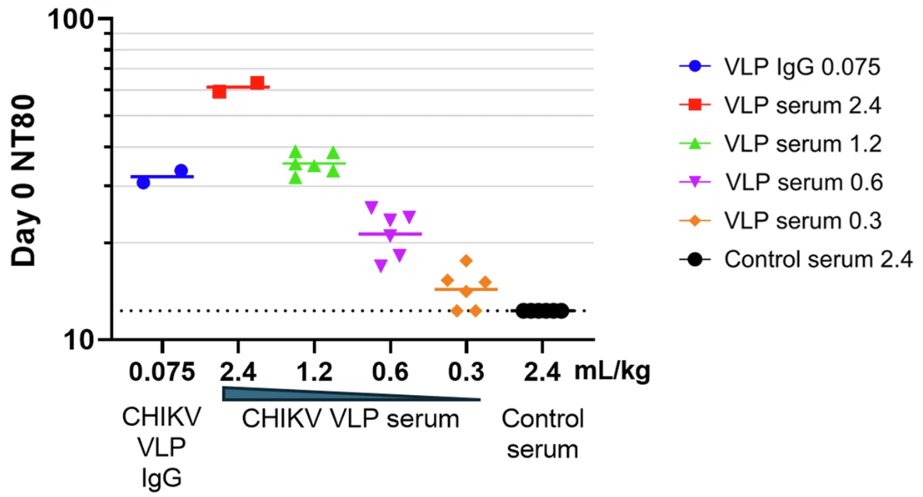
On Day -1, NHPs were given an IV injection with either a CHIKV VLP IgG preparation or a pooled CHIKV VLP serum from Vimkunya vaccinated human participants, or a pooled pre-immune serum from baseline seronegative study participants (control serum). Treatment dosages of serum or purified IgG are described as mL per kg body weight. Symbols represent the SNA results from individual NHPs and horizontal bars represent GMT. The dotted line represents the LOD and LLOQ of the assay (12.3).

Table 2 Geometric mean titers of each group by study day
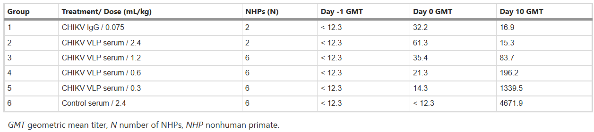

Challenge outcomes, disease signs, hematology, and blood chemistry
By clinical observation, all NHPs presented as unremarkable for the entirety of the study. Body weights remained relatively consistent throughout the study (Figure S1). Body temperatures were measured every 15 min via implantable loggers (Figure S2) and rectal temperatures were measured at each anesthetic event (Fig. 3). The CHIKV VLP IgG group (Group 1) consistently had lower temperatures throughout the study including prior to challenge due to one animal (4669919768) averaging 0.46 °C lower than the other animals in the group (Fig. 3). Body temperatures stayed relatively consistent throughout the study, with no overt fever observed in any of the groups. Using the temperature loggers, the control serum group (Group 6) had consistently higher body temperatures throughout the study when compared to the other groups (of note, animal 3056061099 was excluded due to faulty data logger programming), however this difference was not seen in the rectal temperature data (Fig. 3). This is likely due to the NHPs being anesthetized during the measurement. The difference in body temperature on Day 1 was observed at night, but rectal temperatures were taken in the morning.
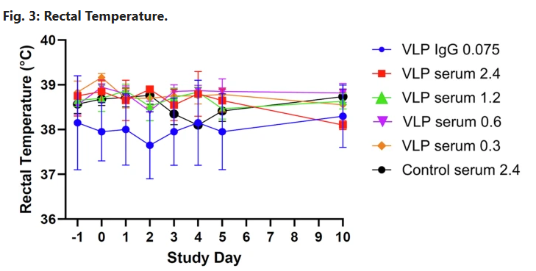
Symbols represent group means and bars indicate standard error.

Clinical chemistry panels were run on each NHP. No group effect was observed for clinical chemistry parameters (data not shown).
Blood collected on study was also assayed for hematological changes. Total WBC count is illustrated in Figure S3. The WBC counts were within the ranges seen in other studies of cynomolgus macaques13. All NHPs were within the normal hematological ranges.

Viremia

Plasma and serum samples were obtained before and after challenge to quantify CHIKV RNA by RT-qPCR and infectious virus levels by plaque assay, respectively. The RT-qPCR assay methodologies were designed and validated to detect the challenge virus genome in NHP plasma samples. Onset of detectable CHIKV RNA was on Day 1 (Fig. 4A, Table S3), with 6 of 6 control animals (Group 6) having detectable CHIKV RNA with a group mean level of 6.7 log10 gc/mL (Figure S4-F) that was maintained through Day 3, and then decreased until gene copies levels on Day 10 were <LOD for 5 of 6 animals. In contrast, CHIKV RNA was <LOD at all timepoints for all animals in groups receiving the CHIKV VLP IgG and serum doses of 1.2 and 2.4 mL/kg (Groups 1–3) (Fig. 4, Table S3, Figure S4A, B, C). Two of six of the 0.6 mL/kg group (Group 4) had detectable RNA on at least one day (Figure S4-D), and 6 of 6 animals in the 0.3 mL/kg group (Group 5) had detectable CHIKV RNA on at least one study day examined (Figure S4-E). As expected, there was a negative correlation between Day 0 log10 SNA titers and peak log10 gc/mL by linear regression (R = 0.78, p < 0.0001, Fig. 4-B).

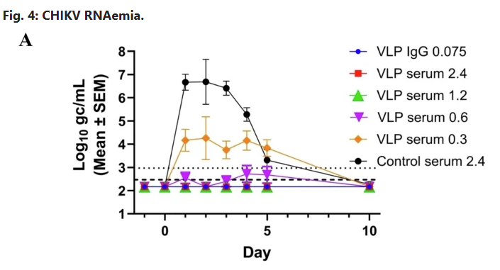
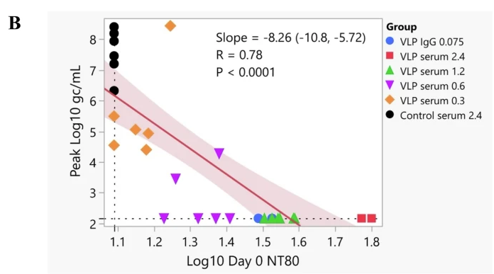
A CHIKV RNAemia by RT-qPCR of plasma. Group log10 gc/mL results with symbols representing the mean log10 gc/mL of the NHP groups shown and error bars representing standard error of the mean. The validated CHIKV RT-qPCR assay LOD (dashed line) and LLOQ (dotted line) were 292 and 931 gc/mL, respectively. Results <LOD were imputed to half-LOD ( ~ 146 gc/mL) and values between LOD and LLOQ were imputed to half (LOD + LLOQ) (611.5 gc/mL) for calculations and plotting. B Relationship between peak viremia by RT-qPCR vs pre-challenge Day 0 SNA titers. Day 0 NT80 and maximum gc/mL results were log10-transformed. Least squares linear regression was performed with the solid line and shading representing the regression result and 95% confidence interval, respectively. Each symbol represents an individual animal with the group shown in the key by test article and dose in mL/kg. Regression results of slope and 95% confidence interval in parenthesis. Dotted lines on the X and Y axes represent the LOD/LLOQ of the SNA assay (NT80 12.3) and LLOQ of the RT-qPCR assay (931gc/mL), respectively.

Infectious virus was only detectable by plaque assay (greater than assay LOD of 33 PFU/mL) in control animals (Group 6) (Table S4). All 6 control NHPs had infectious CHIKV detectable either from Day 1 to Day 3 or Day 2 to Day 3, with the group peak on Day 2 (Figure S6-A). Kinetics of circulating infectious CHIKV and CHIKV RNA were found to be similar, with the latter being detectable for 2 days longer after challenge (Figure S5-B). One exception was control serum animal 3056061099 (Group 6) that showed a single <LOD gc/mL day in the Day 1 to Day 4 period (Day 2, Figure S4-F) but a peak PFU/mL level of 1.5 × 105 on that day (Figure S5-A). This difference may have possibly been due to a template concentration greater than the upper limit of quantification which led to thermocycler software being unable to process the baseline data.

RNAemia
Analysis of the presence of CHIKV RNA in plasma by RT-qPCR demonstrated that CHIKV sera protected animals from the presence of CHIKV RNA in a dose-dependent manner. All 10 animals in Groups 1 through 3 were fully protected from CHIKV RNA accumulation, along with 4 out of 6 animals in Group 4. No animals from Groups 5 or 6 were protected from the presence of CHIKV RNA. All animals that had a pre-challenge (Day 0) SNA NT80 ≥ 25.7 were fully protected from the presence of CHIKV RNA (Fig. 5). Overall, no viremia was detected in 14 animals: all animals in the CHIKV VLP IgG and two highest CHIKV VLP serum dose groups (Groups 1 to 3) and 4 of 6 in the 0.6 mL/kg group (Group 4). Animals with detectable viremia included 2 animals in Group 4 who had Day 0 SNA titers of 18.2 and 24.0, as well as the CHIKV serum 0.3 mL/kg group and the control serum group (Groups 5 and 6) who had Day 0 SNA titers below the LOD or of 15.1, 15.3, 17.6 and 14.1. All animals that had a pre-challenge (Day 0) SNA NT80 ≥ 25.7 were fully protected from the presence of CHIKV RNA (Fig. 5).
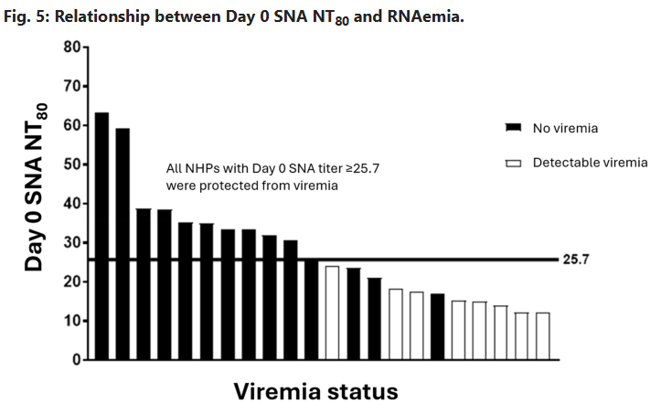
Relationship between Day 0 SNA NT80 and RNAemia as measured by RT-qPCR for CHIKV VLP immune sera- or IgG-treated NHPs with RNAemia ≥ LLOQ detected on at least 1 day (detectable viremia) or undetectable on all days (no viremia). Group 6 negative control animals are not shown.

A logistic regression model was fit to the binary response data where success is no detectable viremia on any day after challenge as detected by RT-qPCR (RNAemia), with log10 Day 0 SNA titer as a predictor (Fig. 6). As expected, log10 Day 0 SNA was a significant predictor of success (no viremia, corresponding to CHIKV gc/ml <LOD) in the model (Wald chi square p-value = 0.0104). Note that the same 14 animals (all animals in Groups 1 to 3 plus 4 of 6 animals in Group 4) that were considered immune protected based on all results <LOD were also considered protected based on all results <LLOQ (the predefined primary endpoint analysis). The odds ratio estimate for a doubling of Day 0 SNA titer (0.3-unit increase on the log10 scale) was 423, meaning a 423-fold higher odds of no viremia (Wald 95% CI 4.1 to >1000). The Day 0 SNA antibody titers associated with 80% or 90% probability of immunity/ protection were estimated from this model. From the model, a predicted probability for no viremia of 0.80 (80% chance of immunity/ protection from CHIKV RNAemia) corresponded to a Day 0 SNA titer of 23.6, while a predicted probability of 0.90 corresponded to a Day 0 SNA titer of 25.9 using linear interpolation (see red dashed lines in Fig. 6). An SNA titer of 50 predicted a 99.97% (95% CI: 81–100) probability of protection against RNAemia.

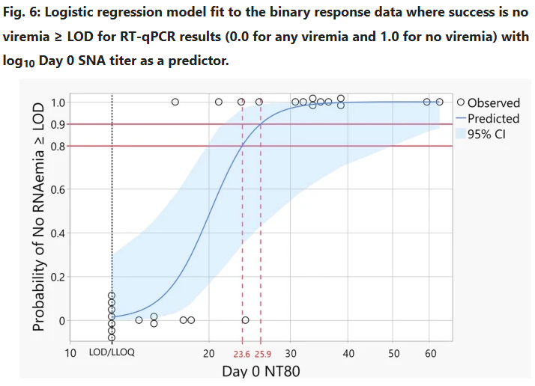
The y-axis represents the probability of immunity/protection from CHIKV, the x-axis represents the Day 0 NT80, and each symbol is an individual NHP (Observed), with points jittered around 0.0 and 1.0 to view all animals. The solid curve represents the predicted probability of immunity/protection (Predicted), the shaded area represents the 95% confidence interval for the prediction (95% CI), the dotted black line represents the SNA assay LOD/LLOQ of 12.3, and dashed red lines represent the Day 0 SNA titers associated with 80% or 90% probabilities (shown by solid horizontal red lines at 0.8 and 0.9, respectively) of immunity/protection of 23.6 and 25.9, respectively. Day 0 SNA titers < LOD/LLOQ were imputed as LOD/LLOQ to be conservative.

SNA titers post-challenge
Following challenge, Day 10 SNA results were higher in all animals compared with their respective Day 0 values except for NHPs in the CHIKV VLP IgG (Group 1) and CHIKV VLP serum 2.4 mL/kg (Group 2) groups that had decreased titers, and one animal in the 1.2 mL/kg serum group (Group 3; 3300141353) that had a Day 10 titer similar to Day 0 (within assay precision) (Figure S6, Table S2). These results suggest that while the level of protection afforded from the control IgG and highest serum dose was sufficient to abrogate a detectable primary antibody response to the challenge virus, the lower serum doses allowed enough viral replication to generate a response despite being undetectable in the circulation.

Discussion
The objective of this passive immunization and challenge study was to evaluate the protective efficacy of serum derived from human volunteers who received a single 40 μg dose of Vimkunya in an NHP model. This objective was successfully met, with 28 cynomolgus macaques treated and challenged. RT-qPCR analysis demonstrated that pretreatment with either immune sera or purified CHIKV IgG conferred dose-dependent protection against viremia. Notably, all animals with a pre-challenge SNA titer ≥25.7 were fully protected from detectable viremia following CHIKV challenge. Viable virus was isolated only from control animals, and viral RNA was undetectable in the CHIKV IgG group and the two highest serum dose groups. This absence of viral RNA suggests the induction of sterilizing immunity, which represents a particularly high threshold bar for vaccine-mediated protection. Additionally, in the control group, CHIKV RNA was detectable for 2 days longer after challenge than by plaque assay indicating that RT-qPCR is the more sensitive assay, potentially also detecting non-infectious CHIKV (defective particles or genomes only) and is therefore likely overestimating viremia. Collectively, these findings indicate that serum from CHIKV VLP-vaccinated human volunteers effectively prevents viremia and clinical disease in CHIKV challenged NHPs, supporting the vaccine’s potential to confer protective immunity.

A logistic regression model was used to evaluate the relationship between circulating SNA titer at time of challenge and protection against viremia post-challenge. With protection defined as viremia being below the LOD (292 gc/mL) of the validated RT-qPCR assay, the SNA titer associated with an 80% probability of protection was determined to be an SNA titer of 23.6.

Due to the unpredictability of CHIKV outbreaks, a traditional path for regulatory approval of chikungunya vaccines, based on efficacy, would have been challenging and could have delayed clinical development. It was therefore agreed upon with regulators to develop a surrogate endpoint of efficacy, specifically a protective SNA threshold titer that could reliably predict clinical benefit in humans. An initial SNA NT80 threshold of ≥40 was proposed to regulatory agencies as a surrogate endpoint for protection against chikungunya disease. This value was derived from a prospective sero-epidemiological study by Yoon et al.3, where a baseline CHIKV PRNT80 titer ≥10, corresponding to a CHIKV-luc NT80 titer of 35, was associated with 100% protection from symptomatic CHIKV infection (95% CI: 46.1, 100.0). To further substantiate this surrogate endpoint, the present NHP passive transfer study evaluated the relationship between circulating SNA titers at the time of challenge and protection from viremia. The study also demonstrated that vaccination elicited cross-strain-neutralizing anti-CHIKV antibodies in NHPs, which cross-protected against challenge with CHIKV LR2006 OPY-1, a heterologous strain that represents amongst the highest diversity in the virus envelope proteins compared to strain 37997 represented in the vaccine. Logistic regression analysis identified an SNA titer of 23.6 as the level associated with an 80% probability of protection from viremia, defined as viral load below the LODof the RT-qPCR assay. Regulatory authorities recommended a more conservative NT80 titer of 100 as a surrogate endpoint reasonably likely to predict protection in humans. This threshold was subsequently adopted for phase 3 clinical trials endpoint analyses7,8.
The challenge route in this study was designed to approximate the natural transmission of CHIKV via mosquito bite, introducing the virus into a peripheral anatomical compartment distinct from the intravenous administration of immune serum; in this case, a subcutaneous route was used for virus challenge, whereas mosquito-borne inoculation occurs through an intradermal route. This reflects the initial localized replication of CHIKV before systemic dissemination, a process that may influence the efficacy of neutralizing antibodies introduced systemically14. The viral dose used for challenge was selected based on estimates of viral load transmitted by Aedes mosquitoes15 and is consistent with dosing strategies that have been employed in other NHP studies to validate CHIKV vaccine efficacy16. This biologically relevant dosing enhances the translational value of the study, ensuring that the observed protective effects of the vaccine-induced antibodies are applicable to real-world exposure scenarios. A limitation of this study is that while viremia was used as a stringent and quantifiable primary endpoint for assessing vaccine efficacy, it may not fully capture the complexity of CHIKV pathogenesis, particularly viral replication in joint tissues and other anatomical compartments that are not evaluated through blood-based RT-qPCR.

In addition to the Vimkunya 6-month safety and immunogenicity demonstrated in phase 3 trials7,8, preliminary evidence from phase 2 studies10 indicated that Vimkunya provides protective immunity lasting up to 2 years. Notably, the phase 3 trials also reported a rapid and robust immune response by 15 days postvaccination. Long-term durability of protection is currently being evaluated in an ongoing phase 3 trial (ClinicalTrials.gov NCT06007183), which aims to assess immune persistence up to 5 years postvaccination. Furthermore, a confirmatory vaccine efficacy trial is planned for populations residing in regions at risk for local CHIKV transmission. Given the unpredictable and explosive nature of CHIKV outbreaks, participant vaccination in this trial will be initiated upon detection of early signals indicating potential outbreak onset in preselected geographic areas, allowing for a responsive and targeted immunization strategy.

This passive immunization and challenge study in cynomolgus macaques provides evidence that antibodies elicited by a single dose of the Vimkunya can confer protection against CHIKV viremia and associated clinical signs. The logistic regression analysis identified a protective SNA titer threshold of 23.6, though a more conservative NT80 titer of 100 was adopted for phase 3 trials to ensure robust prediction of clinical benefit. These results support that an SNA NT80 ≥ 100, the regulatory threshold used to predict protection against CHIKV disease in humans, represents a conservative benchmark. This suggests that the percentage of participants in phase 3 trials who achieved immunological protection from CHIKV disease is likely underestimated. Notably, this threshold reflects the contribution of circulating neutralizing antibodies alone and does not account for potential protection mediated by cellular immune responses, making the estimate even more conservative. An upcoming trial will further investigate the NT80 titer associated with protection by analysing pre-disease onset titers, aiming to establish a real-world, evidence-based protective threshold. Collectively, these findings reinforce the use of neutralizing antibody titers as a surrogate endpoint for vaccine efficacy and highlight the potential of Vimkunya to provide rapid and durable protection against CHIKV disease in both endemic and epidemic settings, as well as among travellers to these regions.

