Stunning and slaughter methods in gilthead seabream: Animal welfare and muscle quality

海鲷的致昏和屠宰方法：动物福利和肌肉质量
Abstract
European Union directives and international guidelines emphasise the need for humane slaughter practices, with particular attention to the proper stunning of fish prior to slaughter. This study investigates the impact of various combinations of stunning and slaughter methods on the welfare of gilthead seabream (Sparus aurata), a widely farmed species in the Mediterranean and Black Sea regions. Specifically, the study explores electrical stunning, anaesthesia, and no stunning, followed by slaughter using either ice-slurry or the ikejime (hand-held spike tool) technique. Fish were monitored for visual signs of consciousness, heart rate, internal temperature, plasma stress and osmotic parameters, and muscle quality parameters. The findings revealed that electrical stunning, although inducing brief unconsciousness, did not sustain it long enough to be effectively combined with ice-slurry, resulting in stress responses and muscle quality parameters comparable to those observed in unstunned fish. In contrast, anaesthesia effectively reduced stress and improved meat quality. The ikejime technique, despite its labour-intensive nature, demonstrated significant advantages, including reduced physiological stress and superior muscle quality outcomes. These results suggest that the viability of electrical stunning as a humane option for industry implementation has important limitations, while ikejime, with further refinement and automation, could offer a humane and effective solution to optimise both animal welfare and meat quality in industrial settings.

欧盟指令和国际准则强调了人道屠宰做法的必要性，特别注意在屠宰前对鱼类进行适当的电击。本研究调查了电击和屠宰方法的各种组合对地中海和黑海地区广泛养殖的物种金鱼鲷（Sparus aurata）福利的影响。具体而言，该研究探讨了电击、麻醉和非电击，然后使用冰浆或ikejime（手持刺入工具）技术进行屠宰过程中，监测鱼类的意识视觉体征、心率、体温、血浆压力和渗透参数以及肌肉质量参数。研究结果表明，电击虽然会导致短暂的昏迷，但并不能持续足够长的时间，无法与冰浆有效结合，从而导致应激反应和肌肉质量参数与未经电击的鱼类相当。相比之下，麻醉有效地减轻了压力，提高了肉质。尽管ikejime技术具有劳动密集型的性质，但它显示出显著的优势，包括减少生理压力和提高肌肉质量。这些结果表明，电击作为工业实施的人道选择的可行性存在重大局限性，而ikejime通过进一步的改进和自动化，可以提供一种人道有效的解决方案，以优化工业环境中的动物福利和肉类质量。

Keywords
Compassionate killing，Aquaculture Animal care，Unconsciousness，Alternative methods

1. Introduction
The global production of aquatic animals has increased markedly over the past few decades, and has recently surpassed capture fisheries for the first time in terms of quantity, reaching 94.4 million tonnes in 2022 (FAO, 2024). It is projected that the production of aquatic animals from aquaculture will reach 111 million tonnes by 2032 (FAO, 2024). This increase in production is accompanied by major challenges for the sector, being fish welfare one of them (FAO, 2024). In the European Union, minimum standards for the protection of farmed fish were established in the Council Directive 98/58/EC of 20 July 1998. This directive stipulates that farmed animals, including fish, should not be subjected to any unnecessary pain, suffering or injury. Subsequently, a number of guides, codes of good practice, and recommendations pertaining to fish welfare have been published, particularly in recent years, with the intention of informing aquaculture producers and other relevant stakeholders (e.g., APROMAR, 2022; Leary et al., 2020; Saraiva et al., 2022b; Saraiva et al., 2021; Studer et al., 2020; World Organisation for Animal Health, 2024).
One of the key aspects surrounding farmed fish welfare is their stunning and slaughter. Most recent guidelines and codes of good practice emphasise the significance of ensuring that fish are properly stunned prior to slaughter to prevent unnecessary suffering (APROMAR, 2022; European Commission. Directorate General for Health and Food Safety et al., 2017; Humane Slaughter Association, 2018; Leary et al., 2020; J. L. Saraiva et al., 2022b; Villarroel and Lambooij, 2022; World Organisation for Animal Health, 2024). The efficacy of stunning is determined by observing the immediate loss of consciousness in the fish, which can be indicated by the observation of brain activity using electroencephalograms (EEG) (e.g., Bowan and Gräns, 2019; Bowman et al., 2020; Brijs et al., 2021; Hjelmstedt et al., 2022; Lambooij et al., 2008; Retter et al., 2018). Alternatively, loss of consciousness may potentially be inferred through the observation of visual indicators of consciousness such as the cessation of opercular activity and vestibulo-ocular reflex (VOR), otherwise known as eye-roll (Bowman et al., 2020; Kestin et al., 2002). These reflexes are the last to disappear during anaesthesia in several fish species, persisting even after the disappearance of visually evoked responses (VERs) in the brain (reviewed in Kestin et al., 2002). VERs are brain responses to flashes of light directed at the eyes, and their absence indicates a loss of sensory processing and brain function (Kestin et al., 1991). This has led to the assumption that the absence of opercular activity and VOR reflects a state of insensibility or unconsciousness (Kestin et al., 2002). However, this inference has not yet been validated through direct neurophysiological recordings in seabream. It is essential that the state of unconsciousness be immediate and of sufficient duration to ensure that the fish do not recover before death. In the past, self-initiated behaviours, such as the loss of free swimming or loss of equilibrium, as well as responses to stimuli, such as handling or pricking, were employed as visual indicators of insensitivity. However, it has been demonstrated that these are not reliable indicators of unconsciousness (Kestin et al., 2002). Nevertheless, in the absence of more sophisticated methods, such as EEG, visual indicators represent a valuable operational tool for assessing the reaction of fish to specific stunning or slaughter methods, with the potential to identify likely shortcomings in a given method for a particular species. For example, the observation of aversive reactions prior to reaching unconsciousness led to the classification of carbon dioxide narcosis as an ineffective stunning method, as evidenced in several species, including Atlantic salmon (Salmo salar; Robb et al., 2000b; Roth et al., 2002), Arctic char (Salvelinus alpinus; Gräns et al., 2016), rainbow trout (Oncorhynchus mykiss; Bowman et al., 2020; Marx et al., 1997), common carp (Cyprinus carpio; Marx et al., 1997) and eel (Anguilla anguilla; Marx et al., 1997).
The current commercial practices that are considered humane regarding the stunning of fish prior to slaughter include the use of electrical and mechanical stunning (Humane Slaughter Association, 2018). The process of electrical stunning entails the application of an electrical current of sufficient strength, duration, and frequency to induce immediate unconsciousness in the fish. Electrical stunning is reversible in most cases; therefore, it is imperative that the animal does not regain consciousness during the slaughter procedure. Importantly, the electrical stunner must be designed to accommodate the specific species in question, and the parameters must be tested and validated on-site: in the case of in-water stunners, for example, the water conductivity may vary significantly from one location to another, which can lead to considerable differences in the method's efficiency. Saltwater is less efficient in conducting electrical current, which makes this method more suitable for freshwater fish or saltwater species that can tolerate brackish water. To circumvent these issues, an alternative approach involves the use of semi-dry electrical stunners, which are better suited for saltwater species yet require the fish to be emersed before entering the stunner. In such devices, it is important that the fish enter the device head-first, as this ensures the optimal functioning of the apparatus (Daskalova et al., 2016). Recent evidence highlights the need to both validate and adapt electrical stunning methods to each species, regardless of the type used (Bowman et al., 2020; Brijs et al., 2025; Hjelmstedt et al., 2025; Hjelmstedt et al., 2022).
Other types of stunning entail mechanically impairing the brain's functioning. This can be achieved through a number of techniques, such as percussive stunning (where a blunt blow to the head is applied above or immediately adjacent to the brain with sufficient force), spiking or coring (where a spike or core is introduced in the brain, physically damaging it) and using small explosive charges (which is only employed in large fish such as tuna, and is called lupara when done underwater). A mechanical stunning and killing method that is commonly employed in recreational fishing is the Japanese technique known as ikejime, which translates as “kill with purpose” (Sullivan, 2022). The method entails the insertion of a spike into the brain of the fish, which results in immediate cessation of brain function (Robb and Kestin, 2002). To avoid unnecessary suffering and ensure proper execution of the technique, ikejime, as any other spiking method, should be preceded by an effective stunning method that renders the fish unconscious (Davie and Kopf, 2006; Robb and Kestin, 2002). However, it is important to note that in both recreational and commercial fishing contexts, stunning is not always performed prior to brain destruction, despite these recommendations (Boyd et al., 1984; Davie and Kopf, 2006; Robb and Kestin, 2002). For this method to be distinguished from simple spiking, it must be followed by the immediate bleeding of the fish, which retards the process of meat decay (Sullivan, 2022). Subsequent to this, the fish must be placed in ice-slurry to prevent bacterial contamination (Sullivan, 2022). A related technique, known as shinkeijime, involves the destruction of the spinal cord and is sometimes used in conjunction with ikejime (M J C-Á, personal communication 2023). While shinkeijime can further improve the quality of the fish, it requires a highly skilled practitioner to avoid damaging the fish improperly. The application of ikejime alone requires a high investment of time and labour, given that each fish must be killed individually. Nevertheless, reports indicate that the utilisation of this technique can enhance the value of the fish by 20 to 400 % per pound in certain locations (Sullivan, 2022).
Unfortunately, other methods of slaughter considered inhumane are still commonly employed in the industry. These include methods of asphyxiation in ice or ice-slurry, stunning with carbon dioxide (CO2) in holding water, chilling with ice and CO2 in holding water, salt or ammonia baths, asphyxiation by removal from water, and exsanguination without stunning. A detailed description of these methods and their associated welfare issues can be found in previous literature (e.g., van de Vis et al., 2020; Villarroel and Lambooij, 2022).
Notably, a considerable number of fish species are killed without prior stunning, despite the growing awareness of the necessity for such practices, which can significantly improve the welfare of farmed fish (Maia et al., 2024). This is the case of gilthead seabream (Sparus aurata), for which the most prevalent method of slaughter for farmed specimens is asphyxia in an ice-slurry (EFSA, 2008; European Commission, 2017). Gilthead seabream is the most farmed species in Mediterranean and Black Sea countries, with a production volume of 281,914 t in 2021 (FAO, 2023). In terms of number of animals, the production of seabream in Europe is comparable to salmon: in 2021, salmon production in Europe accounted for 1,801,388 tons, i.e., roughly 450,347,000 animals (assuming a harvest weight of 5 kg per fish). Seabream production was 208,021 tons accounting for 651,144,000 individuals (FEAP, 2023). Commercial scale electrical stunning equipment has been developed and are currently employed in some farms, driven by a growing interest from industry stakeholders (APROMAR, 2024; Ryba and KvPelt, 2023; van Pelt et al., 2024). Given the need to validate electrical stunning effectively ensures humane slaughter and prevents recovery before death, it is essential to gather sufficient data before these systems are widely adopted by the industry. This is not only important for ethical reasons, but also for economic ones, as companies investing in such expensive technologies must be confident that they are achieving the desired outcomes in terms of both animal welfare and product quality.
The impact of different slaughter methods on the welfare of gilthead seabream and on their muscle quality has been the subject of previous investigations, based on the premise that metabolites released during stress would accumulate in the muscle tissue (Poli Parisi et al., 2005; Poli, 2009). The following studies compared the effects of slaughter using ice-slurry with those of alternative methods, which may include both existing techniques that are already employed in the industry (e.g., asphyxia in air), as well as potential enhancements to current practices (e.g., CO2 stunning). It was observed that gilthead seabream asphyxiated in air exhibited a longer struggle time than fish asphyxiated in ice-slurry (Bagni et al., 2007), despite previous findings indicating that brain function cessation occurs at a similar time under both conditions (Robb and Kestin, 2002). Additionally, both slaughter methods were found to be highly stressful and detrimental to muscle quality, with earlier and more intense rigor mortis and an immediate pH drop post-mortem in fish that had been crowded prior to slaughter, compared to unstressed fish, highlighting the negative effects of pre-slaughter practices (Bagni et al., 2007). In a separate study that compared asphyxia in air, asphyxia in ice-slurry, and percussive stunning followed by immersion in ice-slurry, it was observed that the onset of rigor was delayed in the fish that had been previously stunned by percussion in comparison to the other two slaughter methods (Tejada and Huidobro, 2002). Additionally, the muscle of fish killed by asphyxia in air exhibited lower pH values, reflecting a preponderance of anaerobic metabolism accompanied by increased production of lactic acid, which contributes to protein and muscle denaturation and resulted in the lowest score for flavour (Tejada and Huidobro, 2002). Another study demonstrated that the administration of an isoeugenol-based liquid anaesthetic during the harvesting process resulted in a delayed onset of rigor mortis and an improvement in muscle pH (Matos et al., 2010). Additionally, the muscle pH was still better 48 h post-mortem in fish slaughtered with that anaesthetic than in fish slaughtered in ice-slurry. However, no effect was observed on muscle structure as measured by instrumental texture analysis and collagen and sulphated glycosaminoglycan content, as a result of either harvesting or slaughter stress (Matos et al., 2010). In a study comparing the muscle quality of gilthead seabream that had been stunned with CO2 or killed in an ice-slurry bath, it was found that the fish exhibited visual indicators of consciousness for a period of 15 to 20 min, compared to 5 min in fish that had been stunned with CO2 (Giuffrida et al., 2007). Additionally, the depletion of ATP was also observed to occur more rapidly in the muscle of fish that had been killed in ice-slurry (Giuffrida et al., 2007). While the fish stunned with CO2 showed a shorter period of visual consciousness, it is important to note that CO2 causes a strong aversive reaction in fish, which should be considered when interpreting these findings. In a study comparing behavioural and electroencephalographic measures of brain function across different stunning and killing methods, gilthead seabream lost self-initiated behaviours, stimulus responses, reflexes, and VERs immediately following the onset of electrical current (Kestin et al., 2002). In contrast, loss of self-initiated behaviour occurred after four and five minutes, responses to stimuli after 7.5 and 10 min, reflexes after 14 and 10 min, and VERs after 5.5 and 5 min during asphyxia in air and ice-slurry (Kestin et al., 2002). These findings highlight the rapid and simultaneous loss of brain function indicators following electrical stunning, in contrast to the prolonged loss observed during asphyxia in air and ice-slurry, underscoring the effectiveness of electrical stunning as a more humane method of inducing unconsciousness in gilthead seabream. However, since seabream can regain consciousness within approximately 4.8 min after a 3-s stun using 50 Hz AC at 4.6 A (van De Vis et al., 2003), it is crucial that electrical stunning is either immediately followed by a rapid killing method or that stunner settings are optimised to prolong unconsciousness. In a different study, gilthead seabream killed in ice-slurry or stunned with electricity followed by immersion in ice-slurry had higher lactate than fish slaughtered by spiking, but plasma cortisol and glucose were at the same levels in all slaughter treatments (Papaharisis et al., 2019). Also, muscle hardness was higher in the fish killed in ice-slurry compared to the ones that had been previously stunned with electricity (Papaharisis et al., 2019). While this study provided valuable physiological and quality data, it did not include measures of unconsciousness, which limits insight into certain aspects of animal welfare. Additionally, alternative novel methods of slaughter have been described for gilthead seabream, including immersion in liquid ice (Huidobro et al., 2001; Urbieta and Ginés, 2000). Although this method reduces the immobilisation time from over 40 min to under 20 min in comparison to immersion in ice-slurry, the overall effects of this novel approach are considered to be detrimental for the welfare of fish due to other complications such as gill haemorrhage and crystalised eyes (Huidobro et al., 2001), as observed as well in rainbow trout (Saraiva et al., 2024).
The aim of the present study was to assess the impact of diverse combinations of stunning and slaughter techniques on welfare indicators and quality parameters of gilthead seabream. Particularly, we explored stunning with electricity, stunning with anaesthesia, or no stunning. Electrical stunning was included to assess the efficiency of this method; anaesthesia was used as a positive control, since it provides arguably the most reliable and humane way to induce unconsciousness, despite not being considered a stunning method due to the prolonged induction time and its restricted use in the food industry; finally, no stunning prior to slaughter was included as a negative control and because it is still the most used procedure in commercial seabream farming. Each of these methods was followed by slaughter with either immersion in ice-slurry (as the commercial method), or the ikejime technique (as an alternative to commercial methods). The fish were monitored for visual indications of consciousness, as described by Kestin et al. (2002), as well as, heart rate, internal temperature and circulating plasma parameters to explore the physiological effects of the methods employed. Quality parameters measured immediately after death included pH, water holding capacity, water loss, fat loss, and texture. It was hypothesised that fish that had been stunned and fish that had been slaughtered using the ikejime technique would show less intense visual and physiological indicators of distress, experience a quicker death, and display improved muscle quality parameters compared to those slaughtered using ice-slurry.

2. Materials and methods

2.1. Subjects and housing
The study was conducted at the Estação Piloto de Piscicultura de Olhão (EPPO) of the Instituto Português do Mar e da Atmosfera (IPMA), Olhão, Portugal, from 4 July to 20 July 2022 in 32 adult gilthead seabreams (mean body weight: TW ± S.E.M = 923.1 ± 25.8 g). The fish were randomly distributed in three outdoor cylindrical tanks, each with a volume of 3000 L and a diameter of 2 m, with the water level maintained at 90 cm. The tanks housed 10–11 fish per tank, resulting in a density of approximately 3 kg.m−3. All tanks were equipped with air stones and a continuous water flow in an open flow-through system, as well as a dark cover to prevent direct sunlight. The fish were fed ad-libitum daily with commercial 8 mm pellets (Standard Orange 8, AquaSoja, Portugal).

2.2. Bio-logging and surgery procedure
Following their distribution to their respective housing tanks, the fish were left undisturbed for a period of seven days (apart from daily feeding and weekly tank maintenance). Thereafter, one bio-logger (DST milli HRT, 13 mm × 39.5 mm, 12 g, Star-Oddi, Iceland) that measures heart rate and internal temperature was surgically implanted on each fish in accordance with the procedures outlined by Cabrera-Álvarez et al. (2024). Surgical procedures were performed on three consecutive days, with all fish within a single tank undergoing surgery on each day.
The fish were fasted on the day prior to the surgical procedure. On the day of the surgery, the fish were anaesthetized with 2-phenoxyethanol (0.55 ‰, Sigma–Aldrich, USA), and maintained in a state of deep anaesthesia throughout the duration of the procedure using a gill bath containing 0.3 ‰ 2-phenoxyethanol. Following disinfection of the skin with 5 % povidone-iodine ointment (Betadine gel, Viatris/Mylan, Lda., Portugal), a 2 cm abdominal incision was made along the ventral midline to insert the bio-logger into the intraperitoneal space of the thoracic cavity, near the pericardium. The bio-logger was secured to the ventral thorax with a single stitch of non-absorbable monofilament nylon suture and a second stitch of silk suture. This step was necessary to prevent any movement of the bio-logger inside the fish, which would otherwise compromise the accuracy of the data recording. The abdominal incision was closed with two interrupted stitches of absorbable glyconate monofilament suture, after the inclusion of 0.5 mL of a 1:1 mixture of nitrofural (Furacin 2 mg/g ointment, SeidLab, Spain) and Blastoestimulina® (1 % ointment, Almirall, Spain) within the wound. This was done to prevent wound infections and promote a faster wound healing process. Subsequently, all stitches and wounds were treated with an ointment (Aloclair® PLUS Gel, Alliance, Spain) to alleviate discomfort and facilitate healing. Immediately after, the fish were transferred to a new housing tank, which was identical in its characteristics to their original housing tank. They were then monitored until they had fully recovered. The fish were left undisturbed (apart from feeding) for a period of seven days to ensure that they had fully recovered before they were subjected to the subsequent stunning and slaughter protocols. This recovery period exceeds the 60 h previously reported for adult gilthead seabream (Cabrera-Álvarez et al., 2024; Mignucci et al., 2021). Three fish died prior to the beginning of the subsequent phase of the study (one fish in tank 1, and two in tank 2) and were not replaced, to circumvent the introduction of any further disruption to the groups.

2.3. Experimental design
The study was conducted over three consecutive days, with one tank being tested on each day. The order of treatment application was randomly assigned on each day of the study, and the treatments themselves were counterbalanced. This was done to guarantee that all treatments were conducted daily and to prevent any effect related to tank, day, or time of day. The tank water level was reduced by a quarter of its volume within six minutes. The first fish, selected at random, was then caught with a hand net and placed in a bucket of water from the same tank. The bucket was transported within one minute to the indoor facilities where the stunning and slaughter equipment had been prepared.
Each fish was either stunned (either electrically or anaesthetised) or not stunned and each treatment group were then individually slaughtered using either ice-slurry or the ikejime technique. The methodology employed for the treatments is outlined below.

2.3.1. Stunning treatment
- a)
Electrical stunning

The fish was carefully retrieved from the bucket by hand and transferred into a custom-made electrical stunner (Ace Aquatech Ltd., United Kingdom) which was devised to accommodate individual specimens. The dimensions of the stunner were 500 × 300 × 150 mm, and it was filled with 15 cm of water at a salinity of 8 ‰, ensuring that the electrodes placed at each end of the machine 50 cm apart were completely submerged. The lower concentration of salt was necessary to ensure optimal conductivity of the electrical current within the fluid, which was tested in a pilot study together with the settings described below. In this preliminary test, visual observations indicated that fish immediately entered a state consistent with a brain seizure upon activation of the current, indicating that the electrical stunning method was effective in inducing an immediate loss of consciousness. However, the duration of unconsciousness varied depending on the stunner settings. Since the voltage applied was already relatively high, we opted to extend the duration of the stun to ensure a sustained loss of consciousness. An RMS voltage of 100 AC V, corresponding to a required field of 2 V/cm, an RMS current of 6.1 A, a conductivity of 13,632.39 μS/cm and tank resistance of 16.3 Ω, was applied for a period of 15 s at an average water temperature of 24.2 ± 0.9 °C. A minimum of two observers were present to assess visual indicators in the fish and verify the correct performance of the equipment. Subsequently, the fish was manually retrieved from the stunner and was subjected to one of the two slaughter treatments described below. A total of 10 fish were stunned using this method, five were slaughtered by hypothermia in ice-slurry (mean body weight: 994.8 ± 51.4 g) and the other five with the ikejime technique (mean body weight: 873.8 ± 42.3 g). An air stone continuously aerated the tank when not in use, and the water was replaced after every two fish were stunned.

- b)
Anaesthesia

The fish was carefully retrieved from the bucket by hand and transferred into a 20 L rectangular black plastic tank containing 2-phenoxyethanol at a concentration of 1000 ppm, a dose previously used to euthanise seabream (Cabrera-Álvarez et al., 2024). The water temperature was 24.4 ± 0.8 °C. Two observers jointly monitored the fish to assess when all visual indicators of consciousness had ceased, as described below. Once this was confirmed, the fish were retrieved from the tank to undergo one of the two slaughter treatments. A total of 10 fish were stunned using this method, five were slaughtered in ice-slurry (mean body weight: 855.8 ± 32.5 g) and the other five with the ikejime technique (mean body weight: 838.2 ± 88.0 g).

- c)
No-stunning

The fish was carefully retrieved from the bucket by hand and subjected to one of the two slaughter methods. A total of nine fish were not subjected to stunning; five were directly slaughtered in ice-slurry (mean body weight: 980.4 ± 58.3 g) and the other four with the ikejime technique (mean body weight: 1013.7 ± 72.7 g).

2.3.2. Slaughter treatment
- a)
Ice-slurry

The fish was placed in a 20 L rectangular white polystyrene tank containing ice and seawater at a 4:1 proportion, as previously described in Matos et al. (2010) and considered a standard practice in the industry. The resulting solution had an average temperature of −0.62 ± 0.06 °C and a salinity of 30.5 ± 1.0 g/L. Two observers monitored the fish's visual indicators of consciousness by observing it with a pneumatic trough positioned over the gill and eye regions. When the fish was energetically moving and there was a risk of it exiting the tank, an opaque polystyrene cover was placed over the tank until the fish ceased its frantic activity, after which regular monitoring resumed. The observation period concluded when the research team was unable to discern any signs of life in the fish because all the visual indicators were lost and therefore concluded after handling the fish that it was no longer alive.

- b)
Ikejime technique

The fish was covered with a wet cloth to prevent slippage and was positioned on its side on a bench. Subsequently, one of the researchers identified the location of the brain through visual examination (Fig. 1) and proceeded to introduce the ikejime tool (Shinkei-Jime Fish Spike Wire Tool Medium Size, Lumica Corp., Spain) rostrally into the cranial cavity, reaching the brain and ensuring the destruction of the neural tissue by oscillating the tool once it was positioned within the cranial cavity. An additional observer was responsible for monitoring the fish's visual indicators of consciousness during the procedure. Following the collection of a blood sample (for further details, please refer to section 2.3.2, Physiological sampling), the fish gills were cut, and the fish was transferred to a bucket containing a slurry of ice and water for the purpose of exsanguination, which is one of the steps of the ikejime technique.
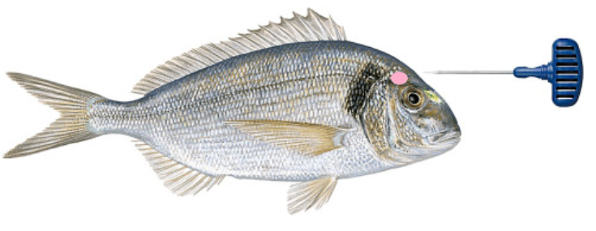
Fig. 1. Lateral view of a gilthead seabream (Sparus aurata) illustrating the correct positioning of the ikejime tool for brain spiking. The brain location is indicated by a pink ellipse, situated above the eye and aligned with the lateral line. (For interpretation of the references to colour in this figure legend, the reader is referred to the web version of this article.)

2.3.3. Visual indicators of consciousness
A series of behaviours and reflexes, previously identified as potential visual indicators of consciousness in fish (Kestin et al., 2002), were selected for analysis: free swimming, equilibrium, opercular movement pattern (regular and irregular), and vestibulo-ocular reflex (VOR). To assess the VOR, the orientation of the eyes was observed while the fish was in a lateral position; eyes aligned with the horizontal plane indicated absence of VOR, whereas tilted eyes indicated its presence (Kestin et al., 2002). The loss or gain of these behaviours and reflexes was examined in relation to the loss or recovery of consciousness (Table 1). These data were not subjected to statistical analysis and are presented descriptively.
Table 1. Ethogram of visual indicators of consciousness. The left column lists the behaviours and reflexes monitored as a visual indicator of loss or recovery of consciousness, presented in the order in which they were typically lost or regained in gilthead seabream. The right column provides a description of each behaviour.
Loss of consciousness
Loss of free swimming | Cessation of regular swimming activity
Loss of equilibrium | Cessation of vertical position
Onset of irregular opercular movement | Cessation of regular gill movement and resumption of irregular gill movement
Loss of vestibulo-ocular reflex (VOR) | Cessation of vestibulo-ocular reflex (VOR)
Loss of opercular movement | Cessation of gill movement
Recovery of consciousness
Onset of irregular opercular movement | Resumption of gill movement at an irregular pace.
Gain of vestibulo-ocular reflex (VOR) | Resumption of vestibulo-ocular reflex (VOR)
Gain of regular opercular movement | Resumption of regular opercular movement
Gain of equilibrium | Resumption of vertical position
Gain of free swimming | Resumption of regular swimming activity

2.3.4. Heart rate data processing
The bio-loggers had been programmed with the Mercury v 6.14 software to record four seconds of heart rate and internal temperature of the fish once per hour between the day of the surgery and the initiation of the trials. This allowed us to ascertain the recovery of the fish from the surgical procedure and to establish the baseline heart rate of the fish. On the day of the trial, the bio-loggers were programmed to record the heart rate and internal temperature of the fish for 10 s every 30 s, starting from the moment the water level in the housing tank began to decline.
Following the slaughter and blood sampling procedures, the bio-loggers were retrieved, and the data downloaded using the software Star-Oddi Mercury v 6.14. The initial exclusion criteria included heart rates with a quality index (QI) equal to 3 (identified by the software as of poor quality), or a beat per minute (bpm) limit inferior to 20 or superior to 200, as values outside the selected range are uncommon in gilthead seabream, based on previous studies (Cabrera-Álvarez et al., 2024; Mignucci et al., 2021). The selected data points were automatically processed with the software Star-Oddi HRT Analyzer v 1.0.2. All data points that had been excluded were subsequently verified manually using the software and/or the Star-Oddi Pattern Finder v 1.24 due to the presence of noise in the sample. The values of additional data points were subjected to a second verification process when a threshold of at least 10 bpm was observed between the value being studied and that of the preceding or subsequent data point. This discrepancy between subsequent data points was unusual when the recordings were of good quality; however, it was a common occurrence when there was noise in the samples, and thus the values of these data points had to be validated before further analyses.

2.3.5. Physiological sampling
Blood samples were collected from each individual both prior to slaughter (i.e., after stunning) and post-slaughter, immediately after death had been confirmed. However, for fish in the no-stunning group, blood sampling was conducted only post-slaughter, as it was not feasible to collect blood from conscious fish. Approximately 1 mL of blood was collected from the caudal vein with 1 mL heparinised (1000 units/mL lithium heparin, Sigma-Aldrich) syringes (Terumo®) and needles (23G, 0.6 × 32 mm, Agani™, Terumo®) and immediately transferred to tubes containing 10 μl of heparin and stored in ice. The blood was centrifuged at 9500g for 5 min at 4 °C, after which the plasma was separated and placed in aliquots at −80 °C until further analysis. Circulating cortisol was analysed using a Cortisol ELISA Kit for plasma (Tecan, IBL International, Switzerland) following the instructions provided by the manufacturer. Plasma metabolites and electrolytes were determined using colorimetric assay kits (Spinreact™, Spain). Glucose (assay ref. 1001192), lactate (ref. 1001330), calcium (ref. 1001061) and magnesium (ref. 1001285) were measured according to the manufacturer's instructions in assays adapted to 96-well microplates and the optical density (OD) was determined in a microplate reader (MultiScan Go, ThermoFisher Scientific, Japan). Plasma sodium and potassium concentrations were measured using a flame photometer (BWB XP, BWB Technologies, Newbury, UK). Plasma osmolality was determined with a vapour pressure osmometer (VAPRO 5520, Wescor, USA).

2.3.6. Muscle quality parameters
The fish were placed into a closed polystyrene box with ice and transported within 30–45 min to the Food Chemistry and Food processing laboratories of the Institute of Engineering, University of Algarve, where the following measurements were taken: pH, water-holding capacity (WHC), water loss (WL), fat loss (FL), and texture (hardness, springiness, chewiness, cohesiveness and gumminess; Table 2).
Table 2. Description of the texture measures explored in this study (Cheng et al., 2014; Szczesniak, 2002).
Hardness is a measure of the force required to deform or break the fish muscle sample. It provides information about the firmness of the muscle and can be used to assess the freshness of the fish. | Springiness measures the ability of the fish muscle to return to its original shape after being compressed. It reflects the elasticity and resilience of the muscle and can be used to assess the freshness of the fish.
Chewiness represents the effort required to masticate or break down the fish muscle during chewing. It combines attributes of cohesiveness, hardness, and resilience and can be used to assess the freshness of the fish. | Cohesiveness measures the ability of the fish muscle to stick together after being deformed. It indicates the degree of internal bonding within the muscle and can be used to assess the freshness of the fish.
Gumminess measures the energy required to disintegrate a semi-solid food to a state ready for swallowing. It reflects the overall texture of the muscle and can be used to assess the freshness of the fish. | Adhesiveness measures the tendency of the fish muscle to stick to surfaces. It indicates the stickiness or tackiness of the muscle.
The pH was measured directly using a digital pH meter (model GLP 21, Crison, Spain). Three measurements were taken per fillet and averaged, representing that fillet's pH value. WHC, WL, and FL were determined using a centrifugation method, following the procedures described in Gómez-Guillén et al. (2000), Pacheco-Aguilar et al. (2003), and Rørå et al. (2003). A Texture Profile Analysis (TPA) was conducted using an LFRA Texture Analyzer equipped with a 1 kg load cell. The method involved compressing the sample twice with a 50.8 mm diameter clear perplex flat-end probe at a speed of 2 mm/s until 50 % of the compression height was reached. A waiting time of 1 s was observed between compressions, and the resistance force was recorded in grams-force (g.f) and then converted to Newtons (N).

2.4. Statistical analysis

2.4.1. Heart rate data
The heart rate data were grouped into specific periods: the control period (from 9:30 to 12:30 on the day preceding the study, corresponding with the time of the study), the pre-trial period (from the moment the water level in the tank began to lower until the fish was caught), the stunning period, and intervals of 5 min after the first 5, 10, 15, 20, 25, and 30 min within the slaughter treatment. The mean heart rate for each of these periods was calculated for each fish.
The data was analysed using linear mixed models (LMM) with a first-order autoregressive (AR1) repeated covariance matrix. In all models we used individuals as the subject variable and random factor, period as repeated measure and fixed factor, stunning treatment, slaughter treatment, and crowding duration as fixed factors, and heart rate as the dependent variable. We first ran an initial analysis including crowding duration as fixed factor to check whether there was a potential order effect on the heart rate data, given that some fish had been waiting in the tank with lowered water for a longer period than others. Crowding duration had no effect (F (1, 12.8) = 0.09, p = 0.77), so it was removed from the model. We checked the normality of the residuals to meet the assumptions of the model and removed two outlier datapoints shown by the software, which improved the fit of the model based on its Akaike's Information Criterion (AIC). When there were significant effects, we ran pairwise comparisons with Sidak correction for multiple comparisons. In instances where interactions between variables were observed, planned comparisons of Kruskal-Wallis tests were employed to account for the non-normality of the data, while Tukey post-hoc tests were utilised to ascertain the groups that exhibited differential responses.

2.4.2. Internal temperature data
We analysed only the data from the fish that were slaughtered in ice-slurry, because there were only 2 to 3 data points for the fish that were subjected to the ikejime technique and a change in internal temperature was not expected for that treatment. The internal temperature data was selected from the moment the fish entered the ice-slurry, since that was the moment when internal temperature was expected to start changing. The data was analysed using a LMM with a diagonal matrix. We used individuals as the subject variable and random factor, time as repeated measure and fixed factor, stunning treatment as fixed factors, and internal temperature as the dependent variable. We checked the normality of the residuals to meet the assumptions of the model. When there were significant effects, we ran pairwise comparisons with Sidak correction for multiple comparisons.

2.4.3. Physiological data
The data were analysed using a LMM for each blood parameter (i.e., cortisol, glucose, lactate, calcium, magnesium, potassium, sodium, and osmolality) with a diagonal matrix. We considered individuals as the subject variable and random factor, sample collection (after stunning and after slaughter) as repeated measure and fixed factor, and each blood parameter as dependent variables. The normality of the residuals was verified to ensure that the model assumptions were met. When significant effects were identified, pairwise comparisons were conducted with the Sidak correction for multiple comparisons. When an interaction between treatment and sample collection was observed, a pair-sample t-test was performed for each treatment, with blood collection point (i.e., after stunning and after slaughter) as the paired variables, and we reported the two-tailed results.

2.4.4. Muscle quality data
A one-way ANOVA was carried out per parameter to ascertain differences among the distinct stunning treatments. The assumptions of ANOVA, namely normality and homocedasticity, were verified. Principal components analysis (PCA) was then used to better understand and reduce the dimensionality of large datasets containing a diverse set of parameters, while preserving as much variance (information) as possible. Bartlett's sphericity test and the KMO index were used to assess the suitability of PCA.
The statistical analyses were conducted using SPSS Statistics 29 (IBM Corp., Armonk, NY, USA) considering a significance level of 0.05. The software R (R Core Team, 2023) and packages FactorMineR (Lê et al., 2008) and factoextra (Kassambara and Mundt, 2016) were used for PCA.

2.5. Ethical note
The experiment was conducted at Estação Piloto de Piscicultura de Olha ̃o (EPPO) facilities from IPMA (Olhão, Portugal), after compliance with internal ethics boards and under ethical permit 2023DGV/000066293 issued by Direção Geral de Alimentação e Veterinária, Ministério da Agricultura, Florestas e Desenvolvimento Rural, Portugal in compliance with the European (Directive 2010/63/EU) and Portuguese (Decreto-Lei no. 113/2013 de 7 de Agosto) legislation for the use of laboratory animals. All procedures were conducted by trained scientists under Group-C licences issued by the Direção Geral de Alimentação e Veterinária, Ministério da Agricultura, Florestas e Desenvolvimento Rural, Portugal, and under the supervision of an inhouse veterinarian at EPPO.

3. Results

3.1. Visual indicators of consciousness

3.1.1. Electrical stunning
All ten fish that were stunned with the electrical stunner exhibited immediate loss of visual indicators of consciousness following the application of the electrical current, except for one fish that did not lose the VOR. The five fish that were subjected to ikejime did not display VOR or opercular movements during the procedure, which took on average 37 ± 9 s. However, two of them exhibited sudden movements while the ikejime technique was being performed. The five fish subjected to the ice-slurry slaughter process exhibited irregular opercular movement shortly after being placed in the ice-slurry (for further details, please refer to Table 3). One fish gained VOR but subsequently lost it again. All five fish lost opercular movement after a period of 16 ± 3 min in the ice-slurry.
Table 3. Number of gilthead seabream exhibiting each visual indicator of consciousness during stunning and slaughter, and the corresponding time of occurrence (mean ± SEM [range], in mm:ss). Values are presented as n/N (individuals showing the indicator / total observed). NA indicates the indicator was not observed. Asterisk denotes inconsistent or unclear observation in one or more individuals.
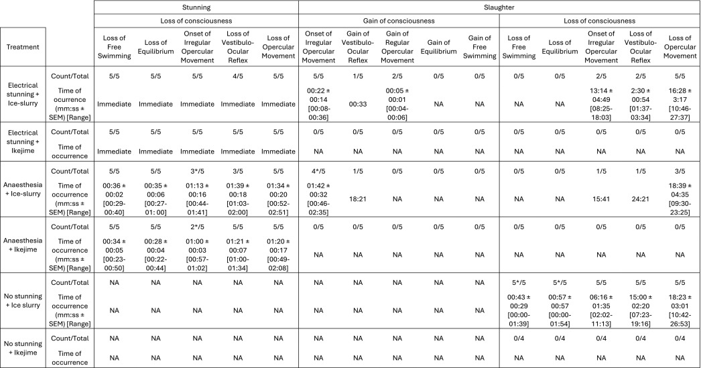

3.1.2. Anaesthesia with 2-phenoxyethanol
All ten fish exhibited loss of all consciousness indicators within two minutes of being placed in the anaesthetic bath. However, assessment of irregular opercular movement was challenging in some individuals, which seemed to have proceeded directly to lose opercular movement or lose VOR. The five fish that underwent ikejime did not exhibit VOR or opercular movements during the procedure, which took on average 43 ± 13 s. However, four of the subjects displayed sudden movements while the ikejime technique was being performed. Of the five fish slaughtered in ice-slurry, four exhibited irregular opercular movement shortly after being placed in the ice-slurry (for further details, please refer to Table 3). One fish regained VOR after 18 min from the start of the slaughter process and remained in that state for five minutes. Three fish exhibited loss of opercular movement after a period of 18 ± 4 min in the ice-slurry.

3.1.3. No stunning
All nine fish that had not been stunned showed signs of being conscious throughout the slaughtering process. The ikejime technique proved challenging to perform due to the fish's sudden movements, taking on average 136 ± 107 s, which resulted in two fish not being properly slaughtered with the ikejime technique, even after multiple attempts. With regards to the five fish that were immersed in the ice-slurry, determining the exact moment at which the fish lost the capacity for independent movement and equilibrium was challenging, given the limited range of motion permitted in an ice-slurry bath. All the fish exhibited irregular opercular movement after a mean time of 6 ± 1 min in the ice-slurry, and lost VOR after a mean time of 15 ± 2 min in the ice (for further details, please refer to Table 1). Opercular movement ceased altogether after a mean time of 18 ± 3 min in the ice-slurry. During the slaughter process, all five fish exhibited continuous signs of stress, including abrupt moments and gasping.

3.2. Bio-logging data

3.2.1. Heart rate
The heart rate was significantly lower in fish slaughtered in ice-slurry compared to those slaughtered with ikejime (Fig. 2; LMM, F(1, 41.7) = 36.0, p < 0.001) but no significant differences were found among stunning methods (Fig. 2; LMM, F(2, 27.9) = 0.8, p = 0.45). The time periods were also significantly different ((LMM, F(7, 16.7) = 34.7, p < 0.001), with the stunning event increasing the HR (p = 0.005), and minutes 10 to 25 of the slaughter process having a significantly lower heart rate (HR) than the control day (all p-values <0.001). The HR during the first and last 5 min of the slaughter process (i.e., from 0 to 5 min and from 25 to 30 min) were not significantly different from the HR on the control day (first 5 min: p = 1.0; final 5 min: p = 0.31).
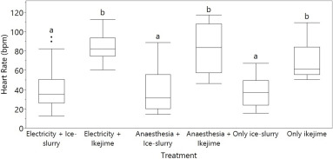
Download: Download high-res image (108KB)
Download: Download full-size image
Fig. 2. Mean heart rate (in beats per minute) of the overall procedure, for each treatment: electrical stunning followed by immersion in ice-slurry or ikejime, no stunning followed by immersion in ice-slurry or ikejime, and anaesthesia with 2-phenoxy-ethanol followed by immersion in ice-slurry or ikejime.
Furthermore, a significant interaction was observed between stunning and slaughter methods (Fig. 2; LMM, F(2, 46.9) = 4.0, p = 0.025). The treatments involving ice-slurry exhibited a significantly lower heart rates compared to the treatments involving ikejime (see p-values in Supplementary Fig. 1).
There was also a significant interaction between slaughter and period (Fig. 3, LMM, F(2, 36.5) = 22.6, p < 0.001), with all ice-slurry events having significantly lower heart rate than the control day (Tukey pairwise comparison: 5 min: p = 0.012; 10 min: p < 0.001; 15 min; p < 0.001; 20 min: p < 0.001; 25 min: p = 0.002; 30 min: p = 0.025) except for the stunning event (p = 0.83). The heart rates during the ikejime events were not significantly different from the control day (Tukey pairwise comparison: stunning: p = 0.16, 5 min: p = 0.48) but they were significantly higher than during the ice-slurry slaughtering events (i.e., from the first 5 min till the 30 min of ice-slurry slaughter; all p-values ≤0.003).
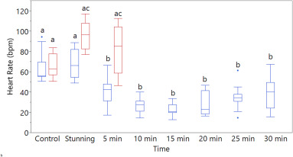
Download: Download high-res image (122KB)
Download: Download full-size image
Fig. 3. Heart rate over time for slaughter in ice-slurry (blue) and ikejime (red). The control group was the average heart rate of the same individuals during the same period of 24 h before the treatment. The stunning group comprise the combination of fish stunned with electricity and anaesthetic. The remaining time points are the average heart rate for each 5-min period from the start of the slaughter procedure. (For interpretation of the references to colour in this figure legend, the reader is referred to the web version of this article.)
There was no interaction between stunning and period (F (13, 16.5) = 2.0, p = 0.093) nor between stunning, slaughter, and period (F (3, 42.3) = 2.6, p = 0.063).

3.2.2. Temperature
Following the introduction of the fish into the ice-slurry, a gradual decline in their internal temperature was observed (Fig. 4). A significant difference was observed between the time points (LMM, F(61, 16.7) = 1234.4, p < 0.001), with the temperature consistently demonstrating a notable decline relative to the initial temperature (i.e., the temperature at the time of the subject's entry into the ice-slurry). From minute 3 onwards, there was a significant difference in temperature between the time points (time 0 vs. time 3 min: p = 0.015; for all other comparisons with time 0 and after min 3: p ≤ 0.002; and before min 3: p > 0.2).
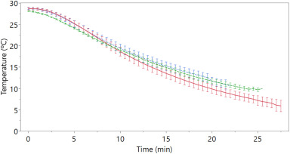
Download: Download high-res image (87KB)
Download: Download full-size image
Fig. 4. Mean temperature in °C over time in minutes. Temperature of non-stunned fish represented by a solid red line, electrically stunned fish by a dotted blue line, and fish stunned with anaesthesia (2-prenoxy-ethanol) by a dashed green line. Error bars depict S.E.M. (For interpretation of the references to colour in this figure legend, the reader is referred to the web version of this article.)
A significant difference was observed among treatments (Fig. 4; LMM, F(2, 101.1) = 36.0, p < 0.001), with fish that did not undergo any prior stunning procedures and were subsequently included in the ice-slurry exhibiting a more pronounced temperature decline than the fish that were stunned (electrical stunning: p = 0.001; 2-phenoxy ethanol: p = 0.036). No significant difference was observed between the two stunning treatments (p = 0.47). Furthermore, there was no significant interaction between time and treatment (LMM, F(112, 2.6) = 2.3; p = 0.3).

3.3. Physiological data
Regarding cortisol, there was a significant difference among treatments (Fig. 5A; F 5, 30.1 = 85.94, p < 0.001), with cortisol in the group of ice-slurry without prior stunning being significantly higher than all other treatments (electrical stunning followed by ikejime: p = 0.018; anaesthesia followed by ice-slurry: p < 0.001; anaesthesia followed by ikejime: p = 0.004; and ikejime without prior stunning: p = 0.024) except for electrical stunning followed by ice-slurry (p = 0.27). The cortisol in the group that underwent electrical stunning followed by ice-slurry was also significantly higher than the group that underwent anaesthesia followed by ice-slurry (p = 0.037). All other comparisons were not statistically significant (all p-values >0.27). There was no significant difference between the blood collection points (F (1, 38.4) = 0.01, p = 0.92), nor an interaction between the treatment and the blood sample collection (F (3, 38.4) = 0.64, p = 0.59). The results of the statistical analysis for the remaining analised blood parameters are summarised in Table 4.
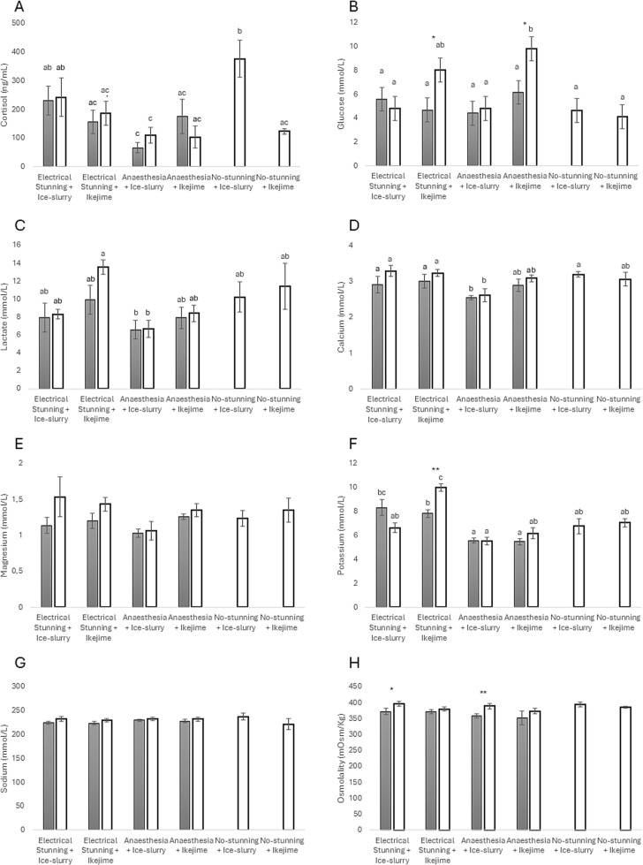
Download: Download high-res image (762KB)
Download: Download full-size image
Fig. 5. Plasma analysis (mean ± SEM) before (grey) and after (white) slaughter techniques applied to seabream: A) Cortisol, B) Glucose, C) Lactate, D) Calcium, E) Magnesium, F) Potassium, G) Sodium, H) Osmolality. Different letters above the columns indicate statistical differences (p < 0.05) between columns, established by a LMM with pairwise comparisons. Asterisks show statistical difference (*: p < 0.05; **: p < 0.01) between the before and after groups for the same stunning & slaughter treatment pair as determined by a two-tailed paired t-test.
Table 4. Summary of statistical results for blood parameters across slaughter treatments and sampling times. This table presents the main effects of treatment, blood sampling time (before vs. after slaughter), and their interaction for each measured blood parameter with the exception of cortisol, which is comprehensively detailed in the main text. Significant pairwise comparisons are also listed when applicable. Treatments include electrical stunning (E), anaesthesia (A), ice-slurry immersion (Ice), and ikejime, either alone or in combination. Combined treatments are denoted using a plus sign (e.g., A + Ikejime = anaesthesia followed by ikejime). Only statistically significant results (p < 0.05) are reported in the “Key Significant Comparisons” column unless otherwise noted.
Parameter | Effect of Treatment | Effect of Sample Timing (Before vs After) | Interaction (Treatment × Timing) | Key Significant Comparisons
Glucose | Yes (F(5, 25.6) = 8.52, p < 0.001) | Yes (F(1, 27.7) = 8.55, p = 0.007) | Yes (F(3, 27.7) = 3.75, p = 0.022) | A + Ikejime > Ikejime (p = 0.001), Ice (p = 0.003), A + Ice (p = 0.003), E + Ice (p = 0.023); Significant interaction: A + Ikejime (p = 0.022), E + Ikejime (p = 0.015)
Lactate | Yes (F(5, 29.5) = 3.64, p = 0.011) | No (F(1, 36.8) = 1.50, p = 0.23) | No (F(3, 36.8) = 0.78, p = 0.51) | E + Ikejime > A + Ice (p = 0.007); all other p > 0.13
Calcium | Yes (F(5, 27.5) = 3.28, p = 0.018) | No (F(1, 32.7) = 4.04, p = 0.053) | No (F(3, 32.7) = 0.34, p = 0.79) | A + Ice < Ice (p = 0.018), E + Ikejime (p = 0.023), E + Ice (p = 0.030); other p > 0.17
Magnesium | No (F(5, 28.4) = 1.54, p = 0.21) | Yes (F(1, 33.9) = 4.44, p = 0.043) | No (F(3, 33.9) = 0.86, p = 0.47) | Post-slaughter > Pre-slaughter, driven by E + Ikejime (p = 0.039); other p > 0.12
Potassium | Yes (F(5, 30.2) = 16.93, p < 0.001) | No (F(1, 38.4) = 0.93, p = 0.34) | Yes (F(3, 38.4) = 7.41, p < 0.001) | E + Ikejime > all other treatments (all p < 0.05); E + Ice > A + Ice (p < 0.001), A + Ikejime (p = 0.005); interaction driven by E + Ikejime (p = 0.001)
Sodium | No (F(5, 28.2) = 0.84, p = 0.54) | No (F(1, 33.3) = 2.33, p = 0.14) | No (F(3, 33.3) = 0.11, p = 0.95) | –
Osmolality | No (F(5, 24.8) = 1.13, p = 0.37) | Yes (F(1, 26.2) = 7.89, p = 0.009) | No (F(3, 26.2) = 0.37, p = 0.78) | Post-slaughter > Pre-slaughter, driven by E + Ice (p = 0.008), A + Ice (p = 0.003); Ikejime treatments not significant

3.4. Muscle quality data
There were marked differences in muscle pH (ANOVA, F(5,23) = 13.18, p < 0.0001), with significantly lower pH observed in the muscle of the fish that were electrically stunned or slaughtered directly with an ice-slurry bath compared to the fish that were anaesthetised prior to slaughter (Fig. 6; Tukey HSD, p < 0.005).
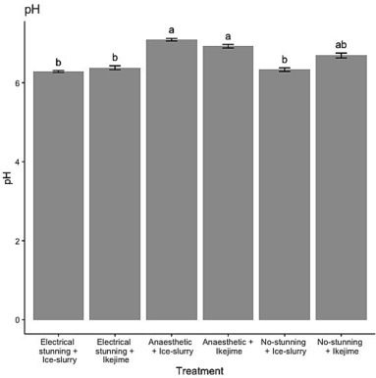
Download: Download high-res image (133KB)
Download: Download full-size image
Fig. 6. Muscle pH (mean ± SE) following the stunning and slaughter techniques applied to seabream. Different letters above the columns represent statistical significance (Tukey HSD, p < 0.05).
Regarding texture, samples of muscle from fish that had been stunned using only ikejime or stunning with anaesthesia prior to slaughter were softer (Fig. 7 A), less chewy (Fig. 7 D) and less gummy (Fig. 7 C)). However, no statistically significant differences were found between the various stunning and slaughter procedures (ANOVA, 0.19, < p < 0.47) for any of the texture parameters analysed herein (Fig. 7B, E and F).
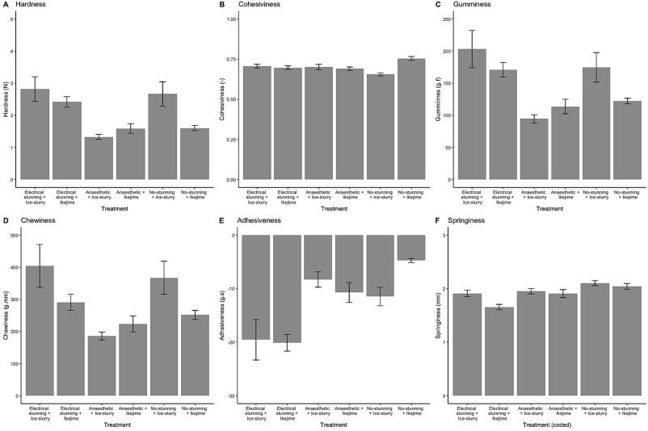
Download: Download high-res image (477KB)
Download: Download full-size image
Fig. 7. – Parameters of texture measured in the muscle (mean ± SE) following the stunning and slaughter techniques applied to seabream. Different letters above the columns represent statistical significance (Tukey HSD, p < 0.05).
Additionally, significant differences between procedures were observed in the water and fat loss (WL and FL, respectively; ANOVA, F(5,23) = 10.17, p < 0.0001 and F(5,23) = 9.13, p < 0.0001), but not in water-holding capacity (WHC, ANOVA, F(5,23) = 1.75, p = 0.163) of the muscle samples of fish (Fig. 8). The muscle of fish anaesthetised prior to slaughter had higher WHC and significantly much lower WL and FL compared to the fish electrically stunned prior to slaughter (Fig. 8; Tukey HSD, p < 0.001).
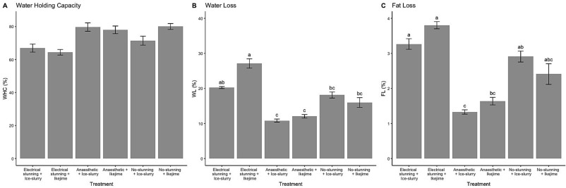
Download: Download high-res image (251KB)
Download: Download full-size image
Fig. 8. Water retention capacity of muscle (mean ± SE). A. Water holding capacity. B. Water loss. C. Fat loss. Different letters above the columns represent statistical significance (Tukey HSD, p < 0.05).
A principal component analysis (PCA) revealed significant variability explained by the first few components. The first principal component (PC1) alone accounts for 35.6 % of the variance, primarily influenced by high loadings from variables such as Hardness (0.86), Gumminess (0.87), Chewiness (0.82), Adhesiveness (−0.71), and pH (−0.82). PC2 contributes an additional 21.4 % variance, predominantly influenced by variables WHC (0.57) and WL (−0.65) (Fig. 9B). PC3 and PC4 further explained 13.1 % and 9.6 % of the variance, both PCs add an eigenvalue >1 (Keiser-Guttman rule), thus PC1 to PC4 are retained herein. The cumulative variance explained by the first four components is 79.7 %, suggesting these dimensions do effectively capture the dataset's variability. Bartlett's test of sphericity (χ2 = 401.7, p < 0.0001) and the Kaiser-Meyer-Olkin measure (overall MSA = 0.62) support the suitability of PCA for these data, particularly pH, WHC, WL and FL (MSA = 0.89, 0.71, 0.70 and 0.74 respectively), despite some variables showing less than ideal sampling adequacy (namely cohesiveness and springiness, MSA < 0.40).
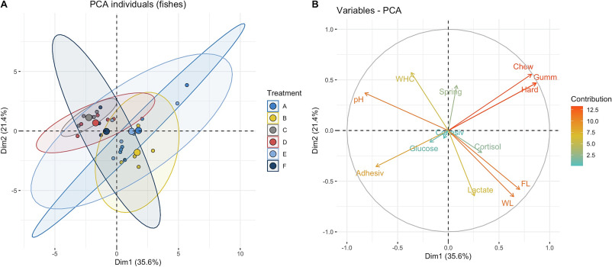
Download: Download high-res image (540KB)
Download: Download full-size image
Fig. 9. PCA plots of individuals (left) and variables (right) of muscle considering the muscle quality data. PCA plot of individuals: the 95 % confidence ellipses group fishes according to treatment. PCA plot of variables: The larger the value of the contribution, the more the variable contributes to the component. Treatments are: A. e-stunning + ice-slurry, B. e-stunning + ikejime, C. no stunning + ice-slurry, D. no stunning + ikejime, E. anaesthesia + ice-slurry, F. anaesthesia + ikejime.

4. Discussion
We studied the visual indicators of consciousness and physiological effects of two different slaughter methods preceded by either one of two stunning methods or no stunning at all. We found significant differences between treatments at behavioural, physiological, and muscle quality parameters.
Observations of visual indicators suggested that fish not subjected to any stunning procedure remained conscious throughout the slaughter process. This process was never immediate; with the fastest method, ikejime, took more than two minutes, while ice-slurry required 18 ± 3 min to kill the animal. It can be concluded with certainty that the fish remained conscious for at least 11 min during the latter process. For the fish that were stunned using either anaesthesia or electricity, it is not possible to be completely certain that the techniques were 100 % effective, as the VOR was regained in one individual (20 % of the sample) from each treatment, and several instances of reactions (body and opercular movements) were observed in response to the slaughter procedures. Notably, the time to loss of opercular movement during the killing process in ice-slurry appeared comparable across all three slaughter methods, whether or not a stunning technique was applied, highlighting that neither anaesthesia nor electrical stunning maintained unconsciousness long enough to prevent the reappearance of visual indicators of consciousness during ice-slurry immersion. Based on the overall dataset (including visual, physiological, and muscle quality parameters), it can be concluded that while visual indicators of consciousness may be useful for estimating the level of wakefulness of the fish when they are present, more accurate techniques, such as EEG recordings of brain activity, are warranted to ascertain consciousness in their absence.
The data collected by the internal bio-loggers revealed that heart rate exhibited a similar response to either anaesthesia, electricity or no stunning. However, a significant difference in heart rate was observed between the slaughter methods ikejime and the submergence in ice-slurry, with the latter inducing a clear bradycardia (reduced heart rate) in the fish. This is due to the fact that gills have a diminished capacity to collect oxygen at the low temperatures experienced during the ice-slurry bath, which results in a hypoxic exposure that causes a rapid reflex bradycardia (Driedzic and Gesser, 1994). Interestingly, the rate at which the internal temperature of the fish decreased during the ice-slurry bath differed significantly depending on whether the fish had undergone prior stunning. The fish that were placed directly in the ice-slurry without prior stunning exhibited a reduction in internal temperature at a faster rate than the stunned fish. A possible reason may be related to the maintenance of a higher blood flow in non-stunned fish, which also display higher body movement while in ice-slurry compared to electrically stunned or previously anaesthetised fish. Blood circulating through the peripheral vessels at a faster rate would have a higher heat-loss and would contribute to a quicker reduction in internal temperature as it flows back into the core of the fish. Although we did not observed significant differences in heart rate between these and the stunned/anaesthetised fish, it is known that fish can dramatically increase cardiac output by modulating stroke volume (Shiels et al., 2006) and is thus possible that the acute stress of immersion in cold water resulted in increased stroke volume likely modulated by cholinergic factors such as adrenaline (Axelsson, 1988; Bernier and Perry, 1999; Rytter and Gesser, 2007). The effects of adrenaline and cortisol in modulating nitric oxide production and consequent increase in vasodilation have also been described (Gerber et al., 2017; Östlund and Fänge, 1962) and such a process would further contribute to an increased blood flow. Both catecholamines and cortisol increase when fish are subjected to acute cold stress (Chen et al., 2002).
The perception of ice-slurry as a severe welfare challenge appears to be confirmed by the faster onset of irregular opercular movements, increased cortisol levels, and a longer time until loss of eye-reflex in non-stunned fish. During this period of prolonged awareness/consciousness in cold water the fish's brain would be active. Notably, functional magnetic resonance imaging revealed a reduction in brain blood volume in common carp 90 s after a 10 °C temperature drop (from 25 °C to 15 °C) (van den Burg et al., 2005). This reduction in blood flow would slow the rate of cooling of the brain, prolonging the period of consciousness (van de Vis et al., 2020). In the study conducted by van den Burg et al. (2005), specific brain regions exhibited disparate responses to the temperature reduction. For instance, brain regions engaged in the stress response, such as the preoptic area of the hypothalamus and the pars distallis of the pituitary gland, exhibited a reduction in blood volume at a slower rate than other brain areas. It is noteworthy that the preoptic area has robust connections with the pars distallis of the pituitary gland, which is a region densely populated by cells that synthesise and secrete adrenocorticotropic hormone, thereby stimulating the release of cortisol by the interrenal cells in the head kidney. The preoptic area is also implicated in thermal response in the carp, in conjunction with the brain stem (Crawshaw et al., 1985). However, the brain stem appeared to be less active than the preoptic area during the enforced temperature drop in the study of van den Burg et al. (2005). Consequently, the brain of the common carp exhibits a selective response to a rapid decline in temperature, whereby the blood supply is prioritised for brain regions engaged in the stress response. In a similar study also on common carp, an activation of the sensorimotor pathway was observed, comprising the trigeminal nerve, the primary sensory trigeminal nucleus, the valvula cerebelli and certain motor nuclei, which ultimately resulted in motor activity for escape (van den Burg et al., 2006). Although the common carp and gilthead seabream are distinct species, the conserved nature of the HPA/HPI axis across vertebrates makes it plausible that analogous physiological responses occurred in our study. This is supported by the elevated cortisol levels and frequent escape attempts observed in non-stunned fish, which suggest activation of both stress-related and motor brain regions. Moreover, the greater internal temperature decline observed in non-stunned fish, along with their elevated cortisol levels, suggests that these fish faced greater difficulty coping with extreme temperature changes compared to the stunned fish. This difficulty in coping may be due to brain regions involved in processing temperature changes triggering an alarm response, as the fish struggled to reach homeostasis, with other critical functions of the sympathetic system related to fight or flight response taking priority (Crawshaw et al., 1981). A more comprehensive study of the brain activity of seabream during slaughter in ice-slurry is required to confirm this hypothesis.
Blood indicators provide valuable information for welfare assessment, highlighting the levels of challenges imposed and the potential disturbances to endocrine, metabolic, ionic, haematological, and immune functions, among others (Seibel et al., 2021). In this study, blood plasma samples were collected immediately after stunning (i.e., prior to slaughter) and again post-slaughter. Since the post slaughter sample was taken when the fish were assumed dead, the time intervals between pre- and post-slaughter samples varied considerably. The interval was very short when ikejime was used but much longer and more variable in fish slaughtered using ice-slurry. Average cortisol values ranged roughly between 50 and 200 ng/mL, which are slightly higher than those previously reported for seabream sedated with 2-phenoxyethanol (Molinero and Gonzalez, 1995; Toni et al., 2015; Tort et al., 2002) but we must consider the potential stressful effect of the fish being collected from the tanks prior to stunning. In fact, pre-stun procedures may mask the effects of the treatments (Arends et al., 1999). Nevertheless, fish collection was the same across treatments and the lowest cortisol values were found in the anaesthesia groups (especially followed by slaughter in ice-slurry), indicating that chemically induced unconsciousness is the least stressful method among our tested procedures to stun seabream. This aligns with findings in other species (see e.g. Saraiva et al., 2024). Additionally, no significant difference in cortisol levels was observed between the fish that were electrically stunned and those slaughtered in ice-slurry without prior stunning. This similarity in cortisol levels between the two treatments may have resulted from an alarm response triggered by the electrical shock, as cortisol levels were already elevated immediately after stunning. This finding raises concerns about the effectiveness of electrical stunning as a viable humane alternative. Recent findings indicate that, in rainbow trout, brain pathways related to stress were activated upon electrical stunning, suggesting that the stress response to electrical current may occur in higher brain areas rather than eliciting a purely physiological effect downstream (Saraiva et al., 2024). Additionally, while the cellular responses to electrical stimulation regarding stress are largely unknown, there is some evidence that mild electric shocks in vitro inhibit cortisol release in adrenal gland tissue of rats (Samidurai et al., 2018). Despite these knowledge gaps, such findings may suggest that a complete shutdown of the brain may not be fully achieved with electrical stunning, which could compromise its humaneness. On the other hand, cortisol levels in non-stunned fish slaughtered by ikejime were similar to those in stunned fish subjected to the same slaughter method, likely due to the swiftness of the procedure and immediate death, which occurred before the time needed for an interrenal response. Conversely, fish placed in ice-slurry without prior desensitisation, mounted a very high cortisol response, reaching average values similar to or exceeding those measured in seabream after air exposure (Arends et al., 1999) or acute crowding (Guardiola et al., 2016). In a previous study by Papaharisis et al. (2019), there were no differences in mean plasma cortisol, glucose, or lactate concentrations in seabream killed by pithing (similar to Ikejime), electrical stunning followed by immersion in ice-slurry or ice-slurry alone. However, it is important to note that in their study, blood samples were taken immediately after pithing and after stunning, while fish in ice-slurry were sampled only after movement ceased (5–7 min), which does not necessarily indicate death. In contrasts, in our study, fish in similar conditions lost the eye-reflex 15 min after immersion in ice-slurry, and opercular movement ceased only after 18 min, when the final blood sample was taken.
In contrast with cortisol levels, glucose and lactate levels in plasma did not differ between fish exposed to electrical stunning or anaesthesia, but significant increases were seen in some of the groups slaughtered by ikejime. Glucose rose significantly upon ikejime in the electrically stunned and anaesthetised fish, which could be triggered by adrenaline signalling released directly from disturbing the nervous system. However, it is puzzling that the same rise did not occur in the no-stun followed by ikejime slaughter. Lactate was also found to be different in the group killed by ikejime after electrical stunning, which is surprising, attending to the fact that these fish were rendered immediately immobilized before the slaughter procedure. The reasons for such spikes in glucose and lactate after ikejime may deserve further attention. Given that fish in ice-slurry dropped their temperature at about 1 °C per minute, and were either immobilized or ceased movements within few minutes, a significant accumulation of lactate from excessive anaerobic activity would be unlikely, despite being in potentially hypoxic conditions due to mechanical restriction to opercular movement and water flow through the gills.
Blood osmolality was elevated in groups slaughtered in ice-slurry, which indicates a disturbance in osmotic balance. This was probably caused by the failure of the gills, and to some extent the kidney and intestine, all responsible for osmoregulation in fish, to maintain salt excretion rates during the exposure to its hyperosmotic surroundings, an energy-intensive process. Studies in the eurythermal killifish (Fundulus heteroclitus), showed that a cold shock induced transient impairment in branchial salt secretion (Buhariwalla et al., 2012). Increased osmolality was more evident in the fish that were previously stunned/anaesthetised and therefore possibly less responsive to maintain this physiological function, as they respond to osmosensors in osmoregulatory epithelia but also in the brain that act to quickly restore osmo- and ionic homeostasis (Kültz, 2012). Slight but non-significant increases in blood osmolality have been observed immediately upon acute cold shock in Atlantic salmon (Vadboncoeur et al., 2023) which were restored within hours.
The change in osmolality was not accompanied by modifications in its contributing ions, with no alterations in blood sodium nor relevant changes in calcium or magnesium, and chloride levels were not addressed. It is also possible that osmolality in the fish slaughtered in ice-slurry is additionally being increased by other metabolites not identified, in addition to water loss. Interestingly, fish subjected to electrical stunning showed elevated plasma potassium, which was more obvious in those slaughtered by ikejime. Increases in potassium can be indicative of red blood cell disruption. We have not assessed haematocrit or determined haemolysis levels in these blood samples, and haematological data from electrically stunned fish shows contradictory results (Gräns et al., 2015).
These results, supported by visual indicators, concur to suggest that slaughter by immersion in ice-slurry is a lengthy and stressful process. Although the visual indicators may suggest that the electrical shock induces unconsciousness, it may still trigger a stress response similar to that of ice-slurry slaughter. In contrast, prior desensitisation with anaesthesia mitigated the downstream HPI response during slaughter, suggesting a positive effect by reducing fish perception. However, this desensitisation may interfere with the fish's ability to maintain osmoregulatory homeostasis.
Regarding muscle quality, electrical stunning seems to induce strong muscle contractions, which may explain the lower pH observed in the muscle parameters of the electrically stunned seabream compared to those anaesthetised prior to slaughter, consistent with previous findings in salmonids (Azam et al., 1989; Marx et al., 1997; Saraiva et al., 2024). This reduction in pH resembles that seen in fish subjected to vigorous exercise immediately ante mortem (Robb et al., 2000a). Interestingly, non-stunned fish placed directly in ice-slurry exhibited similar low pH values in muscle tissue, suggesting that this method also imposes significant physiological stress and muscle energy expenditure.
While these results highlight differences in post-mortem muscle biochemistry, it is important to emphasise that such meat quality indicators (e.g., pH, water-holding capacity, texture) should be considered separately from welfare assessments. For example, although electrical stunning is widely regarded as a humane method of slaughter when effectively applied, it may have negative impacts on muscle quality due to excessive muscular activity, a trade-off also noted in other species such as farmed land animals, where electrical stunning has been linked to increased blood spotting (Grandin, 2015).
The pH of fish muscle can have a significant impact on its texture (see below). Fish with a high pH tend to have a soft texture (Kelly et al., 1966). This is because a high pH is associated with a higher solubility of fish muscle proteins, which can result in a softer texture (Kelleher et al., 2004). Conversely, fish with low pH tend to have a higher cell fragility reading, indicating a firmer texture (Kelly et al., 1966). In fact, samples of muscle from fish that had been slaughtered using only ikejime or stunned with anaesthesia prior to slaughter were softer, less chewy, and less gummy. Conversely, the pH of fish muscle can affect its water holding capacity, water and fat loss, and texture properties. When the muscle's pH falls post-mortem, some of the muscle's capacity to store water is lost (Warner, 2017). In fact, as the pH drops, the net surface charge on the muscle proteins is reduced, causing them to partially denature and lose some of their water-holding capacity (Huss, 1995). The muscle of fish anaesthetised prior to slaughter was the least affected by the combination of stunning and slaughter procedures, having higher WHC and significantly much lower WL and FL compared to the fish electrically stunned prior to slaughter. On the other hand, loss of water has a detrimental effect on the texture of fish muscle, and it has been found that a fish with a high pH has a soft texture due to higher solubility (Kelleher et al., 2004; Kelly et al., 1966). Muscle tissue in the state of rigor mortis loses its moisture when cooked and is particularly unsuitable for further processing which involves heating, since heat denaturation enhances the water loss (Huss, 1995).
Different fish cues have an impact on consumers' choice (Saidi et al., 2023). Consumers generally prefer fish and seafood products with certain texture characteristics (Nanou et al., 2023): a firm texture, that is often associated with freshness and quality; and fish that retains its moisture content is preferred, as it contributes to a more pleasant eating experience. However, texture preferences can vary depending on the specific type of fish or seafood product, as well as cultural and individual preferences (Can et al., 2015). Regarding the PCA, when individuals/samples are superimposed on the biplot (Fig. 9A), we can conclude that the fish subjected to anaesthesia prior to slaughter are clearly distinct from the fish electrically stunned, in terms of average value as well as confidence ellipses, relating to pH and WHC in the case of the anaesthetised fish and to WL and FL in the case of electrically stunned fish.
In conclusion, this study reveals significant differences in the behavioural, physiological, and muscle quality responses to various stunning and slaughter methods in gilthead seabream. One of the main takeaways of this study is that better welfare at slaughter corresponds to better muscle quality. Chemically induced unconsciousness seems to provide a blueprint for what a commercial method should be: reliable and effective enough to last through killing procedures. On the other end of the welfare spectrum and in many aspects of quality is slaughter in ice-slurry without prior stunning. Our results demonstrate that gilthead seabream under this procedure endure a long period of poor welfare, alive and conscious during way more time than previously reported. Finally, the effects of electrical stunning remain unclear. Although visual indicators suggest unconsciousness, it is not clear that the brain is not processing external stimuli, as shown by the differences between this method and anaesthesia in many welfare parameters. Furthermore, the meat quality results are sub-optimal for this stunning method and suggest that the fish are experiencing a stressful process, when theoretically they should be unconscious and unresponsive. Searching for validation of electrical stunning using EEG and novel indicators, together with alternative stunning methods that can effectively render gilthead seabream unconscious are interesting avenues for future research. In that sense, anaesthesia prior to slaughter, while effective in reducing stress and improving meat quality, was used only as a control in this study and cannot be applied in the industry due to food safety concerns. Similarly, while the ikejime technique requires considerable manual effort for industry implementation, it demonstrated superior outcomes in terms of short duration, reduced physiological stress, and enhanced muscle quality. These promising results suggest that, with further refinement and potential automation, ikejime, or a comparable percussive technique, holds a great potential as a humane and effective slaughter method capable of ensuring both high animal welfare standards and superior meat quality in industrial settings. Nevertheless, its successful implementation will demand significant development, given the high risk of missing the brain regardless of stunning status. To safeguard animal welfare, pre-stunning procedures must be regarded as essential. With the right innovation and ethical commitment, such methods could represent a transformative step toward more responsible and sustainable fish slaughter practices.

CRediT authorship contribution statement
María J. Cabrera-Álvarez: Writing – review & editing, Writing – original draft, Visualization, Validation, Supervision, Project administration, Methodology, Investigation, Formal analysis, Data curation, Conceptualization. Sónia Marina António Soares: Writing – review & editing, Methodology, Investigation, Formal analysis, Data curation. Samira Nuñez-Velazquez: Writing – review & editing, Investigation. Jaime Aníbal: Writing – review & editing, Writing – original draft, Visualization, Validation, Software, Investigation, Formal analysis, Data curation. Eduardo Esteves: Writing – review & editing, Writing – original draft, Visualization, Validation, Software, Investigation, Formal analysis, Data curation. Rita A. Costa: Writing – review & editing, Visualization, Validation, Investigation, Data curation. Pedro M. Guerreiro: Writing – review & editing, Writing – original draft, Visualization, Methodology, Conceptualization. Pedro Pousão-Ferreira: Resources. Pablo Arechavala-López: Funding acquisition, Conceptualization. João L. Saraiva: Writing – review & editing, Supervision, Resources, Project administration, Methodology, Investigation, Funding acquisition, Conceptualization.

